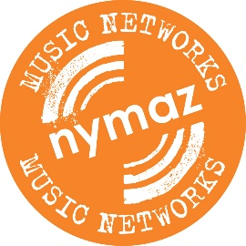
SONG COMMISSION – BRIEF
NYMAZ Early Years Songbook: Songs for modern childhoods
NYMAZ is a youth music development charity championing the transformative potential of music for children and young people. Working with our trusted partners, we deliver high quality music-making activities across North Yorkshire to those in challenging circumstances, including three Early Years projects in Whitby, Harrogate and Catterick Garrison.
As part of our commitment to strengthening the sector in North Yorkshire we run professional networks which enable musicians and practitioners to develop their skills, share best practice and network with peers. The largest of these networks is the NYMAZ Early Years Music Network.
In order to create a brand new resource for the Network, NYMAZ is commissioning up to 12 original songs for a new Early Years Songbook, to be released in 2017, and is now inviting proposals from composers/songwriters who would be interested in writing a song for the collection.
The songbook will aim to reflect and represent contemporary childhoods as experienced by children today, providing an alternative to some traditional Early Years repertoire that reflects experiences of childhood from past generations. We are particularly looking for songs that aim to enhance wellbeing and support emotional literacy in young children, as well as representing the diverse lifestyles of children in Britain, from varied family units, to different cultures, ethnicities and social backgrounds.
The songbook will be published online and printed, and recordings will be made of each song for an accompanying CD. We plan to distribute the songbook to members of the NYMAZ Early Years Music Network, and also further afield to colleagues in the wider Early Years music and education sectors in the UK.

Guidance
- Proposals should be for original songs which have not yet been written. After a selection process conducted by members of the Network Steering Group, NYMAZ will contact the chosen composers/songwriters to confirm their commission.

- NYMAZ will prioritise proposals submitted by composers/songwriters based in or working in North Yorkshire.

- The new songs will be appropriate to sing with children aged 0-5*, and suitable for practitioners and carers who may not have formal musical training.
*Some tips for composing for this age group:
- The most appropriate pitch range is generally agreed to be D4 to B5, keeping to a small number of different pitches.
- Semi-tone intervals should be avoided.
- Simple rhythms recommended, with one note for each syllable.
- Simple lyrics recommended, and repetition is good.

- Songs should be suitable for unaccompanied singing, but composers may also want to include guidance on simple guitar or piano accompaniment. We welcome songs that indicate additional participatory elements such as actions, signs, movement, opportunities to play percussion instruments etc.

- Songs should fall under one of four themes: Friendships and playing; Family and time at home; Travelling and outings; Special events. Please specify in your proposal which theme your song would fall under.
- NYMAZ will pay a fee of £250 for each song commissioned.

- Commissioned composers will retain copyright of their song but must provide permission for their song to be included in the NYMAZ Early Years Songbook.

Timeline and key dates
- Monday 5 December 2016, 10am: Proposal deadline
Composers are asked to complete a proposal form, attached, detailing the themes and subject matter for their proposed song, and including links to examples of previous work. Please e-mail your proposal form to heidi@nymaz.org.uk by 10am on Monday 5 December 2016.
- Monday 12 December 2016: Selected proposals notified, commissions agreed.

- Thursday 26 January 2017: Deadline for commissioned songs to be completed.
Songs should be submitted as a PDF file with full lyrics and staff notation. An audio demo of the song may also be attached as an MP3 file.
- April 2017: Songbook published and distribution to begin.
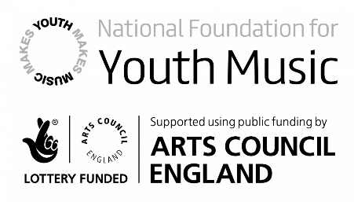
Proposal Form
NYMAZ Early Years Songbook: Songs for Modern Childhoods
Please read the brief attached before completing this proposal form. Once completed, send to heidi@nymaz.org.uk before 10am on Monday 5 December 2016.
Name

E-mail address

Contact telephone

Tell us briefly about your experience as a songwriter/composer. (100 words max)

Which one of the specified themes would your proposed song fall under?
☐ Friendships and playing  ☐ Family and time at home | ☐ Travelling and outings  ☐ Special events

Please tell us about your proposed song, including lyrical content, musical ideas, and how it would reflect contemporary childhoods, enhance wellbeing, and support emotional literacy. (250 words max)

Please provide online links to examples of your previous compositions. These do not have to be Early Years songs.

