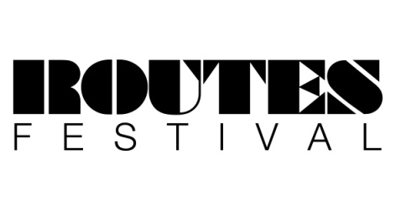
Routes Festival Application Form - 2018

Established in 2013, Routes Music Festival provides a platform for young musicians (aged 12-24 yrs) to showcase their talents on an open and accessible stage.
To apply to perform at Routes Festival 2018, please complete the following application form and return to kane@squarechapel.co.uk Please also send one image of the band / act and an mp3 track (this can either be an original, or cover recording). Don’t worry too much about the quality of your images and MP3’s; these can be as simple as phone pictures, or videos.

Band / Artist Name............................................................................Genre.................................................
(Once you have sent you’re application, you cannot change the band / artist name)

Main Contact Name................................................Main Email Address.........................................................

Band / Artist Facebook and Twitter pages...........................................................................................................................
Band / Artist Information
Name | Instrument Played | Age | Postcode
EXAMPLE Ben Smith | Bass guitar + vocals | 15 | HX1 24G

Any other specific technical requirements –
................................................................................................................................................................................................
................................................................................................................................................................................................

Please sign if you give permission to be photographed for documentation and publicity purposes.

(Parent/guardian if under 18) ……………………………………..….…….……….Date ……………..……..…………..………..

*Disclaimer*
Incomplete application forms will not be considered. Please provide as much information as possible. This year, Routes will take place at the Orange box young people’s centre (Halifax), on Saturday 23rd June 2018; applicants must be available all day on this date.
If successful, you will be contacted in May, with more information about the day.
Application forms must be sent before 1st May. Preference will be given to Calderdale based musicians and bands.
All performers must be aged between 12 – 24 years of age.

Equal opportunities monitoring form

Please state numbers of people in your band (for solo artists complete for yourself)

No’s
Number of females
Number of males
Ethnic Background
White | English/Scottish/Welsh/Northern Irish /UK
 | Irish
 | Gypsy or Irish Traveller
 | Any other White background
Mixed ethnic background | Mixed ethnic background
Asian/Asian UK | Indian
 | Pakistani
 | Bangladeshi
 | Chinese
 | Any other Asian background
Black / African / Caribbean /  Black UK | African
 | Caribbean
 | Any other Black / African / Caribbean background
Other ethnic group | Arab
 | Any other ethnic group

Religion or belief | No’s
No religion
Christian
Buddhist
Hindu
Jewish
Muslim
Sikh
Other religion

Number of people with disabilities

Signed.............................................................................................................Date…………………........................................

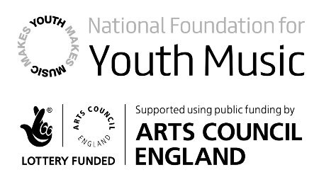
All information is for monitoring purposes only and is strictly confidential

