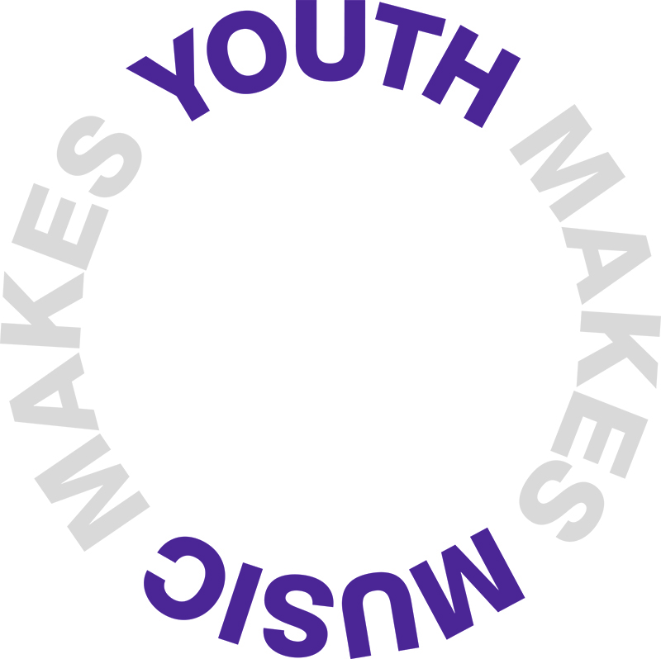

Living Wage uplift criteria – January 2018
Introduction
In 2017 Youth Music became a ‘living wage friendly funder’, to signify our commitment to ending low pay in the charity sector. At £8.75 across the UK and £10.20 in London, the rate is higher than the government national living wage and applies to everyone aged 18 or over. More details are available on the Living Wage Foundation website.
Youth Music is proud to be a living wage employer and to have become the first living wage friendly funder from the cultural sector. The initiative resonates with our core values and means we are part of a wider movement to create change. This Arts Professional article by our Programme Manager Daniel outlines why we signed up to become a living wage friendly funder, and why we think it’s important for arts organisations and charities to pay the living wage.
As part of our commitment, we’re offering Youth Music-funded programmes the opportunity to:
- Uplift their grant so that Youth Music is funding posts paid at the living wage
- Pay for the first year of accreditation to become an accredited living wage employer (please note that Youth Music will not meet the ongoing costs of this accreditation, which starts at £60 per year for organisations with less than 10 staff).
Eligibility
To be eligible to apply, you must be an existing Fund A or Fund B grantholder with at least six months remaining on your funding agreement on 1 April 2018. The uplift will apply from 1 April 2018 to the end of your grant and cannot be applied retrospectively.
To work out the amount of uplift to apply for, you can use our Living Wage calculator.
How to apply
To apply, please complete the details below, and sign and return a scanned copy by email to grantholders@youthmusic.org.uk, CCing your Grants and Learning Officer. Ensure the title of your email includes your grant reference number and ‘Living Wage Uplift Application’.
The deadline for submitting this form is 5pm on Friday 2 March 2018. If you require any support or have any questions, then please contact your Grants and Learning Officer.
Funding agreement and payments
All eligible applicants will receive a funding agreement addendum in mid- March, which must be signed and returned to Youth Music within 20 working days.
The uplift will then be added to your next payment.
Application for living wage grant uplift
Name of organisation:
Grant reference number:
Project end date:
Total uplift amount requested (round to the nearest pound): £
How many staff posts (salary or freelance) does this apply to?:
How are these posts shown in your budget? Please copy and paste all relevant budget lines into the space below, adding new lines as necessary.
Expenditure item | Current cost | Revised cost
Copy and paste from application form budget | Copy and paste from application form budget | Insert new cost
 | £ | £
 | £ | £

Does the uplift amount include the cost of becoming an accredited living wage employer? Yes / No
How many staff does your organisation employ?
Declaration (to be signed by an authorised signatory)
I hereby confirm that I am authorised to complete and sign this form on behalf of the grantee organisation, and, to the best of my belief, all information supplied is a true and accurate representation.
Full name:
Position:
Signed:
Date:

