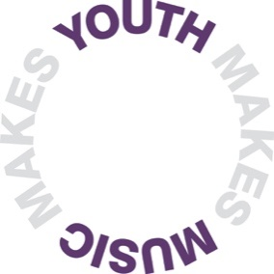
Equal opportunities monitoring form

You do not have to complete this form, but it would really help us if you do. We use the information to try and ensure that our commitment to equality and diversity actually works in practice.

The information you give us here will be used without your name attached, and will not be passed on to anyone. It is used only for statistical monitoring. Thank you!

- Personal details

Position applied for: Click here to enter text.

Please state where you found out about this position:
☐ Youth Music Website or Network
☐ Creative Access
☐ Charity Comms
☐ Social Media
☐ Other

If other, please specify: ………………………………...........
- Gender

Please tick the gender identity that best represents you.

☐ Male ☐ Female
☐ Any other gender (please state) ☐ Prefer not to say

- Ethnicity

Please tick the ethnicity that best represents you. As you make your decision, please think about what ethnic group means to you: that is, how you see yourself. Your ethnicity is a mixture of culture, religion, skin colour, language and the origins of yourself and your family. It is not necessarily the same as nationality.

White

☐English/ Welsh/ Scottish/ Northern Irish/ British
☐Irish
☐Gypsy or Irish Traveller
☐Any other White background, please state: Click here to enter text.

Asian or Asian British

☐Asian Bangladeshi
☐Asian Indian
☐Asian Pakistani
☐Any other Asian background, please state: Click here to enter text.
Black or Black British

☐Black African
☐Black Caribbean
☐Any other Black background, please state: Click here to enter text.

Chinese or other ethnic group

☐Chinese
☐Any other ethnic group, please state: Click here to enter text.
Dual Heritage

☐Dual Asian and White
☐Dual Black African and White
☐Dual Black Caribbean and White
☐Dual Chinese and White
☐Any other background, please state: Click here to enter text.

- Disability
The Disability Discrimination Act 1995, defines a person as disabled if they have a physical or mental impairment, which has a substantial and long term (i.e. has lasted or is expected to last at least 12 months) and has an adverse effect on the person’s ability to carry out normal activities.

Do you consider yourself to have a disability according to this definition?

☐Yes ☐No

The information in this form is for monitoring purposes only. If you believe you need a ‘reasonable adjustment’, please discuss this with the Chief Operating Officer at Youth Music.

5 Sexual orientation

Please tick the sexual orientation category that best represents you.

☐Lesbian ☐Gay
☐Bisexual ☐Heterosexual
☐Prefer not to say

6 Caring responsibilities
Do you have caring responsibilities? (e.g. children living at home, providing care for a relative, partner or friend)
☐Yes ☐No

