Music, Friendship, love

Everyone needs to feel the power of music. Just a single tune could cheer you up from your worst thoughts. Imagine a world without music: mute birds on the trees, concerts without your favourite singer`s voice, football stadiums full of spectators but you can`t hear their cheer. Sounds terrible doesn`t it? So we tried to prove the people how the music could help them to make friends and feel confident.
Creating a song
At first this task seemed hard to us when we looked around the shy faces in the room. But we knew that “’the love of music breaks barriers “

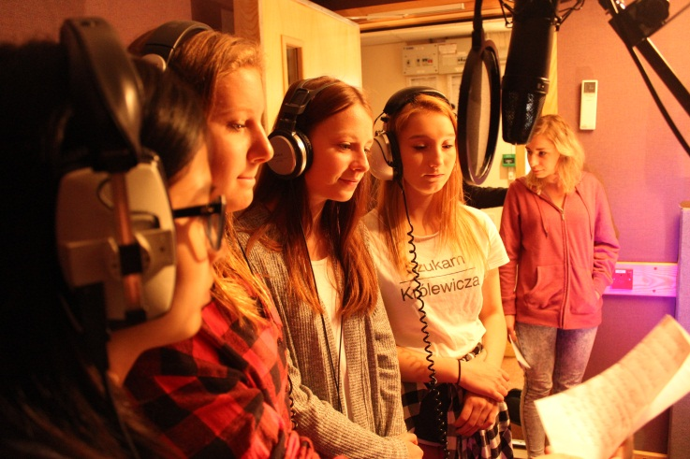
Writing brand new songs and singing them after that wasn`t a big deal for these girls. Their attitude was a good example for how the members could really help each other in a team. The people enjoyed listening every note. The music experts were pretty satisfied with them. It was a great opportunity for every team member to learn about music production.
Gareth, one of the staff members, is a really skilled expert so it was not a miracle that the guys could achieve the best they can. He had a lot of energy to entertain all the people around him. His group games were so funny, everyone was laughing during playing.
Final night celebration.
This activity closed the whole week and we realized that it was time to say goodbye to our new friends. After this eventful week that we spent together, On the one hand we were sad because they had to leave us, but on the other hand the time we spent together was unforgettable. I believe that during this short time everyone did the best and could learn something new.
Finally I would like to thank our organization that we got the opportunity to attend the Project. This is really the best way to gain new skills and I would like to recommend to every young person to try to be a volunteer for a while.

