Grand Union World Music Summer School

Grand Union held it’s 3rd Annual Residential Summer School in Oundle this year. It is unique in that it particularly welcomes players of non-Western instruments who do not have comparable opportunities for ensemble or composition work. The range of activities that took place for the participants crossed a range of World Music traditions and were led by world renown specialists in their areas and including:

Shanti Jayasinha – Trumpet (Sri-Lanka\Scotland)
Yousuf Ali Khan – Tabla/Voice (Bangladesh)
Louise Elliott – Flute/Tenor saxophone (Australia)
Carlos Fuentes – Latin percussion (Chile)
Abass Dodoo – African Drums/Voice (Ghana)

The timetable covered:
- Konokol (Vocal Percussion).
- ‘Big Blow’ – Large mixed ensemble rehearsals and performances using varied World Music influences.
- Indian Rag workshops and performances.
- Latin American percussion music focused on Brazilian Samba.
- African Drumming workshops.
- Improvisation across a range of World Music genres.

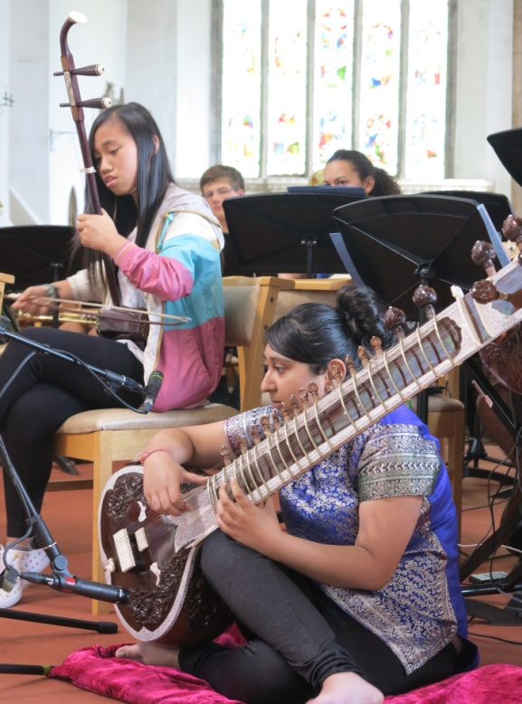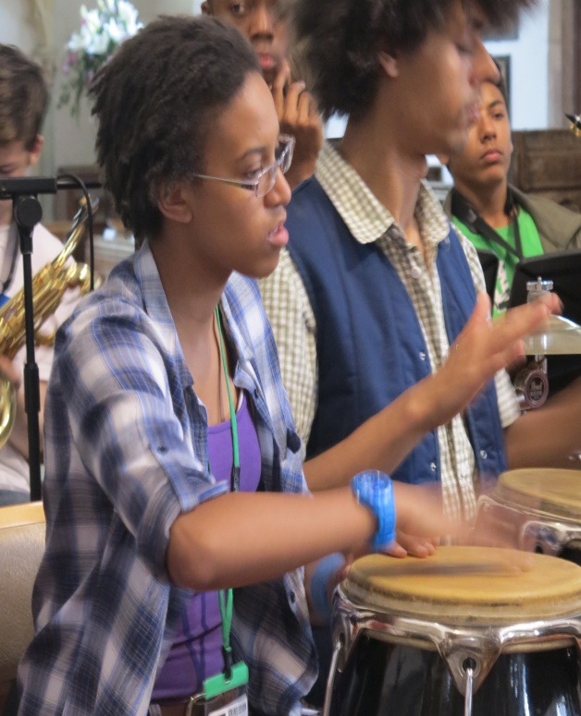

Having Grand Union’s experts together in one place helped facilitate discussion on the progress of participants, increase skills and confidence, and in the sharing of each other’s cultural traditions helped with social cohesion.

Participants told us:

“I enjoyed how we were given the opportunity to compose our own pieces in smaller groups.” (Alice)

“(I hope to) start an Afro-Cuban group in my town. The course is one of my absolute favourite events of the year. The chaperones, teachers and other students are lovely, and it just feels like a big family.” (Kevin)

“The sessions were interesting and I learnt a lot about different music styles, my instrument (chords / triad chord inversions / ways of playing) and talking to tutors between sessions. This will all be useful in the future to me.” (Matt)

“The support given by Youth Music to the Grand Union Orchestra for the Summer School gives young musicians the chance to explore musical content that they may not have been able to access at school or in their community music-making groups in the ways of detail and specialist knowledge offered by the tutors. It gives learners the opportunity to grow their knowledge in World Music in a practical way, and the performances achieved could be used as valuable evidence for young musicians taking Music courses at Key Stage 4 / Key Stage 5 levels back to their respective schools and colleges.”
(Nick Marr, Education & Summer School Tutor)

