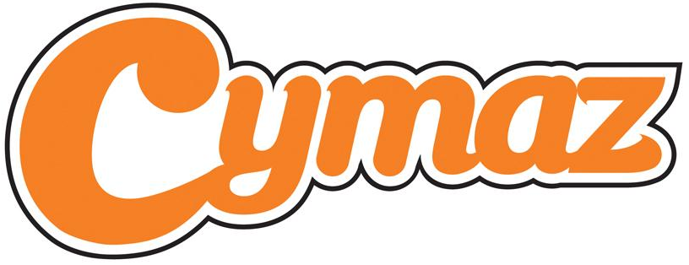

CYMAZ Music Leader application 2013
CYMAZ is seeking to broaden and strengthen a team of freelance music leaders to provide high quality music making opportunities for children and young people in challenging circumstances across Cornwall. CYMAZ is working closely with the Cornwall Music Education Hub and will be delivering a range of music making activities across Cornwall.
Whether you have worked as a CYMAZ music leader in the past, we are refreshing all our quality assurance and recruitment policies and therefore require a completed application form.
Name
Email address
Contact telephone number
Date of birth
Ethnicity
Gender
Do you hold public liability insurance? | YES/NO
Do you have a current CRB/Dbs check? | YES/NO
Have you taken part in child protection/safeguarding training within the last 12 months? (Please list what it was) | YES/NO
NB: To be a CYMAZ Music Leader you will need to be able to answer YES to the above three questions. If you don’t currently have all three, these will need to be satisfied before carrying out any work for CYMAZ. There is guidance on the Musicians Union website regarding CRBs, child protection training and insurance (www.musiciansunion.org.uk)

- Please describe your musical skill/level in all your instruments including voice:

- Please describe your experience of delivering music making activity for children and young people in challenging circumstances:

- Please describe your approach to your reflective practice. What training and development have you undergone in the last 12 months?

- How would you rate your knowledge and understanding about the music offer for children and young people in Cornwall? How confident would you be providing signposting advice?

- Please describe your approach to capturing monitoring and evaluation information from all those involved in music activity

- Please list your availability, your particular interests and any other information

- Do you have your own transport? YES/NO
- Do you have a resource of musical instruments/kit to bring to a session? If yes and electrical, when were they last PAT tested?

- Please provide the name and contact details for a referee who has experienced your delivery as a music leader

Next steps: if selected based on your application, you will be invited to a CYMAZ Music Leader recruitment session. Please let us know now whether there are any particular dates, days you are not available in March.

For information about training, funding, opportunities and contacts, please sign up to the CYMAZ Network by joining the Youth Music Network then requesting membership to the CYMAZ Group. http://network.youthmusic.org.uk/groups/cymaz-network
Closing date: Please submit your application, by email, to Emily@cymaz.co.uk by 5pm on Monday 4th March 2013.



