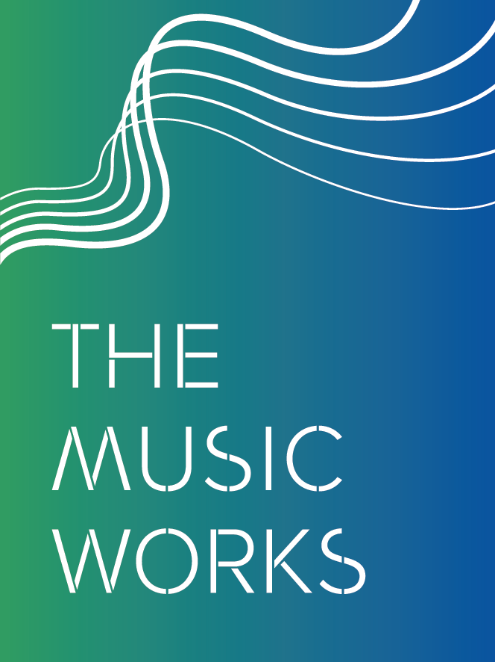

Are you a musician with experience of

studios and working with young people?

We’re looking for a
Creative Music Manager (community)

Part time (24 hours a week)/flexible contract
£25,000 - £28,000 pro rata (plus pension)

Are you an experienced music manager (or do you have the potential to be), and committed to enabling all young people to reach their potential through music? Interested in joining a growing charity at an exciting time in its development?

The Music Works (TMW) is looking for an exceptional Creative Music Manager to work closely with our Creative Director, Malaki Patterson, to help develop and deliver our growing community music programme. The main responsibilities of the role will include:
- Working across our three music studios (Cheltenham, Gloucester and Forest of Dean) to develop and deliver a coherent and exciting music offer for:
  - young people. At the moment this includes The Drop (after-school open sessions), Audio-base (Saturday morning open sessions)
  - local bands and artists (including managing a team of freelance engineers)
- Developing and delivering our community music outreach programme in Gloucester in preparation for the launch of our new Gloucester studio, and as part of the partnership with Gloucester Culture Trust, Strike a Light, the Guildhall and the Camden Roundhouse
- Delivering specialised music mentoring to young people in challenging circumstances e.g. young people excluded from school, young offenders

The Music Works is a Gloucestershire-based registered charity that transforms lives through music. We’re specialists in working with young people in challenging circumstances to help them reach their full potential in music, in learning and in life. We work with around 3,000 young people a year in schools, APSs, Hospital Education, community settings and our three community studios/rehearsal spaces in Cheltenham, Gloucester and the Forest of Dean. We specialise in bands, music technology and production, singing and songwriting, rap and beatboxing.

We’re funded by a range of charities and government bodies including Make Music Gloucestershire and Youth Music.

Read more about how we work and our long term goals here.

Page 1 of 2

What we’re looking for:
- Experience working with young people in a community music setting, as well people with a range of social/personal/educational needs and musical interests/abilities
- Able to lead and deliver a variety of music workshop activities to a high standard - working with young people in groups to engage them in musical activity and inspire them - particularly those facing barriers in music, learning or life
- Experience of working in a music studio including understanding the technical setup
- Active musician working in the industry – performing/recording/industry experience
- Ability to manage staff
- Excellent communication and teamwork skills, and the ability to develop good relationships with young people, parents/carers and colleagues
- Passionate for working with and developing young people/musicians
- Ability and desire to self-organise and work flexibly.
- Drivers license and access to a car.
- A personal commitment to the vision and values of The Music Works
- A commitment to support and innovate the arts sector in Gloucestershire.
Details of the role:

This is a permanent part-time role.

The salary is £25-28k pro rata for 24 hours a week – dependent on experience. We anticipate these hours will be worked flexibly across the week in liaison with Malaki Patterson, the Creative Director.
For enquiries about the role, please contact Malaki Patterson 07532 212462 mpatterson@themusicworks.org,uk

How to apply:

Send your CV and a covering letter (no longer than 2 pages) explaining why you are interested in the role and suitable for this post by 24th August to Malaki Patterson mpatterson@themusicworks.org,uk

Interviews will be scheduled for week beginning 3rd September in Gloucestershire at a venue to be confirmed.

The Music Works is committed to Equal Opportunities.

Page 2 of 2

