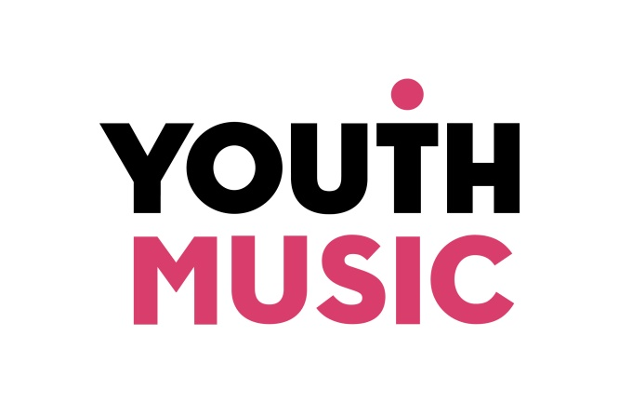
Do, Review, Improve…
Youth Music Quality Framework

What is the quality framework?
A quality framework is a tool to help you understand, measure and evaluate quality in your work. Youth Music’s Quality Framework – Do, Review, Improve – gathers together the criteria necessary to deliver a high-quality music-making session. It’s based on evidence we’ve been gathering from the projects we’ve supported since the charity was founded in 1999. The framework has been designed to promote a common understanding of quality, to provide the language to explain it, and to help individuals and organisations improve their professional practice.
We ask all organisations funded by Youth Music to use Do, Review, Improve to reflect on their practice. We ask anyone applying to us for funding to show how they will build it into their project. However, it’s not just for those holding Youth Music grants: the quality framework can be used by anyone leading a music-making session for children and young people.
You can use Do, Review, Improve for planning, peer observation or self-reflection. It’s not intended to be a test, and you don’t need to score yourself or rank yourself against others. Instead, the Quality Framework is designed to help you think about your practice and the principles behind it, and to identify areas you may wish to develop.

Updated and improved

The Quality Framework was first published in 2014. In the revised 2017 edition, we have sought to create a document that is easier for practitioners to use. Following feedback from grantholders, as well as consultation with academics, project managers and music leaders, we have reduced and simplified the criteria. We have also added a section that outlines the important responsibilities of organisations when managing a music-making project. These include safeguarding, contracting, pastoral support and programme planning.

Using the framework

The framework is intended for session planning, observing the face-to-face interaction between young people and a music leader, and reflecting afterwards. Having said this, sessions don’t usually take place in isolation, and the evidence for some criteria may emerge over a number of sessions. In these instances a wider and ongoing conversation with the music leader may be necessary.
We encourage you to use the Quality Framework in a way that’s appropriate to the capacity and starting point of your organisation or project. Examples of how organisations have used Do, Review, Improve include:
- For planning and termly reflection sessions among the music leader team
- For peer observations between music leaders
- To observe the music leader team to prioritise workforce training needs
- As part of training and induction for music leaders
- To help identify professional development needs in appraisals or supervision
- As a source of evidence for workforce outcomes.

Part 1: Organisational responsibilities criteria

Health and safety of all | Contracting and support for music leaders
H1 Appropriate Health and Safety policies and procedures are in place.  H2 A Safeguarding and Child Protection policy is in place to protect the welfare of young people and staff (including conducting Disclosure and Barring Service checks). | C1 Contracts include time for structured reflection and evaluation activities with key staff or volunteers involved in planning and delivery.  C2 Contracts include clear expectations around music leader planning, including short, medium and long-term planning. Plans should be flexible and adaptable.  C3 Roles and responsibilities of all those involved in the planning and delivery of sessions are clearly outlined.  C4 Organisations support the emotional wellbeing of staff with regular catch-up/supervision sessions  C5 Organisations seek to support music leaders’ training and development needs.
Young people’s pastoral and progression needs | Planning and evaluation
PP1 Appropriate pastoral support is provided for young people.  PP2 When participants are referred by another organisation, information is requested to inform planning and communication (for example about musical ability and experience, pastoral needs, special educational needs and/or disabilities).  PP3 Organisations enable music leaders to develop up-to-date knowledge of progression routes, so that young people can be signposted to relevant opportunities beyond the programme. | PE1 Programmes are planned to ensure that duration of contact time and frequency of engagement are sufficient to achieve the intended outcomes.  PE2 Evaluation activities are devised and scheduled before delivery commences.  PE3 Organisations ensure that evaluation activities are carried out as planned.

Part 2: Session criteria

Young people centred | Music leader practice
Y1 Music-making reflects the young people’s interests, with recognition of their existing musical identities.  Y2 Young people experience equality of engagement and no participant is discriminated against. Their views are integral to the session.  Y3 The young people’s musical, personal and social development are monitored, and achievements are celebrated and valued. Young people are supported by music leaders to set their own goals and targets.  Y4 Young people receive clear feedback on their work, identifying next steps for individual improvement. Young people are encouraged to participate in this process through structured peer and self-reflection. Comparison to others is only made where appropriate.  Y5 The music leader and/or project staff identify the need for any additional pastoral or other support, and seek to provide or signpost to this. | M1 The music leader has relevant musical competence, and is both an able practitioner and positive role model.  M2 The music leader has a clear intention and has planned the session accordingly, while retaining room for flexibility.  M3 The music leader plans sessions that enable young people to make progress and nurtures their understanding of what it means to be a musician.  M4 The music leader regularly checks young people’s understanding. They reflect on their own practice: activities are reviewed and adapted over the course of the session according to how the young people respond.  M5 All project staff are actively engaged with activities. Music leaders and other project staff communicate before, during and/or after the session and collaborate in planning activities. Roles and responsibilities are clear to all involved.
Session content | Environment
S1 Activities are engaging, inspiring and purposeful. They are clearly explained and/or demonstrated to the young people.  S2 Ownership of session content is shared between the music leader and young people. Participants contribute to decision-making and have the opportunity to take on leadership roles where appropriate.  S3 Young people are supported to create and make their own music, and broaden their musical horizons over time.  S4 Activities are designed and delivered in a manner that is accessible to all and tailored to each individual whenever possible, taking account of their starting points and aspirations. Group dynamics and pace of learning have been considered. | E1 There is a suitable ratio of young people to music leaders (and other project staff where required).  E2 Consideration has been given to the physical space, with available resources being best used to make it accessible and appropriate for the target group.  E3 There are sufficient materials and equipment to support the activities.

Glossary
Music leader – the person leading the music-making activities.
Project staff – this refers to other adults who are involved in leading or supporting the project and could include: project managers, youth workers, pastoral support staff, supporting music leaders, trainee music leaders and volunteers.

Young people – the participants in the activities, aged between 0-25.
Progression – this refers to the broadest interpretation of the social, personal and musical development of the young person.
Activities – this refers to the task or process the young people will be undertaking in the session (what they will do).
Learning outcome(s) - the skills, knowledge or understanding that will be gained or enhanced from the session. Activities should be planned to enable the young people to achieve the learning outcomes.

