Network and Training Centre
Soundabout’s new partnership to support music services, hubs and music practitioners across the SEND sector in the London boroughs of Barnet, Brent, Camden, Ealing, Enfield, Haringey, Harrow, Hillingdon and beyond.
FREE CPD opportunity!!!
CREATIVE WAYS TO ENGAGE PUPILS AND USE OF RESONANCE BOARDS
With Sue Simmonds from SOUNDABOUT
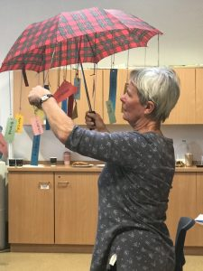
Thursday 25th April 2019
10 am-4pm at:
Mapledown School
Claremont Rd, London NW2 1TR
(nearest tube station: Brent Cross; parking available on or near site)

https://www.mapledownschool.co.uk/
Tea/Coffee provided
Bring your own lunch

RSVP by Feb 15th to jennycooper@soundabout.org.uk
Registered Charity No.1103002 https://www.soundabout.org.uk/

Sue Simmonds

Sue is a founder member of Soundabout. For the past twenty years, she has been instrumental in developing and sustaining Soundabout’s mission to use sound and music to provide enabling opportunities for self-expression for all people with physical disabilities and sensory and complex needs across the age span. Her particular interest is in providing for those with profound and multiple learning disabilities (PMLD) and with Autism (ASD).

Sue’s main and sustained focus has been instilling confidence in those who support people with learning disabilities to believe that they can use musical ideas to provide meaningful opportunities for self-expression, active participation and building relationships.

She has just completed a PG Cert in Sounds of Intent and taken part in researching musical development in young children in children’s centres across the country.

