in partnership with
Network and Training Centre
Soundabout’s new partnership to support music services, hubs and music practitioners across the SEND sector in the London boroughs of Barnet, Brent, Camden, Ealing, Enfield, Haringey, Harrow, Hillingdon and beyond.
2 in 1 FREE CPD opportunities!!! (You may sign up for both or one only!)
1.30-4pm  USING SOUNDS OF INTENT FOR CURRICULUM DEVELOPMENT | With Jenny Cooper from Soundabout
4-6pm  ARTS AWARDS FOR CHILDREN WITH SEND  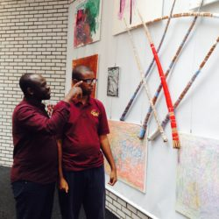 | With Emma Deba-Smith from A New Direction
Thursday 16th May 2019 at:
The Village School,Grove Park,London,NW9 0JY
(nearest tube stations: Kingsbury/ Colindale; there is no parking on site)

Tea/Coffee and light refreshments provided

RSVP by Feb 15th to jennycooper@soundabout.org.uk
Registered Charity No.1103002 https://www.soundabout.org.uk/

