Network and Training Centre
Soundabout’s new partnership to support music services, hubs and music practitioners across the SEND sector in the London boroughs of Barnet, Brent, Camden, Ealing, Enfield, Haringey, Harrow, Hillingdon and beyond.
FREE CPD opportunity!!!
SOUNDS MODERN!
With Pete Ord from SOUNDABOUT showing you
how to engage your SEND pupils in music using 21st century resources
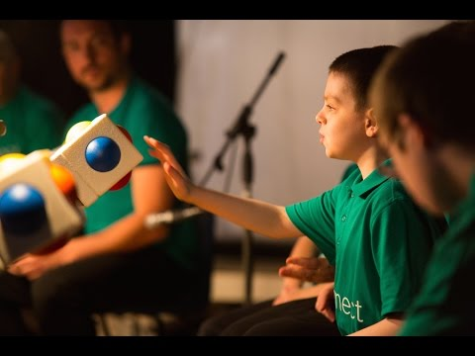

Thursday 20th June 2019
10 am-4pm at:
Kingsley High School
Whittlesea Rd, Harrow HA3 6ND
http://www.kingsley.harrow.sch.uk/welcome/
(nearest station: Headstone Lane overground; parking on or close to site)

Tea/Coffee provided
Bring your own lunch

RSVP by Feb 15th to jennycooper@soundabout.org.uk
Registered Charity No.1103002 https://www.soundabout.org.uk/

