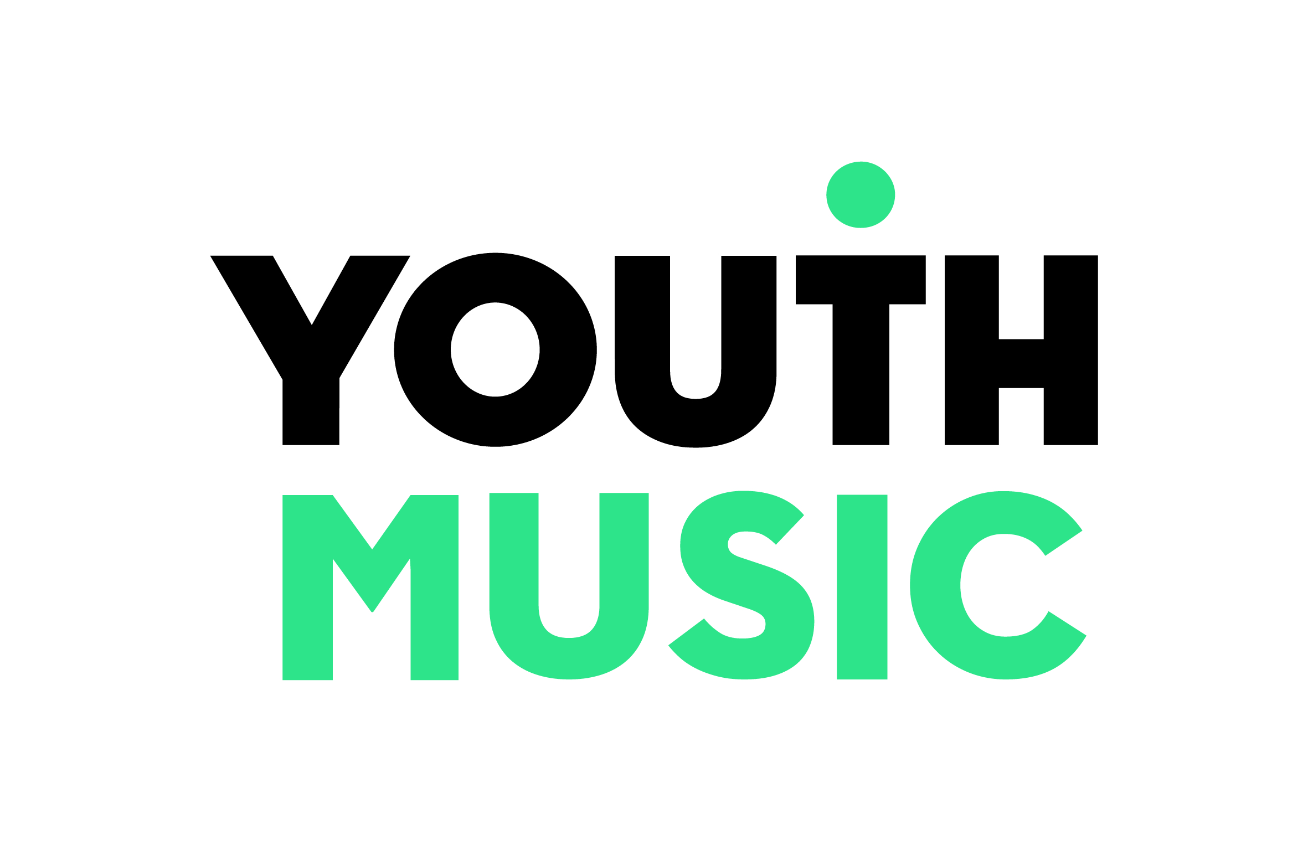

Exchanging Notes: research summary report

Youth Music, based on research by Birmingham City University
May 2019

A note from Matt Griffiths, CEO of Youth Music
Exchanging Notes was always about testing a hypothesis. Throughout Youth Music’s 20 years of operation we’ve seen how the music-making projects we fund – which mostly take place outside of the school environment – engage young people through creative projects which are centred around their existing passion for music and their individual needs. These projects lead to a wide range of positive personal and social outcomes for young musicians, alongside transferable skills.

It seems like stating the obvious to say that young people love music. It’s such an integral part of growing up. For our Sound of the Next Generation research, published earlier this year, we found that nearly all of the young people surveyed had listened to music in the past week and two-thirds had engaged in some form of music-making activity. School is the one place where everyone should be able to access music, but this widespread access is constricting as school music departments disappear by the day. Where they still exist, they are often isolated or under-resourced. The government is currently developing a model music curriculum that promises a ‘sequenced and structured template curriculum’ (DfE, 2019). But there’s little point in having a model curriculum if there are no teachers around to teach it!

Young people on our projects often contrast their Youth Music experience to the music they do in school. Primarily because in school they are given less autonomy over their own learning, and the curriculum doesn’t deliver the type of music they want to make. It’s disconnected from their musical lives. Exchanging Notes was our attempt to address this: bringing community music organisations together with school music departments, so that each could learn from the other.

We wanted to know what wider benefits would occur if young people – particularly those most at risk of exclusion or low attainment – had access to sustained and engaging music in school. It was never designed as an out-and-out intervention study, but we did aim to track a core group of learners across the lifetime of the project. Projects worked to support educational and wider developmental outcomes for young people, alongside their creative, expressive and musical abilities. Use of Youth Music’s quality framework was very important to ensure that the learning was centred on the young musicians’ needs, and promoted personal and social outcomes as well as musical ones.

Through the research we learned that young musicians developed new patterns of social interaction through establishing trusting relationships with other young people and adults. This social development acted as a springboard for a range of other learning outcomes and instilled in young people a greater sense of resilience to navigate life’s challenges. At the end of the programme they had clear ambitions for the future, with music usually playing a central role. Both the young musicians and the staff teams developed different identities, and re-authored new versions of themselves.

Several school staff members in Exchanging Notes talked about the preoccupation in schools with attainment and targets. This meant that they felt less able to prioritise a participatory and creative music curriculum that centred around individual need. In the research it was essential that we looked beyond the standard data to get a comprehensive picture of what took place. And boy, are we pleased we did. It was the interviews with young musicians, music leaders, music teachers and headteachers that gave us the real story of Exchanging Notes: if all we’d collected was attainment and attendance data then much of the positive impact would have been obscured.

This wasn’t always an easy project. The work was taking place alongside the introduction of the EBacc, placing greater focus on attainment in core subjects and, as a result, devaluing the importance of music in the curriculum. The staff and partnerships all had to be resilient too, in the face of many challenges.

We want to thank everyone who took part in Exchanging Notes, including teachers, music leaders, school staff, project managers, support workers from partner agencies, and of course the young musicians. Our research partners at Birmingham City University brought a positive element of critical thinking to the whole process, encouraging us to reflect deeply on the emerging findings throughout. And special thanks must go to the National Lottery, who supported the programme through public funding via Arts Council England.

Our key takeaways from this work:
- The government needs to send a clear, unambiguous message about the importance of music in the school curriculum and take urgent measures to reverse the decline in school music infrastructure that we're currently witnessing.
- But it's time for a new, ethical model of music in schools – one that centres on the social and emotional wellbeing of young people.
- External partnerships with music education charities and music industry organisations are essential to this new model – co-designing and co-delivering an innovative curriculum which is more relevant to young people’s existing lives in music.
- This will be a win-win for all partners and particularly young people. Schools can offer an inspirational music curriculum that better supports young people’s wellbeing; the music industry talent pipeline will grow and become more diverse; and young people’s lives in music will be completely connected both in and out of school.

The future is in partnership. We all need to think about what role we can play and, like the Exchanging Notes partners, collaborate in a way that is open, honest and builds trust.
Music education, let’s face it, has sometimes operated in factions – but now more than ever, we all need to pull together.

Exchanging Notes has cemented our view that music in schools has the power to help young people with some of the big issues facing them today – mental health, isolation, and social inequality. But only if it is reimagined to become more relevant and inclusive of all young people.

Contents
1
Exchanging Notes: research summary report 1
A note from Matt Griffiths, CEO of Youth Music 2
Introduction 6
About Exchanging Notes 7
A note on terminology 8
The Exchanging Notes projects 9
Kinetika Bloco 10
The Barbican Centre Trust 10
SoCo Music Project 10
Drake Music 10
Brighter Sound 10
Accent Warrington & Halton Music Education Hub 11
Derbyshire Music Education Hub 11
Exchanging Notes in visuals 12
In their own words 13
Section 1: the background context 14
Music in schools 14
Music education outside of school 14
Music education ‘pedagogy’ 15
Young people at risk of exclusion, disengagement or low attainment 15
Section 2: outcomes 16
Impact for the young musicians 16
Educational engagement 16
Wellbeing 18
Resilience 20
Developing a positive future through music 20
Improvement in quality of music education 23
Teachers and music leaders developed new pedagogical practices 23
New ethical curriculums were developed, which became more young musician-centred 24
Teachers and music leaders developed new identities, and became more open to learning 25
Impact in the music classroom 26
Broadened perceptions of success, progress and progression 27
Section 3: key learning – what made the projects work? 28
Close multi-agency working 28
The long-term nature of the programme 28
Use of the Youth Music quality framework 30
A culture of honest reflection leading to development 30
Inclusive, collaborative partnership working 30
A curriculum that promotes participation, agency and creativity 31
Making the project visible in school 32
School buy-in (particularly from senior leadership teams) 32
Having a dedicated ‘interlocutor’ 33
Summary 35
Section 4: Recommendations 36
Resources 37
Quality framework criteria 38
Quality framework observation template 39
A model of partnership working 41
Appendix 1: Methodology 42
Ethics statement from Birmingham City University 42
Appendix 2: Bibliography 43

Introduction
- Youth Music is a national charity investing in music-making projects that help children and young people develop personally and socially as well as musically. We work particularly with those who don’t get to make music because of who they are, where they live, or what they’re going through. Young people take the lead in choosing what and how they want to learn, making music of every style and genre.
- Youth Music usually funds projects which take place out of school. Over the past 20 years, we’ve become experts at what works in these projects: putting young people at the centre and recognising their needs and interests, helping them to set their own goals and progress on their own paths, and supporting them to develop personally and socially as well as musically.
- We want all children and young people to be able to access inclusive, creative music-making. In order to achieve this, we need to share what we’ve learned about inclusive practice in music education. We want to influence and support others to come on board with our vision of creating ‘a musically inclusive England’: policymakers, funders, Music Education Hubs, arts organisations and schools.
- The vast majority of young people go to school, so having opportunities to access music education there is essential if we are to meet the ambitions of the government’s National Plan for Music Education. But it’s a tough time for music in schools, with budget cuts, staff cuts, a devalued music curriculum and decreasing numbers of young people studying the subject. Music teachers work long hours, often in isolation while juggling many competing demands.
- Young people’s passion for music is clear: in recent research we found that 97% of young people had listened to music in the last week and 67% of young people had engaged in some form of music-making activity. They’re engaging in music regularly, but this isn’t always in school. Twenty-five per cent of young musicians said that they are teaching themselves and 23% had been taught by a friend or family member.

- We found that young people’s creative identities outside of school often go unrecognised in music education, something we’ve heard time and time again from young people on our programmes. This view was echoed in an Exchanging Notes interview:

“It’s interesting because a lot of schools still classically deliver in music education in a way that doesn’t really engage a large section of young musicians that are interested in music, so there’s, you know, most young musicians are very interested in music but don’t see the connection between their interest in music and their music lessons.” (Music leader)

- Exchanging Notes was set up to address this very point. It was an ambitious - and at times, challenging - project attempting to make real, practical change within the school environment. This report looks back on its impact and what we’ve learned along the way.

About Exchanging Notes

- Exchanging Notes was a four-year Youth Music programme (running between 2014 and 2018), using public funding from the National Lottery via Arts Council England.

- We invested in 10 new partnerships between music organisations and schools. By the end of the programme, seven partnerships remained. In total, Exchanging Notes worked with 974 young musicians, 163 of whom were part of the core group.

- The programme had two linked aims:
  - To support young people at risk of disengagement, low attainment or exclusion from school to achieve the best musical, educational and wider outcomes through participation in the music-making projects.
  - To develop new models of partnership working between schools and out-of-school music providers.
- The intended outcomes were:
  - To improve the quality and standards of music delivery for children and young musicians.
  - To embed learning and effective practice in host and partner organisations and share practice beyond the project.
  - To improve young musicians’ educational and wider developmental outcomes.
  - To develop the creative, expressive and musical ability of young musicians.

- The Exchanging Notes programme was targeted at young people at risk of educational exclusion, disengagement, or low attainment. The young people experienced a number of separate (although in some cases interrelated) aspects that placed them ‘at risk’. These included:
  - Profound and Multiple Learning Difficulties (PMLD) and having Education, Health and Care Plans (EHC)
  - Looked after young musicians
  - Young musicians learning in inclusion units
  - Young musicians from areas of significant economic deprivation
  - Young musicians with challenging home circumstances.

- We appointed a team from Birmingham City University to research the effectiveness and impact of Exchanging Notes. The research involved a mixed-method approach, which included observations of music sessions alongside online perception surveys and face-to-face interviews undertaken with young people, music teachers and music leaders. Schools also provided statistical data on young people’s attendance, and teacher assessment of their literacy and numeracy attainment.

- This was an action research project, which meant that the researchers were involved throughout: feeding back findings and encouraging projects to think about new ways forward, so that the research made a difference to the programme as it unfolded over the four years.
- The full report can be found here: https://network.youthmusic.org.uk/exchanging-notes

A note on terminology
- ‘Throughout this report, ‘teachers’ refers to music teachers in schools; and ‘music Leaders’ refers to the musicians from the music organisations.

The Exchanging Notes projects
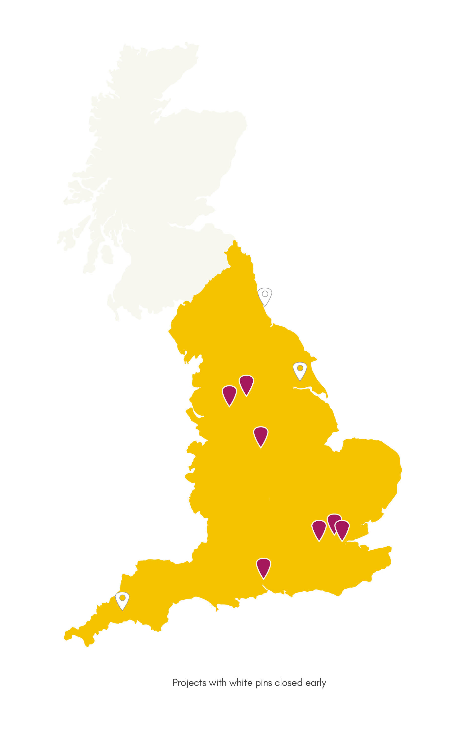
Map of projects
Projects with white pins closed early

Kinetika Bloco
Kinetika Bloco – a performance group with a unique British Carnival sound – led a musical development programme for students at Saint Gabriel’s College in Lambeth, South London. Ensemble sessions were delivered in partnership with the school’s music department, and participants received tuition on percussion, steel pan, woodwind and brass instruments. The students were supported to take an active role in selecting and arranging repertoire and regularly took part in performances at high-profile events and venues such as the Southbank Centre. There were also leadership opportunities delivering music-making sessions to students from local primary schools, and working as young leaders on Kinetika Bloco’s Junior Summer School. Funded in partnership with the Walcot Foundation.

The Barbican Centre Trust
Drum Works (an independent Community Interest Company that was incubated at The Barbican) delivered a programme of fast-paced, high-energy drumming sessions with students from The Warren School in East London. Weekly sessions were led by professional musicians who used culturally-relevant music as the starting point for creating original beats. Regular performance opportunities allowed participants to showcase their work. Students were encouraged to access progression routes through senior ensembles, and take on leadership roles within sessions and through supporting other Drum Works sessions in local primary schools.

SoCo Music Project
SoCo Music Project ‘exchanged notes’ with two settings in Southampton. The team worked closely with subject specialists and support workers to develop nurturing and creative environments, new resources and teaching models to support young people’s musical development. At Rosewood Free School, where students have profound and multiple learning difficulties, many sessions were one-to-one, tailored around individual needs. At the inclusion unit at Woodlands Community College, young people at risk of exclusion worked towards individual learning plans, with activities including music technology, instrument tuition, composition and songwriting.

Drake Music
Drake Music delivered an inclusive music curriculum to students at Belvue School in Ealing. The school’s vision is to be a centre of excellence for children with special educational needs. Sessions supported students - individually and in groups - to use a range of music technology and conventional instruments to create, compose and perform music. The programme was co-delivered with teachers from Belvue School, and aimed to leave a sustainable legacy in the school, trial a new model of peripatetic teaching, and upskill staff at Ealing’s Music Education Hub.

Brighter Sound
Brighter Sound, a creative music charity based in Manchester, delivered Exchanging Notes at two schools in the North West: Manchester Creative and Media Academy and Bolton St Catherine’s Academy. Activities later ran across full days in inspiring off-site professional venues, in response to young people’s feedback. Activities included creating and rehearsing music in venues like Band on the Wall, studio recording, masterclasses with inspirational musicians, performing to peers in school, and creating radio programmes and a school radio station.

Accent Warrington & Halton Music Education Hub
Working with musicians from Score Creative, Warrington’s Exchanging Notes project took place at University Academy (in music lessons and lunchtime) and Orford Youth Base. In-school sessions included ensemble development, music production, songwriting, DJ skills, music business, performance and event planning. Out-of-school sessions at Orford Youth Base involved songwriting, recording and the development of instrumental and vocal skills, providing opportunities for University Academy pupils to engage in musical activities with members of their friendship group who don’t go to their school. Regular performances took place both at school and the prestigious Warrington Parr Hall.

Derbyshire Music Education Hub
Working with partners at Derbyshire’s Virtual School and music and arts development organisation Baby People, looked-after children in Derbyshire participated in an individualised musical development package. Activities included one-to-one music mentoring alongside group activities such as performing at festivals, making film soundtracks, collaborative composition, creating audio podcasts and flashmob musical performances! The final year of activity saw participants delivering music workshops and mentoring other young people at Baby People’s studios.

Exchanging Notes in visuals

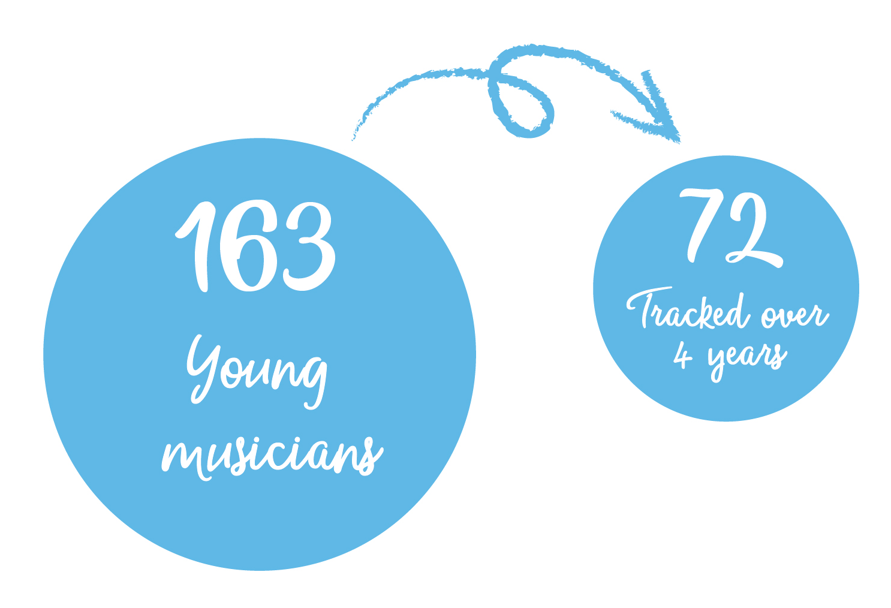

In their own words

“… I was new into foster care and I remember being told about Exchanging Notes at the start, and I was like ‘no, no that's not my thing’ and it took me a couple of months actually to be like, ‘actually I think I'll try it’. Then honestly it was probably the best decision I've ever made, because being part of Exchanging Notes has made me a lot more confident, it's like offered me a lot of opportunities to like go on stage and sing, go to awards and sing, do projects, perform to my family, record my own songs, do covers of songs, be parts of like projects, and if I didn't do this, then I would never think of like doing stuff like that, I wouldn't know who to contact, I wouldn't. I don't think I'd even think about it. I wouldn't just sit up and be like 'I’m gonna go and record today!' But I did and I think it's really helped me as well, because music’s became a really, really big part of my life. It helps me relieve stress, so if I'm, like, ever stressing I know that I can like ring up [music organisation] and ask them if they have got any time, or any projects coming up, where I can, like, come and record, and there's always a space where you can like come and record and just sing.” (Young musician)
“I think we would hopefully agree that approaches to music have categorically changed over the last four years.” (Hub leader)
“The cultural capital is massive. I don’t think people necessarily always understand how much subjects like music bring to the cultural shift in a school. That’s really important.” (Headteacher)
“As a team, we have exchanged ideas. We take that back into the classroom environment. When you see something working you want to replicate that and want to give it a go. If I read something that said try this musically, [the music leader] would say to me ‘do you want to try this?’ I wouldn’t have tried because I would be thinking how do I do that? How do I interpret that? But [the music leader has] modelled a lot to me and that’s been really good.” (Teacher)
“I hope that what we have done here is a resounding commentary about the fact that this is about music, this is definitely about music and it’s definitely about music as an important part of education.” (Music leader)

Section 1: the background context

Music in schools
Music is a compulsory subject at Key Stages 3 and 4 of the national curriculum (usually taught between the ages of 11-16). But there is no obligation for academies to follow the national curriculum, and in 2014 almost 70% of secondary schools were academies (West & Wolfe, 2018). There is therefore no legal obligation on the majority of secondary schools in England to teach music.

The English Baccalaureate (EBacc) is a performance indicator that measures schools on the number of pupils who take and achieve GCSEs in five core subjects. Music is not one of the five EBacc subjects, which means that GCSE Music does not count towards a school’s official measure of success. The EBacc has been criticised for causing a decline in school music education, as schools drop music or decrease provision in favour of the five core EBacc subjects.

The growth in the number of academies, combined with the introduction of the EBacc, has reduced opportunities for children and young people to access music in school.

The way that music is taught is often affected by the ‘performativity agenda’ of schools, where there is a focus on grades, assessment and progress. This can mean a shift in the way music activities are being offered, where the focus moves away from being fun, engaging and young person-centred, to being more about evidencing progress and attaining good grades. It also means that Key Stage 3 music activities are often designed to prepare young people to take GCSE Music, when in reality only very small numbers choose to study the subject at GCSE level.

Music education outside of school
The National Plan for Music Education is the key policy driver of music education in England, establishing 123 Music Education Hubs across the country in 2012. These hubs were tasked with joining up provision at a local level because “No single organisation can hope to provide the full range of tuition and experiences that constitute a sound music education.”.
Music Education Hub lead organisations receive annual funding (c.£75 million in total) to oversee a range of activities linked to instrumental tuition, ensemble opportunities and progression. They work in and out of schools.

In addition, Youth Music distributes around £9 million of funding annually – the majority using public funding from the National Lottery via Arts Council England - mainly to charities and youth-focused organisations. This work usually takes place outside of school, in community venues across England.

There is less regulation attached to music education outside of school, as organisations are not subject to Ofsted inspections or judged on assessment grades.

Music education ‘pedagogy’
Pedagogy refers to the way that music is taught. Often a distinction is made between ‘formal’ music education (which is funded by the state or taking place in school) versus ‘non-formal’ (community-based music). Part of the rationale behind establishing Exchanging Notes was to see what happened when formal and non-formal approaches were combined.

Young people at risk of exclusion, disengagement or low attainment
EBacc measures could be said to have particularly negative implications for the young people Exchanging Notes was designed to help. There are concerns that it has increased anxiety and stress among young people, and that schools which are oversubscribed pick the best pupils and select out those who may not achieve lower grades (Leckie & Goldstein, 2017). An Education Select Committee report in July 2018 voiced “concerns about the over-exclusion of pupils” and “an alarming increase in ‘hidden’ exclusions’ because ‘schools are struggling to support pupils … which is then putting pressure on alternative providers”. This in turn can impact on access to and quality of a young person’s music education, as noted by one Exchanging Notes participant:
“Because we are in the inclusion unit we don’t get to do music that much.” (Young musician)

Section 2: outcomes

Impact for the young musicians

Educational engagement
Most young musicians involved in Exchanging Notes maintained high levels of attendance (>95%), with the median attendance being consistently higher than the national average for the secondary school population.
One data set collected by the research team was whether young musicians were assessed (by their teachers) as working ‘below’, ‘at’ or ‘above’ their target grades in literacy or numeracy. This was tracked for 71 young musicians over the course of the programme. The data shows that at the end of the project, around two-thirds of the young musicians had maintained or improved their attainment in English and Maths.

Combined literacy and numeracy attainment outcomes at the beginning and end of Exchanging Notes
It is not possible to attribute direct causality between participation in Exchanging Notes and improved literacy or numeracy attainment. However, what we can say with certainty is that it helped to open the door for learning. Music was used as a hook to engage or re-engage young people in education:
“They had been at risk of all forms of exclusion. Nor had they been in education for about seven or eight years. They were just not engaged. What we did have at the very start of the project was a very healthy interest in grime music. That was all they would listen to. So that was our starting point.” (Music leader)
“I know it will happen every Wednesday, it gives me a reason to get up. I’d be like ‘I’ve got in today I’ve got Exchanging Notes’. It’s something to look forward to and it’s something I love to do. Say if I’ve had a bad Monday and Tuesday, on Wednesday I’ll say I’ll come in because I have Exchanging Notes.” (Young musician)
“Through the music engagement they are now almost on the full timetable and in other forms of education.” (Teacher).
Often the motivation to create a high-quality musical output improved behaviour and focus:
“At the start… if someone that you don't get along with was talking you might have done something kind of stupid to distract them. Then because we're all in a group we learnt you had to listen to each other and work together to actually produce something. So we learnt that we just, you know, we had to get along to make music.” (Young musician)
“[The young musician] is always out of lessons, and then [the teachers are] gob-smacked they are here. One participant in particular, sitting and writing, which is unusual for them, staying in one place on one chair in one room, not causing problems, writing and absolutely focused on the rap that they were doing, for a whole afternoon.” (Music leader)
At the end of the programme, many school staff had a different view of ‘success’ for young musicians. At the beginning, they might have had a lower perception of young people’s abilities, which changed over time as they witnessed the outcomes of the project:
“… it’s been a reminder that it is possible to get through to even those most challenging kids and also to challenge their musical skills and their learning skills, that they can do even more complex things than you might sometimes assume that they can do.” (Teacher)

Wellbeing
Wellbeing is a complex concept – there are lots of different theories about its definition. Commonly these theories are classified into two different approaches. ‘Hedonic’ approaches focus on happiness, defining wellbeing in terms of pleasure attainment and pain avoidance. The other approach is ‘eudaimonic’, which focuses on meaning and self-realisation, defining wellbeing in terms of the degree to which someone is fully functioning (Ryan and Deci, 2001). The word cloud below summarises some of the words associated some popular wellbeing and related theories (Diener et al (1984); Ryff (1989); Ryan & Deci (2000); Seligman (2011))
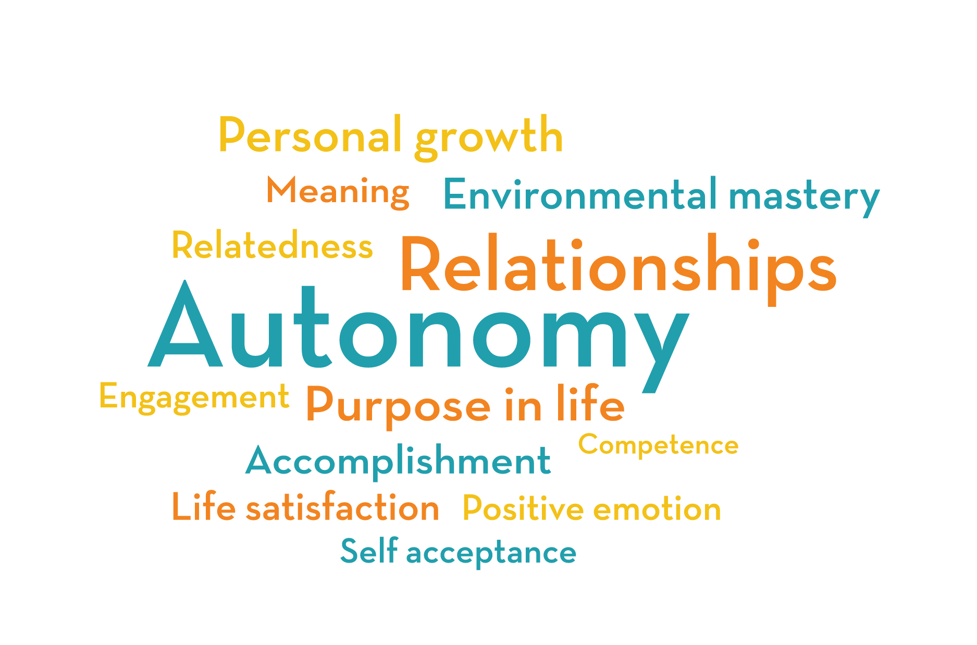

Exchanging Notes promoted wellbeing in a number of ways. The social outcomes were particularly marked – making friends and working with others. Over the course of time, young musicians learned how to get along with others and saw more value in teamwork:
“I’ve made good friends with the rest of the group.” (Young musician)
“At the beginning of the year I always wanted to go on my own but now I have overcome that and I've been able to work with others. And working with others has helped me with things that I can't do.” (Young musician)
Strong, collaborative relationships were developed between the teacher, music leader and young musicians, which provided an environment conducive to learning. The relationship forged between the music leaders and the young musicians was central to the social outcomes. This was less hierarchical than a traditional teacher-student relationship. Music leaders had a strong focus on engagement, participation and enjoyment – enabling them to build strong social connections with the young musicians which helped instil both a mutual respect and sense of self-belief:
“Yeah you get a bit more independence. I like the fact that they don't speak to you like other teachers speak to you. They speak to us as if they are one of us. They are just like us and we are all having a good time.” (Young musician)
“No matter what you do they don't start shouting at you if you do something wrong, they are always accepting us. They are there to help…to inspire to do more and achieve more.” (Young musician)
“Yeah I think, I wouldn't say I cared about school, like I was like just getting on with it, and [music leader] made me like want to be here, like I stood for something.” (Young musician)
The way that the music leaders and teachers worked with young musicians was collaborative – they listened to and acted on young people’s ideas, developed safe spaces for peer-to-peer interaction, encouraged agency and autonomy. This ethnical approach resulted in inclusive learning environments:
“When we were writing a song, we were all talking about it, everyone was saying ideas, and then we made sure that everyone was included.” (Young musician)
The process of being creative helped develop a sense of mastery and competence, as shown in this interview:
Researcher: “What does being creative mean to you?”
Young musician: “I think it’s like creating stuff from scratch and building up the process and trying to make it better. Not always getting it right but just trying something out and seeing.”
Researcher: “Do you think you’re doing that with the music you’re creating?”
Young musician: “Yeah. We’re progressing every time we’re going along. You just get to try things out and see, and then either go with that or not. It’s fun and sometimes not so serious too, like, you get time to just play.”
The strong social bonds created through Exchanging Notes, combined with the collaborative learning environment, helped to support young people’s emotional wellbeing. Alongside Exchanging Notes, young people discussed how engaging in music helped them to release anger and to better manage their feelings:
“It’s a relief. Especially in these last two years definitely, its relieved stress and that could be the past, work stuff with school, all of that in your life. So there will be times when you feel like… I don't know how to explain it…closed in. Then coming to these sessions, it’s like a way out.” (Young musician)
“I don't really play that many instruments but I love to sing and when I sing it really calms me down and I am certainly aware of what's in my environment because it just settles me.” (Young musician)
“Music really teaches you how to play and you can enjoy it and no one can really tell you whether it's right or wrong…I find that music calms me down if you are angry as well. It is enjoyable.” (Young musician)

Resilience
The term resilience is generally associated with the ability to ‘bounce back’ from difficult or traumatic events. According to the Young Foundation (2012):
… resilience has come to be associated predominantly with ‘defensive’ qualities that enable people or systems to cope, survive and get by in the face of adversity. Following this theme, we often hear about ‘protective’ factors that can help ensure survival or mitigate the damage of an adverse event.
The American Psychological Association states:
Many studies show that the primary factor in resilience is having caring and supportive relationships within and outside the family. Relationships that create love and trust, provide role models and offer encouragement and reassurance help bolster a person's resilience.
They list several additional factors associated with resilience, including:
- The capacity to make realistic plans and carry them out
- A positive self-view and confidence in your abilities
- Skills in communicating and problem-solving
- The capacity to manage strong feelings and impulses.
There is evidence that all of these factors were developed across the course of the programme. Wellbeing and resilience are closely linked. Traditional wellbeing measures capture a psychological state at a point in time. Resilience, on the other hand, is more dynamic – it is possible for a person to build resilience making them more likely to cope with problems that may arise in the future, thereby ‘future-proofing’ their wellbeing.
“…we had to like really get our creative brains on and like think in depth on what we would think this piece is going to sound like, and I think another difficult part was lots of ideas were coming out but we could only put, like, certain things into it otherwise it'd just sound like this whole mess of like a speech or something! I thought it was quite good, there are good things about making the music with struggles.” (Young musician)
“We are now patient with ourselves and we have confidence in ourselves as well because before we would have just wanted to give up.” (Young musician)

Developing a positive future through music
By the end of the programme the young musicians had developed new music-related identities. They had started to see themselves as musicians, and had a strong sense of direction for their future.
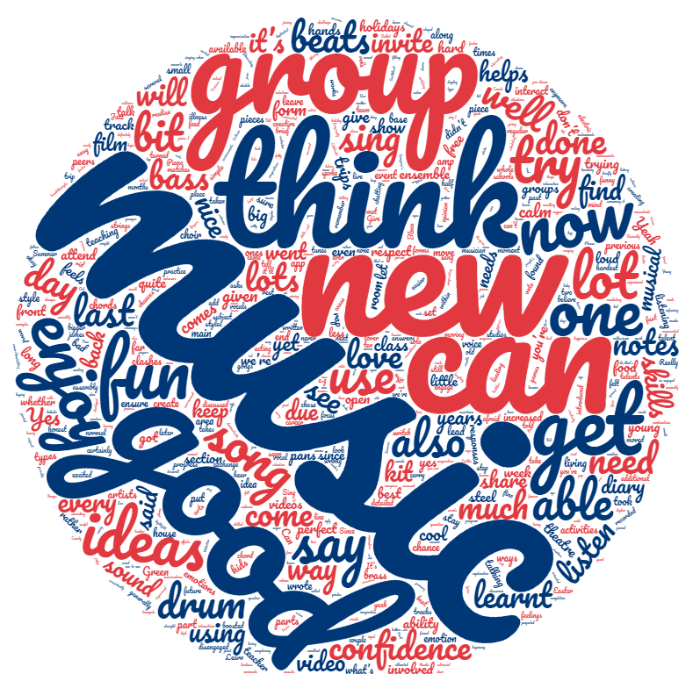

The world cloud above shows those key words which featured most prominently across all of the narrative data collected in student perception surveys across the four years. Apart from the subject-specific words such as ‘music’, ‘group’, ‘drum’, ‘beats’ and ‘song’, the most frequently used words are words associated with positive emotional states, such as ‘enjoy’, ‘good’, ‘fun’; and words associated with competence, self-belief and mastery, such as ‘confidence’ ‘think’, ‘can’, ‘able’, ‘new’, and ‘now’. These descriptors point towards young musicians being able to identify changes in their outlook and abilities in relation to Exchanging Notes and to realise aspects of their potential which they might not have before.
"Before, I never thought I would see myself as a musician.” (Young musician)
“I tell people I'm a musician and I aspire to become, like, not famous, but like known for my music.” (Young musician)
“It's kept me out of trouble to be honest and made me see myself in a better position, and the school, they support me as well. It’s shown me that I could do more than just a normal job, I could use what I've learnt in here and take it further.” (Young musician)
In the final year interviews with the young musicians, we found that they had high levels of aspiration and diverse goals for their futures. Many of the young musicians described the positive outcomes of Exchanging Notes as helping them develop a stronger sense of direction for their future:
“I've got a college place where I'm studying travel and tourism and then hopefully I'll go into… my dream job would be to be like a holiday rep and, like, entertainment in hotels where I could also use my singing for, like, shows.” (Young musician)
“I'd really like to get some music out there and like produce… have, like, albums and things like that or a song on Spotify or something like that and just have, like, little tours in the UK.” (Young musician)

Three important changes in learner perspective were observed during Exchanging Notes:
- Transformative: there has been a shift in young musicians’ musical and non-musical perspectives
- Integrative: participants now have new understandings of music, education, and themselves, causing them to act in different ways
- Re-authoring: for the majority of the young musicians these new practices are unlikely to be forgotten or unlearned. They have ‘re-authored’ themselves, in particular through a new identity of being a musician.

Improvement in quality of music education
Each Exchanging Notes project was visited by the research team up to three times per year, and part of the visit included an observation. A total of 75 observations were conducted across the four years and the observations improved over this period. The chart below shows the overall indicators moving from the orange regions at the start of 2014/15 to green at the end of 2017/18 (observations were not scored in figures, but on a spectrum of red to green, with red being the lower quality score and green being higher):
The increase in average observation scores suggests that the quality of music delivery improved over the course of the four years. There are a number of reasons for this.

Teachers and music leaders developed new pedagogical practices
Over time, teachers and music leaders combined their different approaches to teaching and learning. Together they engaged in regular and honest dialogue to develop their own learning, and built trust and respect for one other. This led to them adapting their practice and working in new ways.
The four-year duration of Exchanging Notes afforded time to try new things, and as a result new thinking and practice emerged. This impact was felt in a wide variety of ways, and was often different for teachers and for music leaders:
“They’ve [music organisation] expanded our thinking in relation to what we now see children can do. I think we were quite narrow before. We are now more ambitious.” (Teacher)
“I have learnt how to question what I am doing. I am really looking at how are they working; are they making progress? Is there any way that we could look at problem-solving or looking at past issues that might be stopping them achieving? I talk to the young musicians, try to get to know them and get feedback on what they have been doing or how their work is going. Or where is it going? For me though, all this now is not just session-by-session based but I actually see progress over a longer period of time.” (Music leader)
“I’ve learnt more ways to handle challenging students than what the rules state and that sometimes it takes a bit of calm, nurturing and quietness to find a completely different route.” (Teacher)

New ethical curriculums were developed, which became more young musician-centred
Projects were led by young musicians’ needs and interests, and were flexible in terms of what the curriculum covered:
“It’s been very much student-led, if there’s an idea where they want to go, we will help them achieve that.” (Teacher)
“I think a big part of it, the success, is the fact that we’ve had open conversations and we’ve planned it together, and we’ve delivered it, it’s worked. It’s worked and it’s exceeded expectations. That’s because at the heart of what we plan is for the young musician, their interests and musical aspirations.” (Music leader)
“I think we’ve learnt… by having that element of student negotiation and the element of group work and giving them responsibility for getting from one point to another. I think we were a little nervous about trying that at the start - now we see it work and the students have valued that opportunity to step up and manage their own events and make those decisions, I’m hoping that that’s a model that we will continue moving forward between the school, provider and hub.” (Hub leader)
The curriculum became ethical, in that children’s views were genuinely listened to, which in turn helped to improve their experiences of learning:
“Because, we are just people working together and, I think, when people feel, you know, you don’t need to be from one particular area or background or anything, that we can build these connections based upon mutual respect. Then, suddenly that opens the door for learning, and I think it’s really clear that any of these guys could have had the same experience in any lesson that they had here, once they believed that they were having a dialogue with the teacher.” (Music leader)
In some projects, the opportunity to learn in external venues helped to broaden knowledge about the music industries, and also helped to focus learning and attention:
“I enjoyed being able to share my ideas with the group that could put them together as a piece, having the support from the group leaders and their advice on what we could do to make it better. And then being able to explore these professional environments, recording studios and that, and live venues. I think it's really good to see what you can do when you get out into the world of music.” (Young musician)
“[Going to the studio] is a lot more different because you had to focus a lot more. Because you have to get it done quickly. In school we just all do it and sometimes you don't get it all done. But there we did.” (Young musician).
New models were developed through Exchanging Notes which led to the development of an inclusive and forward-looking curriculum. The most effective projects included activities that encouraged participation, were musically relevant, extended knowledge, developed musical skills, addressed future needs, and engaged young musicians in ways appropriate to their developmental stages.
“I think the project has really given [school music lead] a huge amount of confidence to deliver what I think is now a really strong curriculum, and to develop that.” (Headteacher)

Teachers and music leaders developed new identities, and became more open to learning
The interviews with teachers and music leaders that took place at the end of the programme suggested that they had developed new identities through the project. Music teachers were no longer just teachers in school. Their musician identity – often left outside the school gate – was now better integrated into the classroom:
“It was nice to input some of my own experience and work with the music leader like you would do with other musicians in an ensemble or band or something.” (Teacher)
This had an impact on their relationships with young people:
“I have learnt a lot about [the music organisation’s] practice and their approaches to teaching and learning that has come directly back into my classroom. I think it’s also helped the pupils see me in a different light, they know now that I’m not just a teacher but I am also a musician too.” (Teacher)
Similarly the music leaders thought about themselves more as educators by the end of the programme:
“I now really aspire to plan for learning … I would say we are focused on learning as well as doing, but I also think we focus on other wider social outcomes, and is the learning taking place more in terms of interactions with others and more general musicianship rather than notes on the page. That’s certainly the angle that I prefer to take now.” (Music leader)
“I think the project has changed my practice hugely, I don’t really recognise myself.” (Music leader)
These changing identities opened people up to thinking about new possibilities:
“[Music leader] and I have built a really good working relation, grounded in an understanding of each other strengths and that we will support one another and try to help each other develop as practitioners, musicians, teachers.” (Teacher)

Impact in the music classroom
As well as having an impact on individual teachers and music leaders, Exchanging Notes has helped to forge new ways of working in schools:
“What Exchanging Notes has done is… it has helped me a lot to arrive at what I consider to be a sustainable model for music practice in school and different ways in which you can train and include a range of members of staff and encourage them. In a way, to create a sustainable music practice that they can transmit themselves.” (Teacher)
In some instances, the practices and impact of Exchanging Notes became embedded throughout the school:
“I think that one of the keys to success is that it is so embedded in the school. It has enhanced the school. And I think it’s enhanced the lives of the young musicians, not just those that were on the project.” (Headteacher)
“It has a favourable impact in the engagement, not just in Exchanging Notes project but the whole school. It is quite interesting to see how you can have this knock-on effect. You start working with a number of individual young musicians, but they belong to different classes, have different teachers, but crucially if you then have a headteacher who is proactive in serving those outcomes, then they will try to capitalise on that. That’s what the CPD has done, it’s engaged and expanded the impact of the project.” (Music leader)
“I think it’s about a new-found understanding …of the power of music for our school community. So, everybody in the school, whether they’re involved in music or not, [has] seen the impact that music has had on our students. It is actually quite profound. So, I think the legacy is that people now understand that that’s a really important tool, in terms of people’s learning, people’s communication, people’s wellbeing and people’s self-esteem, because they have seen it for themselves.” (Headteacher)
Exchanging Notes didn’t just impact on practices within schools and practitioners – in some cases it also extended to Music Education Hubs:
“It’s broken down a perceived barrier between the formal and the informal, and that it’s almost empowered the formal sector, to look at alternative models and not be afraid to run with it because they can really benefit from it. Also there are lots of music leaders and practitioners out there who could help school settings to realise these sorts of pedagogies… Some key things for us to learn about are how young musicians have engaged with this programme over four years and what they’ve got out of it, and therefore what they’d like to see in some of the weeks of tuition, some of the weekly ensemble programmes that we’re running day-to-day.” (Hub leader)

Broadened perceptions of success, progress and progression
“We had our head in our hands to say, how is this going to work because the school wants what it wants, and we work in a completely different way, how can we convince them that the two can complement each other? I think it was at that point that we had this epiphany to say: that means that this project is placed in exactly the right place. And we will work with them, to show them the impact this can have.” (Music organisation leader)
There was friction in some projects at the outset, because music organisations and schools had different priorities, expectations and measures of success:
“Are they learning enough… for me [both] to do those things I would like to do with them and be able to point out what things they did better, according to the school?... If you’re going to become a musician you need to learn how to work with people. And so it’s those little things that I feel are important, but then I’m not always sure: how do I sell this to the school?” (Music leader)
Some music leaders couldn’t understand why schools placed so much emphasis on planning and attainment, when their priority was getting children and young people engaged. On the other hand, some teachers were frustrated at the outset by a perceived lack of structure for progression, and a slow pace of learning. As time progressed these views became reconciled, and both parties developed new understandings of success that went beyond academic attainment:
“The school has never doubted that it has been having a positive impact, which is not always measurable in the ways that we’re collecting data, necessarily. Maybe their attendance was always okay, but they were just very different around school and things like that. Or maybe their grades were okay but there were other issues that we encountered with them. So, I don’t think… the tangible impact that we see in the life of the student necessarily reflects in the data that we collect, but it is recognised, and it is seen, and it’s noted that the students do spend far less time in places like PAC [exclusion in school] and exclusion meetings and things like that.” (Music leader)
Changing ideas about what success looks like often led to changing approaches. For teachers, this often meant a more individualised approach that placed more emphasis on personal and social needs:
“I guess, because of the rigidity of a system which is so based around structure and evaluation and valuing through a marker system, there actually is a freedom that comes with young musicians… being part of something which is not based around that kind of system. Oh, you got a C, you got an A, you got a merit, and you got a distinction. You know, it becomes much more about a personalised journey and the value that comes from the self and, therefore, it becomes about you.” (Teacher)

Section 3: key learning – what made the projects work?

Close multi-agency working
As well as joining up practices between schools, music organisations and Music Education Hubs; developing multi-agency partnerships (i.e. partnerships that involved specialist agencies with a role in supporting young people’s emotional, social or educational outcomes) was an important element. Exchanging Notes projects worked with the following professionals:
- Social workers
- Carers
- Independent reviewing officers (social workers)
- Music therapists
- Special Educational Needs Co-ordinators (SENCOs)
- School pastoral staff
- Learning support teams
- Medical professionals
At the beginning of the project it was often difficult for Exchanging Notes partners to find out information about young people’s personal educational plans and progression from other agencies. Over time the barriers were gradually broken down, and the music organisations were able to be included. This was due to the outside professionals witnessing the impact the project was having on the young musician’s personal, social and emotional wellbeing, as well as their enjoyment at school, their attendance and general engagement in education. This resulted in different outcomes for young musicians than may have otherwise been the case:
“With one young musician for example, that collaborative planning around their education and the bringing together all the different agencies involved in his education enabled us all to recognise the importance of music in their life. It became evident that if the work develops through Exchanging Notes was taken away from this young musician’s provision that it would've been detrimental to them.” (Headteacher)
A number of the projects worked alongside Music Education Hub lead organisations in the delivery and monitoring aspects of the project. When the hub lead organisation was fully involved, progression routes and extracurricular activities were initiated and supported. Some hub leads also played a crucial role, bridging relations and supporting with quality improvement.

The long-term nature of the programme
Working over a relatively long period of time - four years - was a major factor in the success of projects. It enabled strong relationships to develop between teachers and music leaders. The outcomes discussed in Section 2 did not happen from the outset - often they took some time to develop, and particularly to build trust:
“The power of a long-term relationship - that journey I think, is really important. Being able to be vulnerable and then being able to grow from that vulnerability into a new sense of learning, a new sense of confidence and new kind of centre, if you like, within yourself. I think that comes from long term relationships.” (Music leader)
“It’s about sitting down and being open with one another. It’s about constructive criticism but that doesn’t come straight away. We both observed each other’s practice and then were able to understand each other better.” (Music leader)
“I think over time I liked the sessions. I didn’t at first but that changed as I got to know them better.” (Young musician)
“We have had a lot of teachers but [the music leaders] have been with us all the way through, and I am grateful for that really.” (Young musician)
The luxury of time allowed for strong relationships to be developed, which then opened up new opportunities for learning:
The significant thing for us is that sustained contact with the young musician, and the relationship that has been built up between the music leader and the young musician, and that longevity, and the support and learning that can happen on both sides.” (Music leader)
“Students from our area struggle to put in that extra effort and struggle with hobbies, so that was a challenge. Even getting the students acclimatised to that was a challenge. Because whenever anyone else new comes in they’re always a bit wary. But because this was a longitudinal project there was time for us to develop that, without which I don’t think we would have the outcomes we have got.” (Teacher)
For some projects it took the entire four years to see a transformation in practice:

“The work put in to creating equity, a sense of equity between leaders and kids cannot be underestimated. It has taken us, I would say, near the whole time of the project, four years, to reach a point where I think we listen to the kids, take account of the demands of the curriculum but also are informed and led by the non-formal approach of the music leader.” (Teacher)

But working long-term also brought about challenges, particularly associated with staff turnover or limited buy-in from one partner:
“I think it’s totally sustainable, doable and a really good idea to have long term partnerships. And that’s been a totally new experience for us. I think where it doesn’t work is where you don’t have that teacher or that relationship with the school. For us, Exchanging Notes has been hard work because the music teachers kept changing and the school is in a difficult place.” (Music leader)
“I think it’s definitely a great idea and a great way of working, but it’s just so key having that relationship with the school, whether it’s through the music teacher or whatever, someone really needs to champion it in the school. Part of the problem with schools at the moment is the teaching staff, they’re changing at such a rapid rate.” (Music organisation leader)
One regular method of data collection used by the research team was baseline and follow-up perception surveys with music leaders, music teachers and young musicians. One question asked whether young people tried hard in sessions. Music leaders and young musicians perceived that engagement at the end of the programme was lower than at the beginning. This could be due to methodological limitations of the data collection method used, but it could also point to difficulties in project-based work maintaining engagement over a long period of time.

Use of the Youth Music quality framework
The Exchanging Notes projects used the Youth Music Quality Framework as a way to explore session content, teaching and learning methods, and the musical and social environment. The framework was used in a variety of ways by the projects.
Some used it on a termly basis for specific observations aimed at improving the overall effectiveness of sessions (much like what occurs in a typical school classroom observation, where an observer offers constructive reflections aimed at improving teaching and learning). Some focused on a small number of specific criteria per session. Others used it as a reflective device and as a planning tool, where they considered all the criteria across the short, mid and long-term. Doing this helped to develop session activities and pedagogical approaches that were young musician-centred. The quality framework was found to be an effective tool to open up dialogue between teachers and music leaders.
“It makes us really aware to involve the young musician in their learning and allow them to share with us their perceptions and thoughts about where they want to take their learning.” (Music leader)

A culture of honest reflection leading to development
The long duration meant that projects had time to evaluate, learn from their mistakes, and put new models into practice. The quality framework encouraged a culture of reflection and continuous development, as did the action research process:
“Development has been able to happen because we’ve been given the time and because we’ve trusted the process.” (Music leader)

“It’s very, very different from any other project I’ve worked on, in that respect, and I wasn’t expecting that at all. I’ve worked places for three or four years, but not in terms of this, and not in terms of constantly evaluating the situation.” (Music leader)

Inclusive, collaborative partnership working
There were different types of partnership present in Exchanging Notes. The most successful partnerships were inclusive. They involved a wide range of people focused on young people’s musical and educational wellbeing and they made decisions together.
Teachers and music leaders were often had different values and expectations. These differing perspectives needed to be explored openly and honestly:
“I was coming from one perspective; they were coming from another.” (Music leader)
“Engagement is understood in different ways and I think that’s something quite significant, and I think that the non-formal process and practice that our music leader is offering within a formal context can look quite different. But this is something that has always been in discussion with the teacher.” (Music leader)
Where regular, honest and respectful dialogue took place, new bonds were established that created a good atmosphere for learning. Where young musicians were then placed at the centre of the learning process, often the teacher – learner hierarchies were broken down. teachers and music leaders showed that they too were willing to take part in the learning process and this created an authentic educational relationship between everyone.
One thing I have done which is successful is I have got the Exchanging Notes young musicians to peer teach, including teaching me which has been a great thing. (Teacher)
Three Exchanging Notes projects ended early (by mutual agreement between the funder and partners). Whilst the reasons for their early closure are complex, a major factor in all three projects was an inability to align values and expectations between all the different partners. These conflicting objectives ultimately meant that the partnerships could not develop as intended.

A curriculum that promotes participation, agency and creativity
Where projects were too ‘top down’, they restricted young people’s agency and autonomy. This meant that young musicians were unlikely to view the sessions as a joint endeavour, making them more likely to disengage. In one instance, the young musicians’ status was reduced to one of compliance and dependence:
“They could ask everybody what they like and could do combination of everybody's ideas. [But] the music leader was like ‘you get that and you get that’, and then Miss was like writing down which instrument you’re on, ‘you're there, you’re there, and you’re there’. You don't get to choose what instrument you want. You don't get to give your vote or anything, they do it all for you. (Young musician)
The creative process was important in developing a collaborative and ethical learning environment.
“[Young musician] has a box with lots of activities that they will explore in a different ways or forms. So sometimes this is loud, soft, smooth, quick, fast sounds. The way that they are exploring different instruments and sounds… this has been a big growth.” (Teacher)
“We'd write the lyrics and then we would like kind of make an intro on Garageband, and then like start making a chorus and a verse to it, and then build the song up and then record it in the recording booth, and then add harmonies and things like that, and just really like make it a really good piece… so everyone was in it, and everyone had like a main like part of it and no one was like had a little bit or a big bit, it was all equal and everyone was like really happy with what they'd made as well.” (Young musician)
In particular, the process of songwriting was highlighted as being particularly effective, allowing young people to engage deeply with the musical development process at the same time as reflecting on their own life experiences:
“In one case we have focused on lyrics. The young person felt that they could express themselves in the sessions - they would often say that it wasn't just about words but that it was from the heart. I think this broke down a barrier within them. By talking about these things in their music, they were processing things in their mind, all these memories and experiences that they had previously not been able to process. Alongside this they were progressing musically and found they were good at something.” (Music leader)

Making the project visible in school
In projects where the impact of Exchanging Notes extended beyond the young musicians, teachers and music leaders, it was often because the project was made explicitly visible to people who weren’t directly involved in it. Sometimes this visibility was created through performances:
“We’ve been doing occasional gigs out in the courtyard, just in lunch breaks and stuff and we always get a really good crowd, teachers too.” (Young musician)
At other times it was achieved through the Exchanging Notes team delivering CPD to other teachers in the school. In these sessions, music teaching strategies, pedagogy and learning were discussed and explored. Alongside this, teachers got to experience music sessions and consider ways that these approaches could be used in their lessons, even if they did not teach music:
“I have run a number of training sessions for other teachers of different classes who are interested in the music schools and what we have been doing. I would say the community effect of this is positive.” (Teacher)
As well as impacting on teachers’ and young musicians’ perceptions of the project, such visibility was often important in securing senior leadership buy-in for the work.

School buy-in (particularly from senior leadership teams)
The ability for new practices to be trialled and embedded in the school often depended on the level of senior leadership team buy-in:
“If you’re not working with a school that is totally invested ... If you haven’t got that and you haven’t got somebody that really values it and really sees that actually, in the end, this is going to be worth it, so any problems you come up against is going to be worth it…without that, you wouldn’t be able to do it.” (Music leader)
Sometimes school pressures or limited buy-in constrained the way that projects and educators worked:
“It mutes me and then I’m like what do I do with this? I would like to do it like this, but I can’t. I don’t feel like I should be doing it that [the school’s] way.” (Music leader)
“It’s not been a success at all. Hurtful, I suppose because I feel like we have been able to offer something to the school and to the young musicians.” (Music leader)
“Due to timetables I can’t be in the sessions, it is frustrating but I try to engage in the project in other ways, like after school and externally.” (Teacher)
For headteachers and other school staff, being able to see the social and personal outcomes from the work was often important in securing their buy-in. Having this buy-in was important in making the space for music within a busy school timetable:
“It’s about, for me as a leader of a school, ensur[ing] that we balance that [performance in maths, English and science] with making sure that all those other rich cultural things are included. That’s my role, to make sure that we keep the balance there.” (Headteacher)

Having a dedicated ‘interlocutor’
The word ‘interlocutor’ comes from the Latin interloqui, meaning ‘to speak between’. For some of the projects, a project manager was employed to coordinate the partnership. They supported events organisation, arranged timetables, observed practice, and helped with general planning and administration. Their roles evolved into that of interlocutor.
The interlocutors liaised with all partners, developing a sophisticated understanding of all the different perspectives. Their distance from direct teaching blurred the boundaries of insider and outsider. They used the language of both formal and non-formal education, gaining respect from teachers, music leaders and senior leadership teams. Importantly, they promoted dialogue so that partnerships could function well:
“I think a lot of it stems down to a fundamental misunderstanding of what the project was or what their role was, or what the school’s role was, or what the teacher’s role was… we needed to learn from each other’s best practices… [The interlocutor] really helped us to begin conversations about this.” (Teacher)
The interlocutor role was vital to the success of many Exchanging Notes projects.
In some cases, the Music Education Hub leaders played the role of interlocutor, bridging relations between the schools and music organisations, maintaining the sustainability of the partnership and ensuring quality:
“I see my role as maintaining and managing the relationship between the school and us. I’ve been to meetings with the headteacher and school governors as well as talk[ing] to the music hub about this work and the wider music community.” (Music organisation lead)

Summary

The research outlined how Exchanging Notes opened up new spaces for learning. These led to new possibilities, practices and types of learning. In particular the young musicians were enabled to access new (and in some cases, previously closed-off and inaccessible) ways of thinking and being a musician. Three important changes in learner perspective were observed during Exchanging Notes:
- Young musicians’ musical and non-musical perspectives changed
- The young musicians’ new understandings – of music, of education, and of themselves – led to new behaviours
- This resulted in a ‘re-authoring’ of self, in particular through having a new identity as a musician. For the majority of the young musicians these new practices are unlikely to be forgotten or unlearned.
Through building their resilience, the young musicians have developed coping strategies they will be able to draw on as they progress through school and into adulthood, bolstered by the wide-ranging musical and social skills they have developed.
During the four years of Exchanging Notes there were many ways in which the projects challenged the accepted norms of doing music education in schools. In order to challenge school constraints, projects had to find ways to explore new approaches that were democratic, relational, and collaborative.
Many of the Exchanging Notes projects re-evaluated measures of success based on musical standards, or level of skill. New measures of success took account of musical, communicative and discursive practices. Teachers and music leaders had conversations that explored new ways of thinking, being and doing.
These processes have enabled many organisations to begin to move towards a realignment of music education as being socially, culturally and politically conscious, and a change in practice and policies for accounting for progress and progression. They took a more ethical and inclusive approach.

Section 4: Recommendations

We’re calling for:
- An unequivocal message from government about the value of music in schools.
Why? Music in schools is being side-lined due to increasing pressures schools face to demonstrate performance in EBacc core subjects.
- Government should reinforce the benefits of music in schools and ensure it can be adequately resourced from school budgets.
- Each pupil should receive a minimum of one hour of music per week.
Youth Music supports Arts Council England’s view that schools should be unable to receive a ‘good’ or ‘outstanding’ Ofsted grade unless they show a strong commitment to arts and culture.
- Schools to ensure that music is for everyone.
Why? Pressure on schools to focus on measuring musical attainment is coming at the expense of creative and inspiring music-making, which decreases engagement and means that the personal and social benefits of music are being missed.
- Young people’s existing musical tastes should be the starting point to ignite their passion for music in the classroom.
- The personal and social outcomes of music, such as wellbeing and resilience, should be tracked and valued.
- Music in Key Stage 3 should have less emphasis on preparation for GCSE Music.

- Partners to collaborate to co-design an inclusive 21st century curriculum.
Why? There’s a huge opportunity and a great need to work in partnership to reimagine music in schools. Local partnerships can offer opportunities for progression, support young people’s wellbeing, and raise awareness of the full range of music-related career paths.
- Music in schools should be reassessed to best reflect young people’s needs and interests alongside future skills requirements.
- Music teachers should be given the time and space to develop external partnerships to support young people’s engagement, wellbeing and progression.
- The music industries (including charities and Music Education Hubs) should provide strategy and investment to support the next generation of musicians.
- The learning from Exchanging Notes should be embedded within the new model music curriculum (currently in development).

Resources

Quality framework criteria
Young people centred | Music leader practice
Y1 Music-making reflects the young people’s interests, with recognition of their existing musical identities.  Y2 Young people experience equality of engagement and no participant is discriminated against. Their views are integral to the session.  Y3 The young people’s musical, personal and social development are monitored, and achievements are celebrated and valued. Young people are supported by music leaders to set their own goals and targets.  Y4 Young people receive clear feedback on their work, identifying next steps for individual improvement. Young people are encouraged to participate in this process through structured peer and self-reflection. Comparison to others is only made where appropriate.  Y5 The music leader and/or project staff identify the need for any additional pastoral or other support, and seek to provide or signpost to this. | M1 The music leader has relevant musical competence, and is both an able practitioner and positive role model.  M2 The music leader has a clear intention and has planned the session accordingly, while retaining room for flexibility.  M3 The music leader plans sessions that enable young people to make progress and nurtures their understanding of what it means to be a musician.  M4 The music leader regularly checks young people’s understanding. They reflect on their own practice: activities are reviewed and adapted over the course of the session according to how the young people respond.  M5 All project staff are actively engaged with activities. Music leaders and other project staff communicate before, during and/or after the session and collaborate in planning activities. Roles and responsibilities are clear to all involved.
Session content | Environment
S1 Activities are engaging, inspiring and purposeful. They are clearly explained and/or demonstrated to the young people.  S2 Ownership of session content is shared between the music leader and young people. Participants contribute to decision-making and have the opportunity to take on leadership roles where appropriate.  S3 Young people are supported to create and make their own music, and broaden their musical horizons over time.  S4 Activities are designed and delivered in a manner that is accessible to all and tailored to each individual whenever possible, taking account of their starting points and aspirations. Group dynamics and pace of learning have been considered. | E1 There is a suitable ratio of young people to music leaders (and other project staff where required).  E2 Consideration has been given to the physical space, with available resources being best used to make it accessible and appropriate for the target group.  E3 There are sufficient materials and equipment to support the activities.

Quality framework observation template

Date:  Venue: | Session title:  Music leader:
Timeline | Quality Framework Criteria
Example:  4.40pm – As the warm up progresses, the music leader continues to encourage the participants to lead warm-up activities. Latecomers are welcomed into activity seamlessly. New participants are greeted without a great deal of attention being drawn to them so that they feel comfortable – told to join in where they can. Could a Young Mentor have been assigned to supporting them during the warm-up games? | Y2 , S2
Feedback
Keep feedback:
- Positive (if you identify areas for improvement, better to explore these through reflection questions)
- Specific (“that was a great session” is not enough. What specific elements made the session so good – was it to do with something they did or how the young people reacted?)

Questions for music leader / teacher
Agreed next steps (if applicable)

A model of partnership working

Appendix 1: Methodology

Ethics statement from Birmingham City University

The research was approved by Birmingham City University Faculty of Health, Education and Life Sciences Ethics Committee. The evaluation was conducted in adherence with the British Education Research Association (BERA 2014, 2018) guidelines on ethical practice in educational research. Participants were informed of the research objectives and aims via a consent and information form. The research respected autonomy and the consent form noted that participants could withdraw from the evaluation at any time. The responses were carefully monitored so that any issues relating to diversity and equality could be addressed, however none were identified. All participant names have been anonymised in this evaluation report and any subsequent and other reporting of the evaluation – with the exception of case study interviews conducted by Youth Music to support the research, for which specific consent has been given.

The views of the young musicians involved in this project were central to the evaluation of its efficacy and outcomes. Evaluation consisted of a mixed method research design, which involved both qualitative and quantitative methods, allowing a wide range of data to be collected and analysed. This was designed purposefully with a view to enabling the resulting data and evaluation to be as valid and reliable as possible, given the diversity of sources of information about projects and their impact. Inclusion was important for this study; therefore data collection methods were adapted for some school contexts taking account of the range of communication and learning needs of the young musicians involved. These were co-designed with schools and music leaders to ensure that the data collection tools met the needs of the young musicians.

Appendix 2: Bibliography

All Party Parliamentary Group on Music Education, Incorporated Society of Musicians & University of Sussex (2019) ‘Music Education: State of the Nation’. https://www.ism.org/images/images/FINAL-State-of-the-Nation-Music-Education-for-email-or-web-2.pdf
American Psychological Association (2019) ‘The road to resilience’. https://www.apa.org/helpcenter/road-resilience (accessed 24.04.2019)
BERA (2014, 2018) ‘Ethical Guidelines for Education Research’. Fourth edition. British Educational Research Association
DfE (2011) (Department for Education) ‘The Importance of Music: A National Plan for Music Education'. London, DfE - Department for Education
DfE (2019) ‘Government backs young musicians’ News story published 11 January 2019, https://www.gov.uk/government/news/government-backs-young-musicians
Diener, E. (1984). ‘Subjective well-being’. Psychological Bulletin, 95(3), 542-575.
Education Select Committee (2019). ‘Forgotten children: alternative provision and the scandal of ever increasing exclusions’. https://publications.parliament.uk/pa/cm201719/cmselect/cmeduc/342/34203.htm accessed 24.04.2019
Leckie, G. & Goldstein, H. (2017) ‘The evolution of school league tables in England 1992–2016: ‘Contextual value‐added’,‘expected progress’ and ‘progress 8’’. British Educational Research Journal, 43, 2, 193-212.
Ofqual (2018) ‘Entries for GCSE, AS and A level: summer 2018 exam series’ Official Statistics: England https://assets.publishing.service.gov.uk/government/uploads/system/uploads/attachment_data/file/712450/Report_-_summer_2018_exam_entries_GCSEs_Level_1_2_AS_and_A_levels.pdf
Ryan, R. M. & Deci, E. L. (2000) ‘Self-determination theory and the facilitation of intrinsic motivation, social development, and well-being’. Am. Psychol. 55:68-78.
Ryan, R. M. & Deci, E. L. (2001) ‘On happiness and human potentials: a review of research on hedonic and eudaimonic well-being’. Annu. Rev. Psychol. 52: 141-66.
Ryff, C. (1989) ‘Happiness is everything, or is it? Explorations on the meaning of psychological well-being’. Journal of Personality and Social Psychology 57: 1069-1081.
Seligman, M. (2011) ‘Flourish’. New York: Simon & Schuster.
West, A. & Wolfe, D. (2018) 'Academies, the school system in England and a vision for the future'. Clare Market Papers No. 23, London, LSE Academic Publishing.
Young Foundation (2012). ‘Adapting to change: the role of community resilience’. London, Young Foundation
Youth Music and Ipsos MORI (2019). ‘The Sound of the Next Generation’. London, Youth Music.

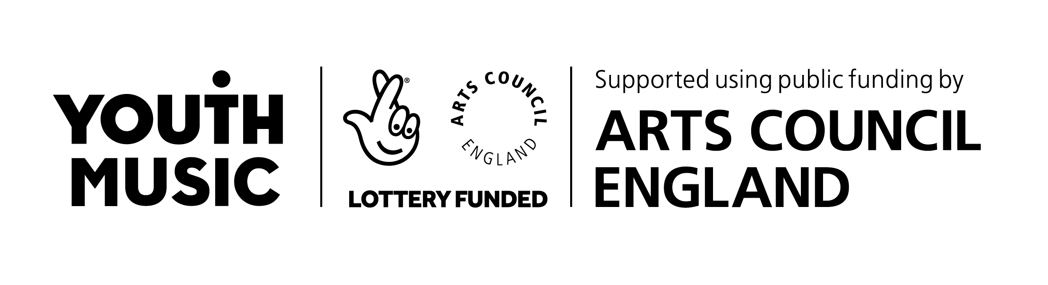
The National Foundation for Youth Music
Address Studios 3–5 Swan Court, 9 Tanner Street, London SE1 3LE
Tel 020 7902 1060 Email info@youthmusic.org.uk Website www.youthmusic.org.uk
Registered charity number 1075032 Limited company number 03750674

The Sound of the Next Generation, Youth Music and Ipsos MORI, January 2019: https://www.youthmusic.org.uk/SONG
The importance of music: a national plan for music education, Department for Education, 2011 p.5
https://network.youthmusic.org.uk/youth-music-quality-framework
Further to holding the focus group with young musicians which led to the above quote, follow-up conversations between Youth Music, the music organisation and the school were held. This resulted in the programme ending early by mutual agreement.

