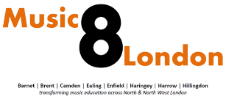
Network and Training Centre
Soundabout’s new partnership to support music services, hubs and music practitioners across the SEND sector in the London boroughs of Barnet, Brent, Camden, Ealing, Enfield, Haringey, Harrow, Hillingdon and beyond.
REQUEST FOR DONATIONS!!!
DO YOU HAVE ANY OLD MUSICAL INSTRUMENTS AT THE BACK OF A CUPBOARD, IN THE LOFT OR LYING UNUSED IN YOUR SCHOOL?
Your rubbish is our treasure!!!
Please contact us to donate items which will be gratefully received by special schools in North London and used to engage our children in sound and music.

NB: We are happy to receive items with missing strings or which will no longer tune properly; we do not expect items in perfect condition but please do not donate COMPLETELY broken items!!

Please contact jennycooper@soundabout.org.uk
Registered Charity No.1103002 https://www.soundabout.org.uk/

