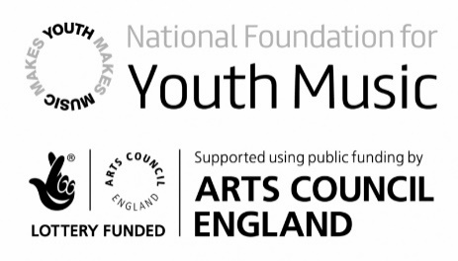
Question | 2018  21 users  Star rating (1 – 6) |  | 2019  12 users  Star rating (1 – 6)
Do you enjoy music sessions with EYFS children? | 1.  2.  3.  4.  5.  6. | 16  3  0  0  0  2 | 1.  2.  3.  4.  5.  6. | 11  1  0  0  0  0
Do you feel confident in planning and delivering creative music-making sessions for EYFS children? | 1.  2.  3.  4.  5.  6. | 3  3  5  8  2  2 | 1.  2.  3.  4.  5.  6. | 5  5  3  0  0  0
How often do children in your setting take part in whole group music sessions?  6 stars = daily  1 star = less than once a week | 1.  2.  3.  4.  5.  6. | 2  4  3  5  4  5 | 1.  2.  3.  4.  5.  6. | 4  4  5  0  0  0
How often do children in your setting take part in small group music sessions?  6 stars = daily  1 star = less than once a week | 1.  2.  3.  4.  5.  6. | 2  0  4  5  4  8 | 1.  2.  3.  4.  5.  6. | 2  3  3  4  0  0
Do you enjoy singing sessions with EYFS children? | 1.  2.  3.  4.  5.  6. | 14  5  0  2  1  1 | 1.  2.  3.  4.  5.  6. | 7  4  1  0  1  0
Do you feel confident in planning and delivering singing sessions for EYFS children? | 1.  2.  3.  4.  5.  6. | 2  1  9  4  4  3 | 1.  2.  3.  4.  5.  6. | 3  7  3  0  0  0

How often do children in your setting take part in whole group singing sessions?  6 stars = daily  1 star = less than once a week | 1.  2.  3.  4.  5.  6. | 5  3  7  2  3  3 | 1.  2.  3.  4.  5.  6. | 3  6  4  0  0  0
How often do children in your setting take part in small group singing sessions?  6 stars = daily  1 star = less than once a week | 1.  2.  3.  4.  5.  6. | 3  2  4  5  2  7 | 1.  2.  3.  4.  5.  6. | 2  3  5  3  0  0
Do you feel confident in supporting colleagues in planning & delivering creative music-making sessions for EYFS children? | 1.  2.  3.  4.  5.  6. | 4  1  3  5  4  6 | 1.  2.  3.  4.  5.  6. | 6  2  5  0  0  0
Do you feel confident in supporting colleagues in planning & delivering singing sessions for EYFS children? | 1.  2.  3.  4.  5.  6. | 4  1  4  4  4  6 | 1.  2.  3.  4.  5.  6. | 5  3  5  0  0  0

