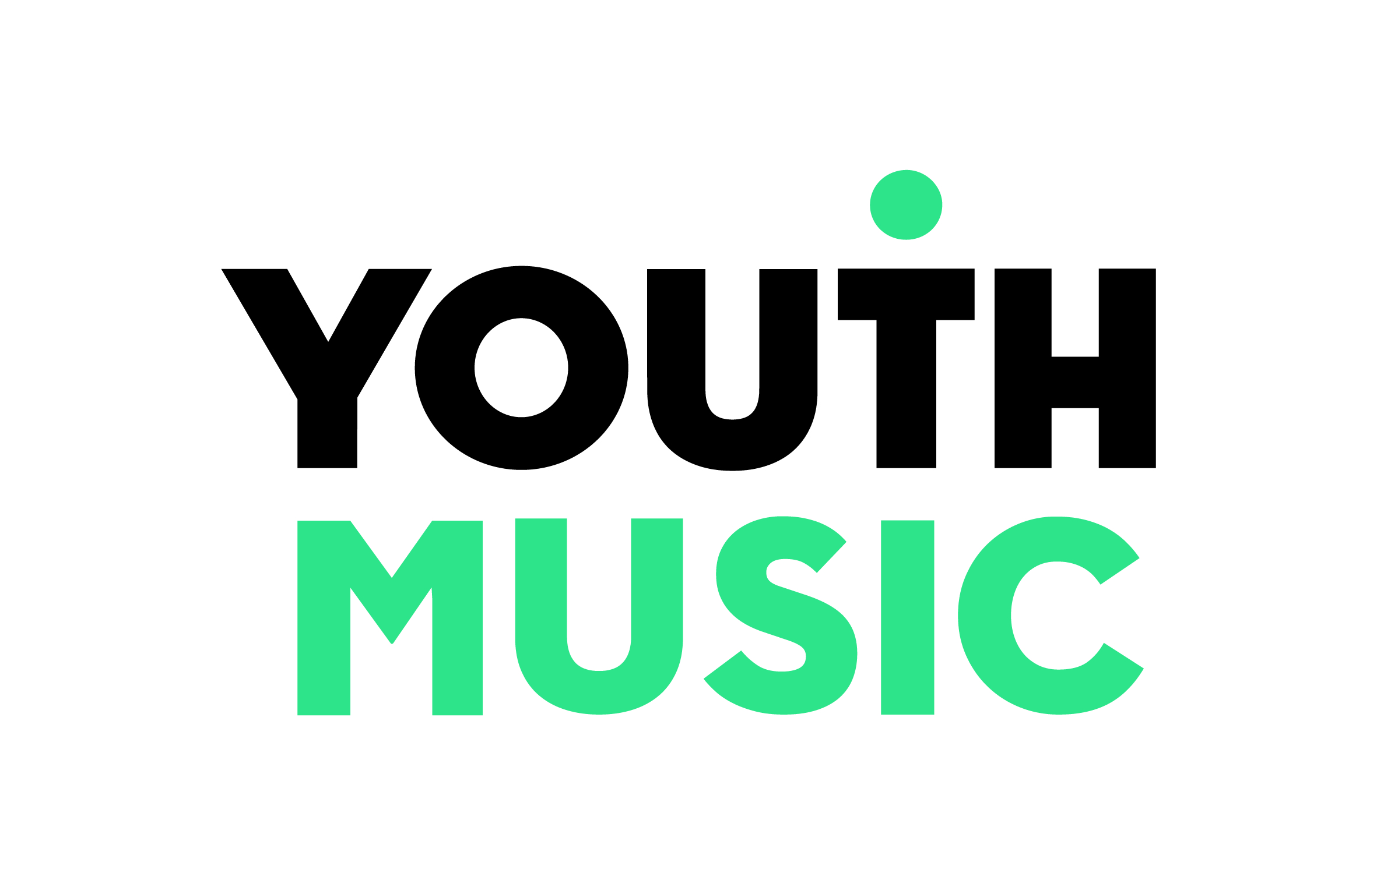

Emergency Fund

Applicant guidance notes
Phase 1, April 2020

Contents

1. About Youth Music 3
About Youth Music's grants programme 3
About this fund 3
What we want to support 4
How we will prioritise those most in need 4
Phase 1 4
2. Eligibility 6
We will fund the following costs: 6
We will fund organisations that: 6
We don’t fund: 6
3. Fund information at a glance 8
4. Application process and key dates 9
5. Application form template 10

About Youth Music
Youth Music is a national charity investing in music-making projects that help children and young people aged 0-25 to develop personally and socially as well as musically.

Our vision is that one day, all children and young people can make music. In order to achieve this, we're working collaboratively to transform music education in England. Our funding is focused on supporting projects for children and young people who face barriers to music-making as a result of who they are, where they live, or the circumstances they are experiencing.

About Youth Music's grants programme
We support around 300 projects across England each year, reaching more than 75,000 children and young people. Youth Music is supported by the National Lottery, awarding funding via Arts Council England. We are a People’s Postcode Lottery promoting society, receiving funding thanks to players; and we receive other corporate and private donations.

About this fund
This fund has been designed as an emergency response to support music-making organisations affected by coronavirus (COVID-19). We are grateful to our supporters for making this emergency fund possible: players of People’s Postcode Lottery, PayPal, and the National Lottery via Arts Council England.

Through this fund we’ll aim to:
- Prioritise the people and organisations in the most immediate need
- Make quick decisions and payments.

This fund is designed to support organisations facing the following challenges:

- Cashflow – organisations are seeing threats to their income, in particular from charged-for services and from contracts. This has significant implications for honouring employment and freelance contracts and core ongoing costs. At the time of writing there is still a lack of clarity about eligibility of government support measures and when any funding might be released.
- Maintaining services – there are/will be challenges in continuing to deliver core services through staff or volunteer absence, social distancing measures, increased childcare responsibilities, venues being closed etc.
- Adapting services – delivering services in new ways, which can be more expensive, have high set-up costs (e.g. IT infrastructure, buying tech or instruments for tutors and young people) or require new policies or expertise.
- Children and young people – the impact of the situation on children and young people’s mental and physical health; the negative implications for some vulnerable children of being out of school; keeping in contact now that the normal music sessions have ceased; engaging young people in new forms of learning; reaching children beyond digital access (e.g. disabled young people; those who don’t have devices or an internet connection).

What we want to support
Our priorities for this fund are:

- Organisational sustainability - Supporting lost income by paying overheads, and encouraging workforce retention by enabling organisations to pay their staff and freelancers. We will prioritise applications where staff and freelancers are in most immediate need.

- Adapting and staying inclusive - Supporting children and young people in vulnerable situations, who are traditionally ‘hard to reach’ and are placed at increased risk because of social distancing measures. We recognise that organisations might need additional resources and expertise to support children and young people in new ways. We are open to different ideas as to what this could look like, and we encourage organisations to share learning and ideas on the Youth Music Network.

How we will prioritise those most in need
We envisage that this will be a highly competitive fund. When we make decisions, we will aim to award grants based on need. This is likely to include assessment of:
- The immediacy of the need
- Who will benefit from the funding – either directly or indirectly
- Whether organisations are eligible for government support measures and other available funding (e.g. grants from Arts Council England, trusts and foundations)
- The existing levels of reserves held by an organisation and how long these will sustain the organisation at the reduced income levels
- Income mix, in particular levels of earned income
- Existing funding from Youth Music. (You do not need to have held a Youth Music grant to be eligible. In general, priority will go those who aren’t currently funded or who have expended the majority of their Youth Music funding).

We are providing this information to help you make an informed decision about whether to apply to the fund. We hope that you will act responsibly and give careful consideration to your relative levels of need in deciding whether to make an application. Our hope is to support as many organisations in need around the country as we can.

Phase 1
This fund is the first phase of our response. There will be weekly application deadlines for an initial six-week period. We will endeavour to stick to the published timescales, but given the current operating environment we cannot offer a 100% guarantee that we’ll be able to do so. We will continue to assess need in planning our response beyond phase 1. We will also be reviewing budgets and resourcing beyond this period.

We will ensure that there is an even budget available for each of the weekly deadlines. The funding will not be allocated on a first-come-first-served basis, to make it fair for people who are late hearing about the fund or for whom it may take longer to make an application. At our discretion, we may carry over applications to the following week’s panel if they are not initially awarded funding but still deemed to be in significant need.

Questions and support

Please direct all questions to grants@youthmusic.org.uk in the first instance. If you can’t access email, then telephone 020 7902 1060. We’ll be adding a list of Frequently Asked Questions to the Youth Music Network in due course.

Access needs
If you have any access needs then we can provide additional support to help you complete an application. Please email grants@youthmusic.org.uk or telephone 020 7902 1060. We will tailor this support to help meet your requirements.

Eligibility

We will fund the following costs:

- Core costs and overheads (including rent, bills, subscriptions, legal, finance etc.)
- Staffing costs
- Equipment purchase (including instruments and hardware)
- IT and other digital infrastructure
- Training and professional development activity.
Please note that this list is not exhaustive. We are open to funding things that we wouldn’t normally cover, based on the needs you have identified.

We will fund organisations that:

- are based in the UK
- are delivering work in England for participants resident in England
- are registered charities or not-for-profits (e.g. Companies Limited by Guarantee, constituted community groups). Local authorities are eligible to apply.
- are legally constituted and have been providing activity for a minimum of one year (if you are
not registered with the Charity Commission or Companies House you must supply evidence of this through your constitution).
- can provide their most recent set of accounts, no more than 18 months old. If you are a voluntary organisation not registered with the Charity Commission or Companies House, then we can accept a signed income and expenditure summary for the last financial year.
- have an Equal Opportunities Policy and Safeguarding Policy in place.
- have Employers’ and Public Liability Insurance in place.
- comply with all statutory laws and regulations relating to the work they will deliver.
- will pay people the real Living Wage with any Youth Music grant received.

You do not need to have held a Youth Music grant to be eligible for this fund.

We don’t fund:

- organisational debt that was in existence prior to the coronavirus pandemic
- individuals and Sole Traders or companies limited by share capital
- activities that promote party political or religious beliefs
- costs incurred in making your application
- the purchase of land or buildings
- VAT costs that can be recovered
- art forms that are not related to music
- activities that other statutory bodies would be expected to fund
- GCSE Music or A Level Music.

Fund information at a glance

Description | The fund is designed to help organisations whose primary activity is inclusive music-making with children and young people – and their freelancers, staff and beneficiaries.
Grant amount | Up to £10,000. We envisage that there will be very high demand for this funding so please only request what you need. We reserve the right to offer a contribution to the amount requested based on the competition for funds.
Application process | Via online application form (available from Wednesday 8 April).  If you have not made an application to Youth Music before, you will need to set up an online account via https://grants.youthmusic.org.uk/  Once you have submitted your application, we may call you to find out further information.  We will aim to notify you of the outcome of your application within one week.
Key dates – phase 1 | There will be six application deadlines. 5pm on the following dates:  Deadline Decision Earliest likely payment  Thursday 9 April Friday 17 April Thursday 7 May  Friday 17 April Friday 24 April Friday 15 May  Friday 24 April Friday 1 May Friday 22 May  Friday 1 May Thursday 7 May Friday 29 May  Thursday 7 May Friday 15 May Friday 5 June  Friday 15 May Friday 22 May Friday 12 June  We will endeavour to stick to the published timescales, but given the current operating environment we cannot offer a 100% guarantee that we’ll be able to do so.
Grant duration | Between three and six months.
Funding agreement restrictions | Existing grantholders are eligible to apply. However, priority will be given to organisations with lower levels of funding and those who are nearing the end of their existing grant.
Match funding | There is no match funding requirement.

Application process and key dates

1  Application | 2  Decision | 3  Initial requirements | 4  Payment | 5  Reporting
Submit your application by one of the application deadlines. | We’ll aim to notify you within one week of your application being submitted. | We’ll require evidence of your organisational bank account, and a funding agreement signed by two of your authorised signatories. | We’ll aim to get the payment into your bank account within 2 weeks of receiving your initial grant requirements (although we recommend that you allow for 3 weeks in your forecasting). | We’ll ask you to fill in a short online survey after the grant comes to an end.
Week 1 | Week 2 | Week 3 | Week 5/6 | End of grant

If your application is unsuccessful, we will aim let you know within one week. Unfortunately we will be unable to provide any detailed feedback to unsuccessful applicants.

Application form template

This template form is provided for information purposes only. Applications need to be made through our online portal available at https://grants.youthmusic.org.uk/ Please note that the online form will not be available until Wednesday 8 April 2020. We’re working hard to get the form online as soon as possible but it involves some development work with a third-party provider.

Section 1: Organisation and contact details

Organisation details

Question field | Notes
Organisation name
Organisation legal name
Organisation address
Website address
Organisation type
Attachment: Signed copy of constitution | If you are a voluntary organisation run by a management committee and not registered with the Charity Commission or Companies House, then we require a signed copy of your constitution to be uploaded with your application.
Charity number if applicable
Company number if applicable
When was your organisation set up?
Organisation location (local authority area in which you are based) | Select from a drop-down list
Please describe what your organisation does and who you work with (50 words)
How many staff do you have on payroll (full time equivalent)?
On average, how many freelancers do you employ at any one time?
On average, how many children and young people do you work with on a weekly basis?
Are you an Arts Council NPO?
Are you in receipt of a Youth Music grant?
Y / N
If yes – estimate how much funding of the total grant amount is currently unspent
Please tell us if 51% or more of your senior management team and board are Black, Asian or Minority Ethnic; Disabled; Female; or LGBTQ+ (Y / N)
Please tell us if your organisation self-defines as having a diverse leadership team based on the background of key strategic decision-makers within the organisation (Y / N)

Details of main contact

Question field | Notes
First name
Last name
Position in organisation
Email address
Telephone number
Second authorised signatory name | This is the person who would countersign the funding agreement and must have been assigned the relevant authority to do so by your organisation.
Second authorised signatory position

Section 2: Your current financial situation

Question field | Notes
Attachments (mandatory):
- Organisational accounts (most recent financial year, must be less than 18 months old)
- Latest cashflow forecast
- Most recent current account statement
Additional notes | If you have any explanatory notes in relation to the attachments you have submitted, write them here
Organisation turnover (at the last financial year end)
Organisation free reserves (at the last financial year end)
How are you utilising your organisational reserves during this period? (250 words)
Based on your current cashflow forecast when would your reserves be fully expended? (100 words)
Please describe how coronavirus has affected your monthly income (250 words) | E.g. our service level agreement income with x commissioner has ceased as we are unable to provide music-making sessions
If you have a budget shortfall as a result of coronavirus, how much is it per month? £
What is the impact of the budget shortfall on your ability to pay for core costs, staffing and other contractual agreements? (250 words) | E.g. reductions in earned income usually covers the salary of our Director (1 day/week) and work of 3 freelancers (each commissioned for 5 hours/week)

Section 3: Proposal summary

Question field | Notes
Which of the priority areas would the emergency funding support?
- Organisational sustainability
- Adapting and staying inclusive
Start date
End date
What impact has coronavirus had on your ability to work with young people - and what are your plans to engage with them over the next few months? (250 words)
Describe what the money will enable you to do (250 words)
Do you intend to access any of the government support packages?
- If yes – please tell us why you still need emergency fund money.
- If no – please tell us why. (100 words)
What are your plans to access other funding? (250 words)
Is there anything else you want to tell us? (100 words)

Section 4: Budget – what do you want to spend the grant on?

Expenditure item | Amount (£)

Section 5: Declaration and data protection
Check the box to confirm the following:

1. You (the main contact named in this application form) are authorised to apply for a grant from Youth Music on behalf of your organisation.
2. You understand that if you make any seriously misleading statements (whether deliberate or accidental) at any stage during the application process, or knowingly withhold any information, this could make your application invalid and you could be liable to repay any funds to Youth Music.
3. You have read the eligibility criteria and can confirm that your organisation is eligible to apply to this Youth Music fund.
4. Your organisation has the legal power to set up and deliver the work described in the application form.
5. You understand and accept Youth Music's obligations under the Data Protection and Freedom of Information Acts as set out on the http://network.youthmusic.org.uk/Funding/policy-and-procedures.
6. You will take all necessary and reasonable steps to provide a safe and secure place for the children and/or young people who will take part in your project.
7. There is a designated person with responsibility for the protection and welfare of children and young people.
8. You confirm that the activities detailed in your budget are not already covered by other revenue funding.
9. Your project will be open to all who want to take part (unless it is designed for a closed group, in which case please provide further explanation below).
10. I am aware that Youth Music will use any personal information provided in this application (including the contacts) to consider the application and, if successful, administer and monitor the grant, and in accordance with its ‘Grantholder and Applicant Privacy Notice’ which can be found here: https://network.youthmusic.org.uk/grantholderapplicant-privacy-notice

Enter the name the person with responsibility for the protection and welfare of children and young people: _____________________

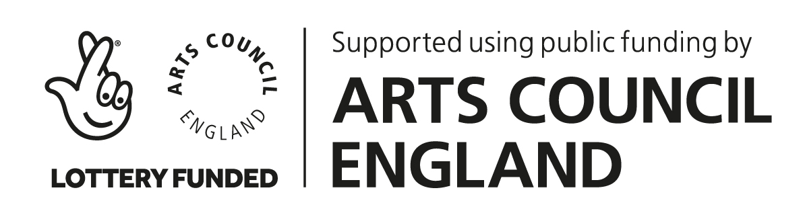

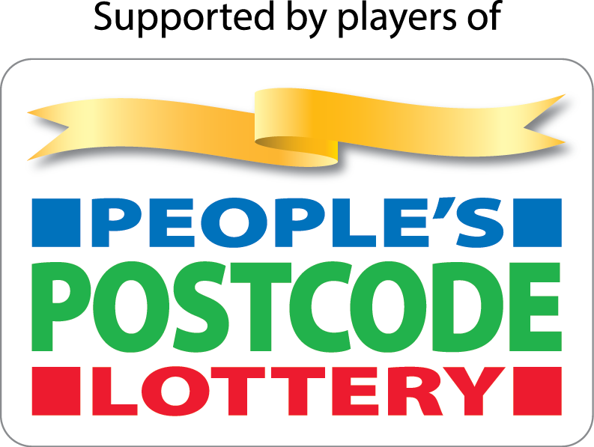
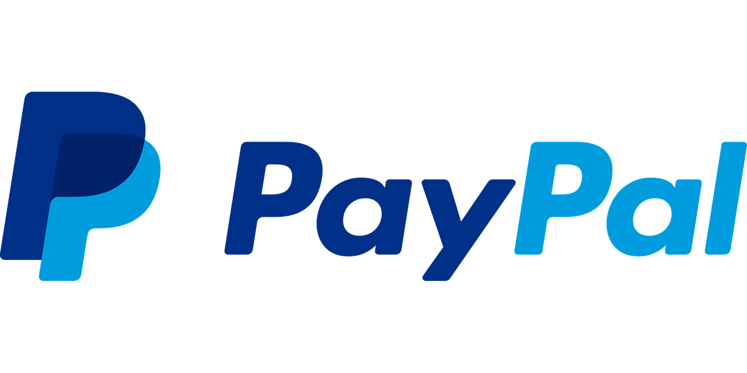

The National Foundation for Youth Music
Studios 3-5, Swan Court, 9 Tanner Street, London, SE1 3LE
Registered charity number: 1075032
Limited company number: 03750674

youthmusic.org.uk

