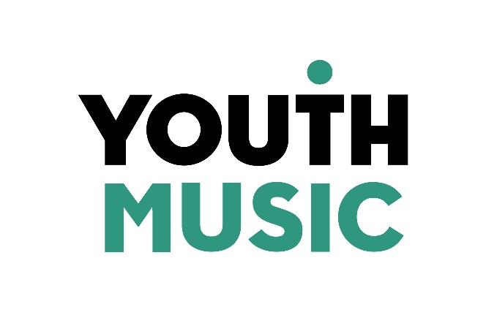

Access Fund Application Form

This fund is available for applicants who identify as Disabled and need additional access support to make an application to Youth Music. All survey questions marked with an asterisk require an answer.
Please email your answers to finance@youthmusic.org.uk. Alternatively, you can record your answers as a video or voice note and then email the file to finance@youthmusic.org.uk.
Please remember to attach a copy of a recent current account statement.
If you would find it easier, you can submit your application by completing the form in SurveyMonkey. Click here to access the SurveyMonkey version of the application form.
We will aim to get back to you with a decision within 5 working days of receiving your request.
If you need further support to apply to this fund, or if you have any questions, please contact the Grants & Learning Team by emailing grants@youthmusic.org.uk or calling 020 7902 1060.

- Name*

- Organisation name*

- Organisation type:*

  - Charitable Incorporated Organisation
  - Community Interest Company (CIC)
  - Company Ltd by Guarantee
  - Company Ltd by Shares
  - Education: Academy
  - Education: Children's Centre
  - Education: Further Education College
  - Education: Nursery
  - Education: Pupil Referral Unit
  - Education: School
  - Education: University
  - Local Authority
  - Music Education Hub Lead
  - Music Service
  - Registered Charity
  - Sole Trader (only eligible to apply for the Incubator Fund)
  - Voluntary or Community Organisation
  - Other (please specify)

- Email address*

- Telephone number

- How would you like us to contact you if we have any questions about this application?*

  - Email
  - Phone call
  - Other (please specify)

- Which Youth Music Fund do you want to apply for?*

  - Fund A
  - Fund B
  - Music Education Hubs Development Fund
  - Incubator Fund

- Why do you need additional support to make a funding application to Youth Music?*

- How much money are you asking for? (Maximum request amount is £900 for a Fund A, Incubator Fund or Music Education Hubs Development Fund application, and £1,500 for a Fund B application.)*

- What will you spend the money on? Where possible, please include breakdowns of specific costs (e.g. paying a support worker for 3 days @ £250 per day).*

- Is there anything else that you would like to tell us?

- When you submit your answers, please attach a copy of your organisation’s most recent current account statement. (If your application is successful, the funds will be transferred into this account.)*

- By submitting this application, you confirm that you have read the Eligibility Criteria (click here to view the Eligibility Criteria), and that your organisation is eligible to apply for Youth Music funding.*

