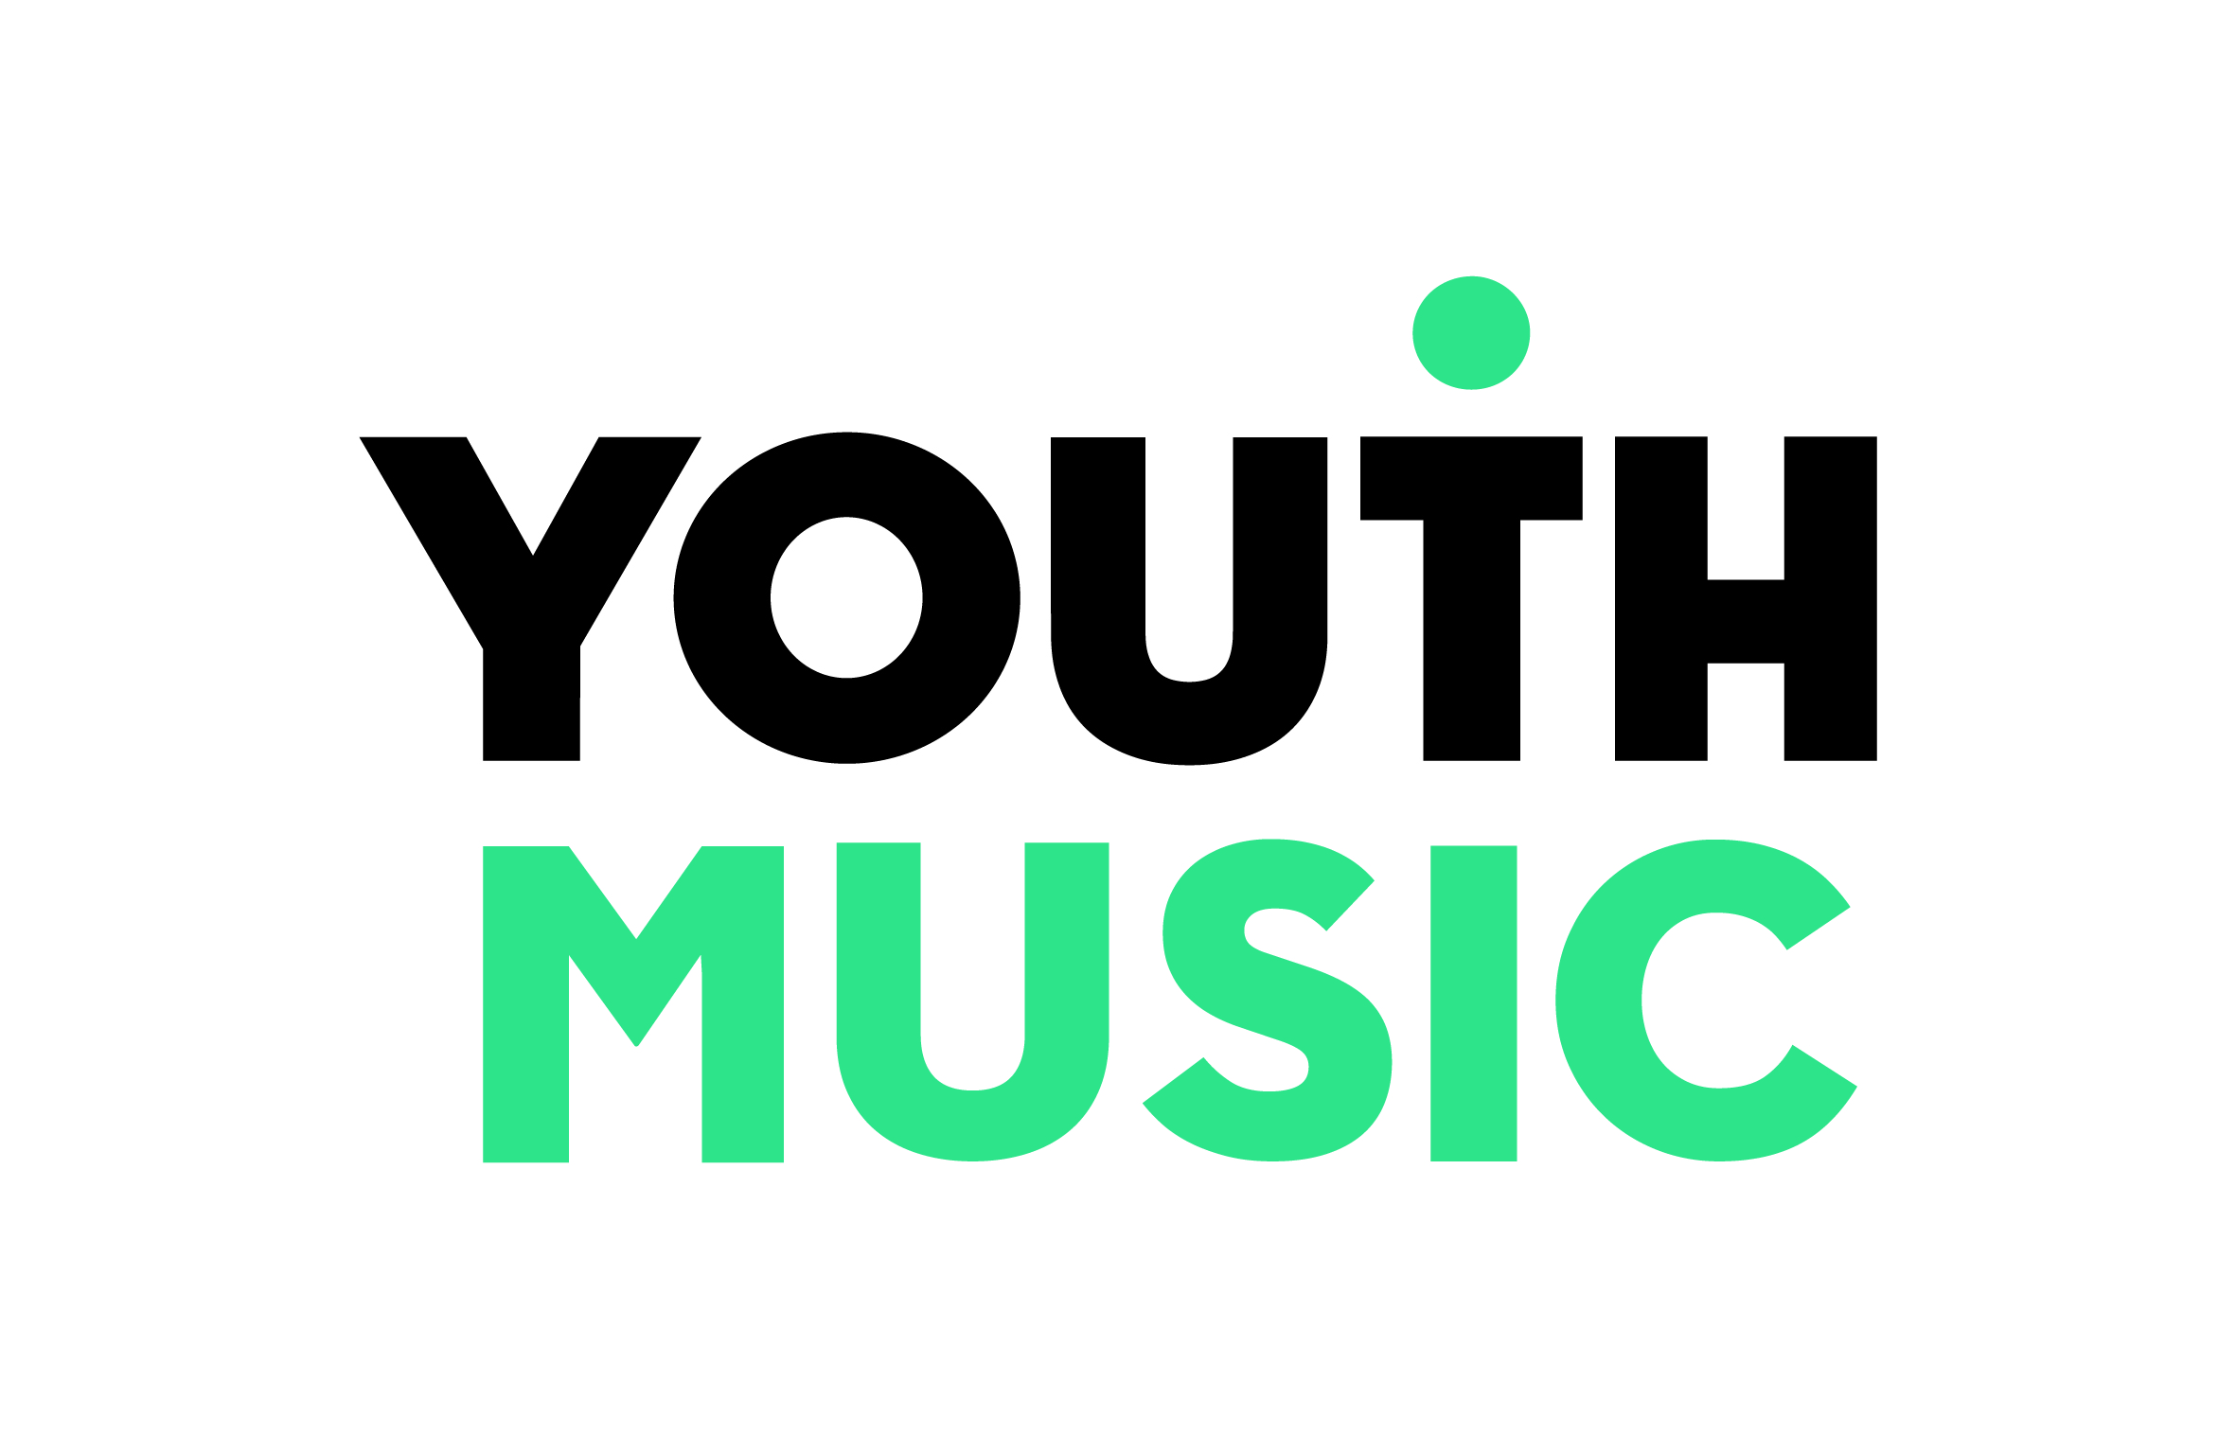
Evidencing how Music Education Hubs are becoming more inclusive
The following indicators and evidence sources will help Music Education Hubs to track and evidence the ways in which they are becoming more inclusive.
Indicator | Evidence sources
The Music Education Hub sees musical inclusion as a priority | Minutes of Hub meetings
 | Hub policy and strategy documents (e.g. business plan, inclusion strategies, fee remission policies)
 | Analysis of participant demographic data
 | Comparison of year-on-year budgets supporting inclusion activities
There is an increase in the sustained engagement in music education of groups of young people who previously did not participate | Participation records, enabling comparison with previous participation levels
 | Feedback from tutors and Hub partners
The Music Education Hub provides a greater range of accessible music making opportunities (e.g. accessible locations (including online), transport provided, cost barriers removed, inclusive ensembles etc.) | Schedules of Hub activities, enabling comparison with previous provision
 | Feedback from teachers and Hub partners
The Music Education Hub provides a greater range of diverse music making opportunities | Schedules of Hub activities, enabling comparison with previous provision
 | Feedback from teachers and Hub partners
The Music Education Hub provides new progression routes for children and young people which give opportunities to move between activities and organisations | Minutes of Hub meetings
 | Agreements with Hub partners and other music education providers
 | Feedback from teachers and Hub partners
The Hub lead organisation and key staff have an increased understanding of inclusion and are better able to support it | Self assessment by key staff and management of Hub lead organisation
 | Feedback from inclusion partner(s)
Inclusive practice is embedded in the Hub’s delivery work | Hub procedural documents e.g. job descriptions, lesson plans, appraisal documents.
 | Hub quality assurance documents, e.g. quality framework, practice observation records.

Indicator | Evidence sources
Inclusive practice is embedded in the Hub’s CPD offer | INSET records
 | Annual CPD schedule of activity
Increasing representation within workforce and/or governance of groups that experience or support exclusion | Business plan
 | List of hub partners, enabling comparison with previous
 | Annual analysis of workforce demographics
Increasing representation within partnerships of people or organisations that support inclusion | Partnership agreements
 | List of hub partners, enabling comparison with previous
Higher numbers and diversity of young people involved in youth voice and participation activities | Participation records, enabling comparison with previous participation levels
 | Schedule of annual youth voice and participation activity, enabling comparison with previous year

