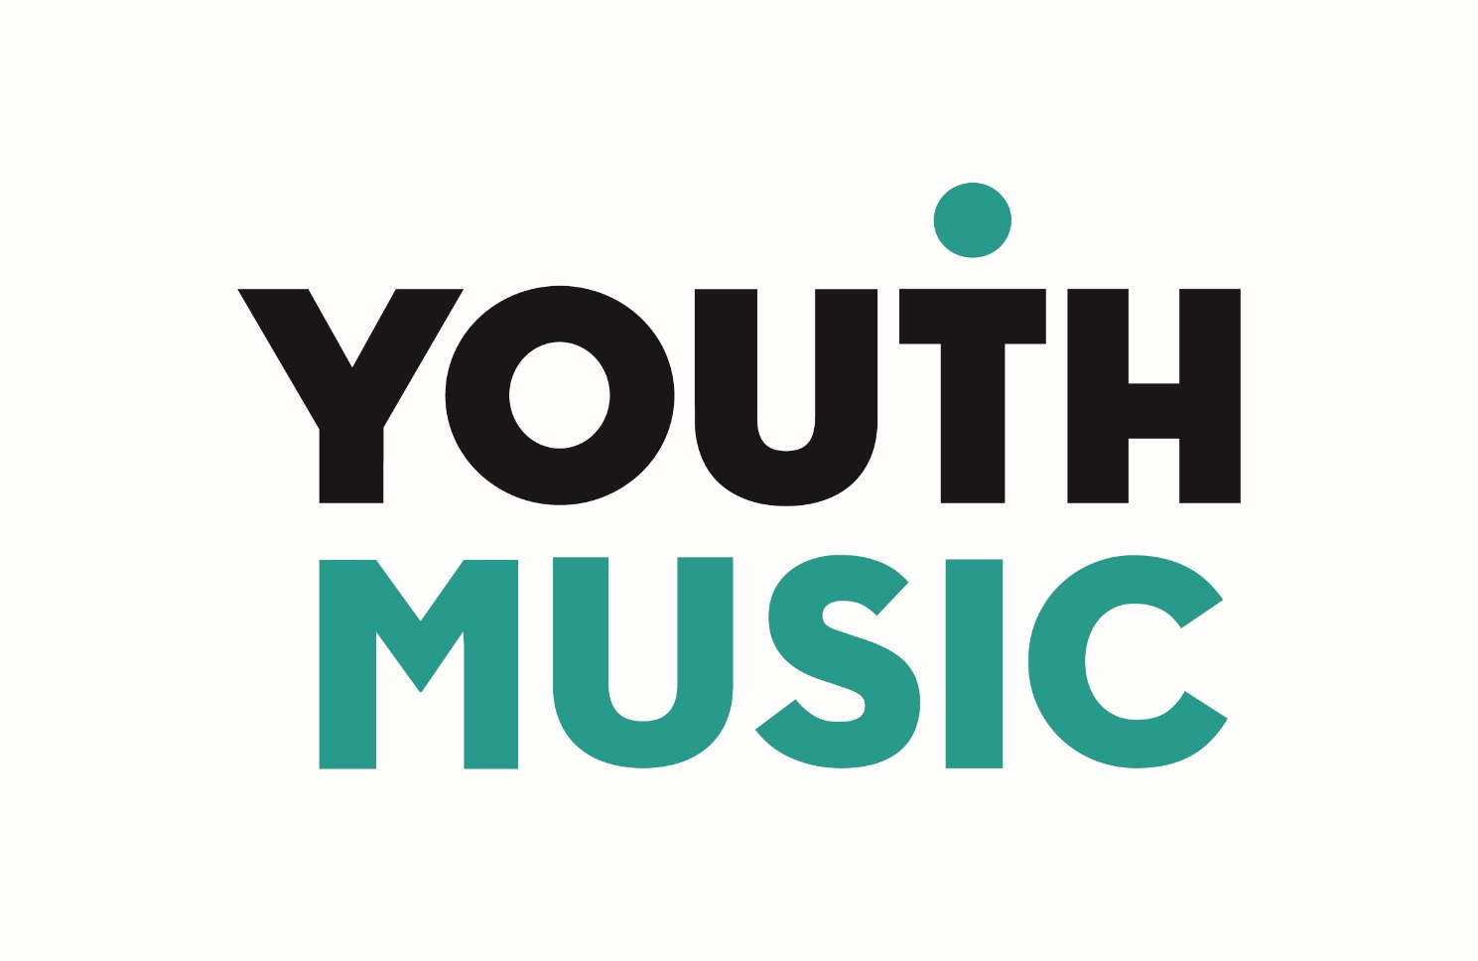

Fund C
Interim progress report (Year 3)

Organisation Name
Name of person completing form
Email address for queries
Reporting Period | 1 April 2020 to 30 September 2020

Guidance

The deadline for submission of this report is Thursday 31 October 2020. The report should cover the period 1 April 2020 to 30 September 2020.

The online report should be available in the grants portal within the next couple of weeks.

Thank you for taking the time to complete this requirement.

Attachments and other questions that you will be required to answer in the online form

- Budget spreadsheet (attachment – please update the budget spreadsheet you submitted previously)
- Latest management accounts
- Latest cashflow
- Headline statistics (to be entered into the online form)
- Declaration form (attachment)

What happens next?

This report and related attachments will be used to sign off on your Year 4 grant award. We’ll aim to notify you about the outcome of the Year 4 grant award by the end of November 2020.

If you have a significant underspend, we may require some follow-up conversations with you.

Section 1: Organisational update

Summarise how COVID-19 has affected your organisation. (400 words maximum)

Provide an overview of your organisation’s current priorities, strategy and operations. (400 words maximum)

How has (or will) your organisation and/or business model change as a result of COVID? (400 words maximum)

In relation to the Fund C programme, describe how your relationships with young people have changed as a result of COVID and your engagement plans over the next six months. (400 words maximum)

Describe the current state of play with your music education hub partners and your priorities for each relationship. (400 words maximum)

Section 2: Looking forward

Year four activity plan (500 words maximum).
At this stage, do you envisage any significant changes to your Year 4 activity plan or budget? NB in line with our coronavirus policy we will maintain flexibility if plans need to change.

