How COVID-19 has affected youth music-making: young people, staff and organisations
October 2020
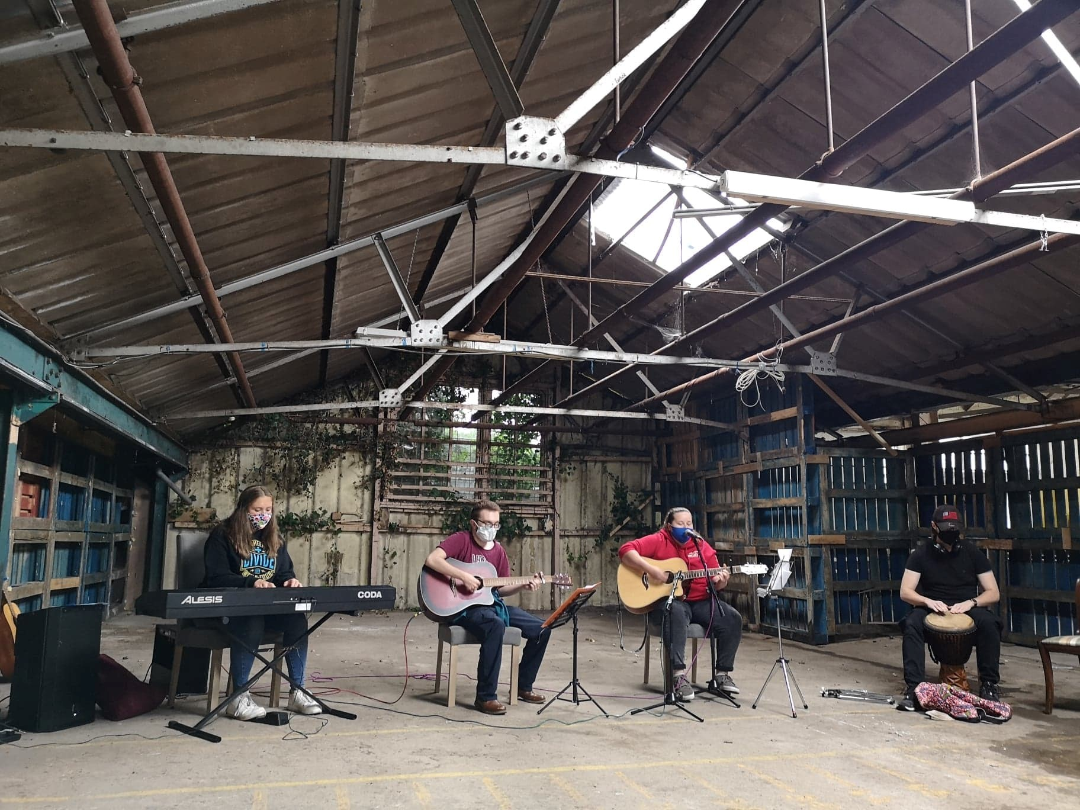

Introduction
Photo credit: YES Brixham
Never in Youth Music’s 20+ years of operation have we seen such a seismic occurrence as COVID-19 affecting the organisations and people we work with. Since lockdown began, we have been consulting with funded organisations, applicants and young people through conversations, focus groups, and a stakeholder survey. We have also gathered data through our funding application processes.
This report brings together a range of data sources to analyse and reflect on how COVID-19 has affected youth music work in England. This report focuses on the organisations and the workforce who support young people to access music-making, helping those who face a range of barriers. This work takes place in settings such as youth clubs, nurseries and arts venues, as well as more formal settings like schools.
In the following analysis we aim to bring together the data we have gathered to provide an up-to-date picture of the situation, to inform both our own work and that of our stakeholders. The findings do not cover the impact on the wider music industries as we do not have enough data in this area. We have published a separate piece exploring the impact of lockdown on seven emerging musicians.
Who did we hear from and when did we hear from them?
- Stakeholder survey – around 130 responses captured in July 2020 as part of our annual survey. Respondents include all those that have applied to Youth Music in the last year.
- Emergency Fund – 414 applications received between 10 April and 15 May 2020. Applicants applied under the priority areas of ‘organisational sustainability’ or ‘adapting and staying inclusive’.
- Fund A – 69 applications submitted in July 2020 for programmes to develop personal, musical or social outcomes through music.
The dataset includes information from Youth Music grantholders as well as organisations that have applied for Youth Music funding but were not successful. All respondents are based in England.
The report charts how the situation has changed and evolved since March 2020. It analyses what else is likely to change and the key things we need to consider as we adapt our work for a post-COVID environment.

Headlines and contents page

At-a-glance 4
Findings 6
1. Opportunities for young people have decreased significantly during lockdown. Unequal access has been made worse. The situation around COVID and lockdown has impacted young people’s mental health. 6
2. Digital provision will be more common in the future but cannot replace face-to-face work. 7
3. The majority of organisations were planning to restart delivery in autumn 2020. But this comes at additional cost and will reach smaller numbers of young people. 8
4. Organisations with a direct relationship with young people and/or their parents and carers have found it easier to continue or re-start their music operations. 9
5. There is high demand from organisations for support in fundraising and income diversification as well as digital, data, web and social media. 10
6. The freelance workforce – so vital to the delivery of music programmes – has been hit significantly. Many organisations have reduced freelance contracts. At the same time many clearly see it as part of their duty of care to support freelancers and have responded accordingly. 10
7. We will see a greater impact on staff on the payroll in the coming months, particularly with changes to the Coronavirus Job Retention Scheme 12
8. The majority of organisations are weathering the storm financially, helped by grant funding and government packages. But they are fearful for their medium and longer-term survival. 12
9. Organisations are concerned about burnout and the deteriorating mental health of their workforce. 13
10. There have been some positive developments that have arisen as a result of COVID-19, as organisations have been forced to work in new ways. 13
What do the findings mean for how we work now? 15
The economic and social impact of COVID means that inclusion has never been more important. Inclusion practices need to keep pace with new ways of working. 15
Organisations should continue to build on their new ways of working and thinking. They should consider ways they can ‘future-proof’ their business models under a range of COVID scenarios. 15
Supporting mental health and wellbeing should be embedded in all organisational planning and activities. 15
Funder strategies should address issues of medium-term income and covering core costs. 15

At-a-glance

Young people
- Only 14% of organisations reported working with the same numbers of young people over lockdown as in pre-COVID times.
- For those who did continue to work with young people, digital exclusion, mental health and digital fatigue were common issues.

“Many seem to have digital fatigue and really miss the sense of connection of face-to-face work.”

- 58% of organisations say they can adapt delivery to comply with social distancing ‘to a certain extent’. But …

“It's likely we'll have to work with smaller groups, so we'll either be reaching fewer people or working with people for a shorter amount of time.”

Staff and freelancers
- COVID has meant that 12% of organisations were unable to honour any freelance contracts over lockdown. A further 37% had reduced them.
- 43% of the funding invested through Youth Music’s Emergency Fund was to be spent on freelancers.
- By July, 12% of survey respondents had decreased staff salaries, and 27% had reduced staff hours. 5% had made staff redundant; and a further 8% were planning redundancies.
- Staff burnout and mental health is an issue:

“We have stayed active throughout the crisis …it has taken its toll on the team … there is a worry that come autumn 2020 we may be completely burnt out.”

Organisations
- Many organisations had weathered the initial storm, but have “significant concerns about the funding landscape as we emerge from COVID”.
- 8% of organisations responding to the survey are at risk of closure in the next year.
- 30% of survey respondents are currently using their reserves.
- 46% of Emergency Fund applicants had reserves of less than 5% of their annual turnover.
- 60% of organisations want help with funding and income diversification.

“Our main challenge, now and into the future, is securing unrestricted income to cover core costs.”

Findings

Opportunities for young people have decreased significantly during lockdown. Unequal access has been made worse. The situation around COVID and lockdown has impacted young people’s mental health.

It’s clear that the opportunities for children and young people’s music-making decreased significantly during lockdown. In the stakeholder survey:
- 63% reported working with fewer numbers of children and young people.
- 23% hadn’t engaged young people since the beginning of lockdown.
- Almost half of organisations (45%) reported reducing their services.
- Only 14% of organisations reported working with the same numbers of young people in lockdown as before.
Young people facing barriers were more likely to miss out. Poverty, digital exclusion and ill-health (perhaps as a result of being Disabled or being in hospital) are common exclusionary barriers that have been made worse as a result of the pandemic.
“Our barriers have been:
- young people having necessary technology
- a suitable place to work online
- confident to engage online
- no music equipment at home
- young people are in care and not allowed to engage online.”
Poverty and digital exclusion meant young people not having laptops and devices, WiFi or data, or a suitable space to work. Almost 15% of the funds awarded through the Emergency Fund went to equipment or IT for young people or staff. Some of this was spent on hardware but there was also a significant proportion that was used to purchase phone data to help young people connect.
Many applicants to the Emergency Fund explained that they were distributing food to young people and families in their local area. Findings in a recent report by Positive Youth Foundation (a Youth Music funded organisation based in Coventry) showed that 50% of the young people they surveyed said COVID had a negative impact on their eating patterns. This was cited as being mainly due to family finances or lack of access to food. As face-to-face work begins to restart, this is something that providers should be mindful of as families’ financial situations are likely to worsen over the coming months.
There were lots of comments about young people’s mental health and digital fatigue, calling for a high degree of careful planning to ensure music activity doesn’t exacerbate existing issues:
“Mental health - many of our young people (especially males) have found that the longer lockdown continues the less motivated they feel to engage online. Many seem to have digital fatigue and really miss the sense of connection of face-to-face work.”
“working remotely is unsatisfying and anxiety inducing for many.”
“For our community based activities we are very aware that many of our participants have mental health conditions as well as other ongoing health conditions and considerations, so we need to be mindful that people aren't going to be excluded from taking part and that we aren't encouraging them to take extra risks to attend.”

Digital provision will be more common in the future but cannot replace face-to-face work.

The speed at which organisations reacted to lockdown and put in place a digital offer is to be commended. Revisions to safeguarding policies to incorporate digital safety happened at pace (this article from an online session on safeguarding provides an overview of the key considerations that were being discussed at the time).
We asked organisations how they had continued working with young people during lockdown.
Figure 1: Stakeholder survey responses to the question ‘how have you continued working with children and young people?’

Zoom was the most common online conference platform being used, but a wide variety of different platforms were mentioned including social media platforms and online learning platforms.
“We have held lots of Zoom sessions each week to work on song-writing, theory, instruments, composition and music technology.”
“Lessons via Skype, Zoom etc. Pre recorded video lessons available on Youtube. Sharing our work and inspiring work from other organisations via social media, which some of our parents follow.”
“We host IGTV Beatbox Battles which are popular with the group.”
“Recording videos to send to young people with their requests.”
“Zoom calls, Instagram group chats, setting daily creative challenges on social media…”
A significant proportion were using phone calls to engage young people – 42%. And home deliveries and the postal service have been important ways to overcome digital access issues.
“With news and activity letters to younger children - not all families locally access the internet!”
“...dropping off music and arts activities and resources to young people, delivering food parcels.”
“By post - we are sending musical care packages out to young people that can be used even if they have no access to the internet.”
There are challenges of inclusivity associated with the new digital offer. Not just about access to equipment, data and a space to learn, but also the challenges of engaging over a digital medium:
“individual circumstances/needs mean that Zoom isn't appropriate or accessible for all young people and there are challenges in catering for every type of learner and musical interest … group sessions over Zoom require a lot of concentration for [young people] and it can be harder to manage group dynamics; for those that might struggle in normal group circumstances, Zoom can be frustrating and challenging.”
Many were keen to reinforce that digital provision is not a replacement for face-to-face interactions. In particular the social aspect of face-to-face delivery has been hard to re-create:
“It's been difficult to reach young people who would normally come to our sessions for the social aspect as well as the musical side.”

The majority of organisations were planning to restart delivery in autumn 2020. But this comes at additional cost and will reach smaller numbers of young people.

The majority of stakeholder survey respondents – 68% – expected to resume delivery in autumn 2020. Fifteen percent said that delivery was unlikely to start before spring 2021. But the new normal won’t be the same as before. The majority of organisations in the stakeholder survey – 58% – said they could adapt delivery to comply with social distancing ‘to a certain extent’. Only one-third said they could comply ‘to a great extent’. Seven percent said they would be unable to adapt at all.
Organisations are facing additional costs to manage the COVID risk as they restart delivery, particularly for staffing and venues as they move to a socially distanced delivery model. The majority of stakeholder survey organisations reported that they will need to work with fewer children and young people.
“We have had to change premises to be able to socially distance, a move that will cost us a lot before we can see any benefit.”
“Barriers to re-starting… lack of money! We have a good big venue & facilities but would need more staff plus more cleaning.”
“It's likely we'll have to work with smaller groups, so we'll either be reaching fewer people or working with people for a shorter amount of time.”
This was also reported in the latest round of Fund A applications to Youth Music:
“…the main impact is on the number of young people we can expect to work with.”
In planning to restart delivery, many people have been confused about which set of government guidelines to follow, as several could apply to their work. There are separate guidance notes for schools, for the performing arts, for out of school hours activities, and for youth sector activities. To add to this confusion, there have been contradictions between the different sets of guidance, for example in relation to group sizes and use of face masks.
Some organisations face greater challenges than others in restarting delivery. In particular organisations who have a large proportion of Black or Asian staff, who have been disproportionately affected by the health risks from COVID. Others facing significant challenges are those working in high risk settings (e.g. hospitals) where restrictions continue to be imposed.
Organisations cannot respond to demand in ways they used to. They have had to find ways to manage demand, for example by introducing booking systems to attend. Some forms of music delivery have proved popular in the past but can no longer be run in the same way:
“The most challenging aspect of adapting our work is looking at our open-access sessions - pre-COVID we could see 50 young people in our centre …we are still working out how we can realistically run open-access sessions safely.”

Organisations with a direct relationship with young people and/or their parents and carers have found it easier to continue or re-start their music operations.

Almost one-quarter of organisations in the stakeholder survey hadn’t worked with children and young people during lockdown. How they reach children and young people has played an important factor in the extent to which they can engage participants, both during lockdown and in re-starting delivery.
Forty percent reported that they reached children and young people through a referral agency or a partner organisation. Reaching young people has become more tricky if organisations do not have a direct relationship with young people and their parents or carers. This takes away a level of autonomy as organisations are dependent on their partners for a green light to restart delivery. Schools and hospital settings were highlighted as particularly challenging settings for restarting delivery.
“We're somewhat beholden to schools in terms of abiding by their measures which will impact what we can and can't do and is still up in the air.”
“All of our work takes place in hospitals which are currently closed to any visitors.”

There is high demand from organisations for support in fundraising and income diversification as well as digital, data, web and social media.

At the start of lockdown we saw great demand from organisations to come together as peer networks. Youth Music ran a series of online networks, regularly engaging 20-30 people as well as speaking to 40 participants in an online focus group to inform our initial COVID response. The sense of being ‘in it together’ and hearing from other organisations grappling with the same challenges seemed to provide some comfort. People also had very practical things they needed to learn in order to adapt their practice, for example in relation to new forms of safeguarding, and online facilitation.
A few months on, the greatest organisational support needs cited in the stakeholder survey were fundraising and income diversification (60%) and digital, data, web and social media (43%). These were significantly higher than the next-ranked options.
Figure 2: Stakeholder survey responses to the question ‘what type of business support is your organisation most in need of at the moment?’.

Resilience / crisis management mentoring and coaching

The freelance workforce – so vital to the delivery of music programmes – has been hit significantly. Many organisations have reduced freelance contracts. At the same time many clearly see it as part of their duty of care to support freelancers and have responded accordingly.

Youth Music’s coronavirus policy for grantholders made clear that we wanted to see the workforce protected through our grant, and in particular the freelance workforce. Freelancers are vital to the delivery of youth music work. This is exemplified by the chart below, which shows the proportion of freelancers versus payroll staff in organisations that were funded through the Emergency Fund. Dark blue representsg the freelance proportion of the workforce, and light blue the staff on payroll. It shows that the majority of staff are freelancers and that the majority of organisations contract greater numbers of freelancers than staff on the payroll. 43% of all the money invested through the Emergency Fund was to be spent on freelancers.
Figure 3: chart showing the proportion of staff on the payroll to freelance workers in successful Emergency Fund organisations (light blue represents payroll, dark blue represents freelancer positions).

We wanted to find out about the extent to which organisations had been able to honour freelance contracts.
Figure 4: Stakeholder survey responses to the question ‘if you had contracts in place with freelancers prior to COVID-19, have you been able to honour them financially?
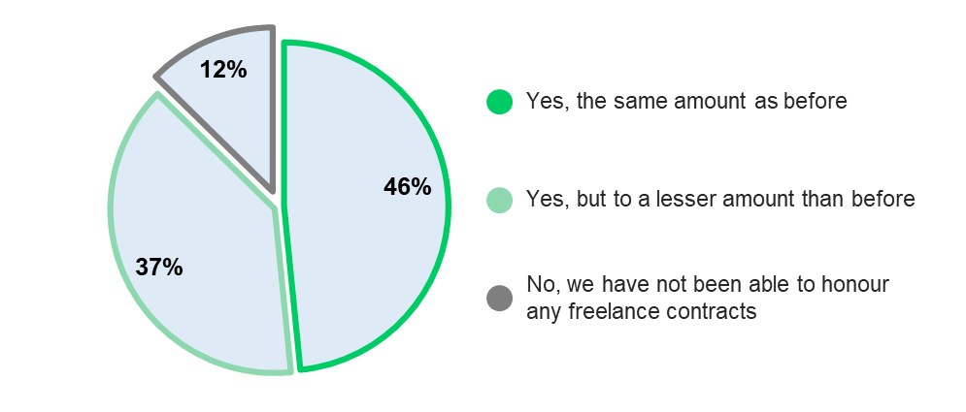
Almost half of respondents (46%) had managed to honour their freelance contracts, but more than a third (37%) had to reduce contracts and 12% reported cutting them completely. Elsewhere in the survey, 38% of respondents stated that the financial implications of COVID means that they will have to revise future freelance contracts.
“It was very important to us to be able to honour financial commitments to freelancers as much as we could”
Some of the freelance workforce continued to be in demand as organisations moved their activities online. Several organisations reported ways in which they had strived to support freelancers, for example by contracting them to undertake other activities and bringing forward future payments. One organisation said they provided a financial support package.
Many organisations talked of honouring existing contracts but were worried about their ability to provide future work.
We know from other sources that many freelancers have slipped through the net of the government’s self-employed scheme. People who are new to freelancing or returning to it, or those doing a mix of freelance and payrolled work in particular were vulnerable. The financial support packages offered by Arts Council England and others for freelancers are welcomed. But this is a short-term solution to the problem, and organisations who employ freelancers do need to think about how they can best support this vital part of the workforce.

We will see a greater impact on staff on the payroll in the coming months, particularly with changes to the Coronavirus Job Retention Scheme

Twelve percent of stakeholder survey respondents reported having decreased staff salaries, and over one quarter (27%) had reduced staff hours. In July when the survey was open, only five percent had already made staff redundant, but 8% said they were planning to make redundancies. Organisations reported grappling with difficult choices. One reported reducing staff salaries in order to prevent further redundancies.
Changes to the Coronavirus Job Retention Scheme (often referred to as the furlough scheme) may result in a cliff edge, as revenue streams have not recovered to pre-COVID levels. This will force restructures and redundancies. The scale is as yet unknown, but two in five organisations in the stakeholder survey reported using the job retention scheme.

The majority of organisations are weathering the storm financially, helped by grant funding and government packages. But they are fearful for their medium and longer-term survival.

Sixty percent of organisations in our stakeholder survey had seen their main income sources reduced. Thirty percent reported currently using their reserves. This is significant because many organisations hold a low level of reserves – almost half of applicants to our Emergency Fund (46%) had reserves of 0-5% of their annual turnover.
Eight percent of stakeholder survey respondents reported being at risk of closure in the next year. In this section of the survey many people reported being worried about their financial survival in the coming months and years:
“I have significant concerns about the funding landscape as we emerge from COVID. Many major funds are still closed to 'normal' applications; and when they do re-open I expect they will have reduced resources due to the value of the stock market as well as having spent reserves on COVID funding streams. This could have a significant impact on our organisation from summer 2021 onwards.”
“We have weathered the past four months fairly well, receiving emergency funding to make up for lost income and adapting our services to continue delivery as much as possible. However, I think the real challenge will come later in the year as it's unlikely that our usual sources of earned income will be back to full capacity for quite some time.”
“Our main challenge, now and into the future, is securing unrestricted income to cover core costs.”
Analysis of the Emergency Fund budget breakdowns showed over one-third of budget expenditure (34%) was planned to cover fixed costs including salaries, rent and overheads. We saw from the Emergency Fund applications that many organisations fund their core costs through earned income. Addressing concerns around core funding and future income are two key considerations for funders and investors.

Organisations are concerned about burnout and the deteriorating mental health of their workforce.

Many people reported working additional hours since COVID hit. Adapting activities, securing income, developing new policies and reforecasting finances have all put additional strain on organisational capacity. This has taken its toll on individuals working across different levels and roles:
“The impact on the amount of coordination time …has been HUGE and had to be managed within our staffing structure without any additional project funding. Though we are proud to have been able to keep activities going, this has been incredibly draining on our staff for such a long period.”
“We have stayed active throughout the crisis supporting young people via online activity and engaging with new participants. It has taken its toll on the team though particularly senior management … there is a worry that come autumn 2020 we may be completely burnt out.”
“Delivering online has definitely taken its toll on our facilitators. They've adjusted brilliantly but we've found it takes a different energy and can be exhausting in a whole new way.”
The personal welfare of staff was clearly in the minds of respondents in the stakeholder survey. There was little information provided about what actions had or should be taken in response. This could suggest that more proactive action is needed in this area.

There have been some positive developments that have arisen as a result of COVID-19, as organisations have been forced to work in new ways.

“It has given time for reflection and strategic planning even though financially we have been hit hard.”
There have definitely been some positive developments in the last few months. Organisations reported upskilling staff to work in new ways, taking more time for planning and strategy, and increasing their digital offer. In a few cases, working digitally has led to better outcomes:
“…on the whole the work we have done during this time feels like it has gone 'deeper' as young people find communicating via digital means so natural. We have been able to do pastoral work in new and effective ways.”
“Some aspects have worked better remotely so we will pick the best bits of each model to go forward with.”
One organisation reported an increase in voluntary support from staff who had been furloughed by other charities. A small minority of organisations in the stakeholder survey (5%) had seen an increase in income.

What do the findings mean for how we work now?

The economic and social impact of COVID means that inclusion has never been more important. Inclusion practices need to keep pace with new ways of working.
- If the first phase of coronavirus has been about adaptation, we now need to turn our attention to inclusion. Reviewing what is and isn’t working and who is and isn’t being engaged could be a good starting point.
- Youth Music will continue to advocate for inclusion in music education as vital to the new ways of working, and will collate guidance and examples of good practice.
- Where they are not already doing so, organisations should consider how they can ‘poverty-proof’ their work with young people: for example by loaning instruments free of charge, arranging transport to sessions, and providing food and refreshments.

Organisations should continue to build on their new ways of working and thinking. They should consider ways they can ‘future-proof’ their business models under a range of COVID scenarios.
- As we move into the next phase, organisations should continue to evolve their new-found ways of working and thinking.
- Digital learning in music education has been transformed. What other practices need to be change as we move forward?
- The organisations who were quick to adapt have been more likely to see good engagement with young people, and to have had the ability to secure additional or emergency revenue. Those who have found it difficult to adapt may wish to consider whether they need to work differently in the future.
- With fewer resources available, partnerships and mergers may be the way forward for some.

Supporting mental health and wellbeing should be embedded in all organisational planning and activities.
- COVID transmission risk has put physical health at the forefront of planning. Mental health is equally important.
- We will continue to feel the effects of COVID for months and years to come, and many things will get worse as the recession kicks in. People’s livelihoods are at risk and organisations will need to find ways to survive.
- Care needs to be taken to support the mental health of individuals and this should be at the forefront of all policy and practice.

Funder strategies should address issues of medium-term income and covering core costs.
- Funders should be applauded for their role in supporting their grantholders through COVID, and the pace at which they made emergency funding available.
- Over 350 funders have signed up to a pledge to ‘stand with the sector’, promising flexibility in budgets and grant requirements. This way of working now needs to become the norm, given the unpredictable nature of the current environment.
- Funders need to adapt their programmes to support organisations to transition their business models and provide vital core costs to the grantholders that are vital to helping them realise their mission.

The National Foundation for Youth Music
Studios 3-5, Swan Court,
9 Tanner Street, London,
SE1 3LE
Registered charity number: 1075032
Limited company number: 3750674

