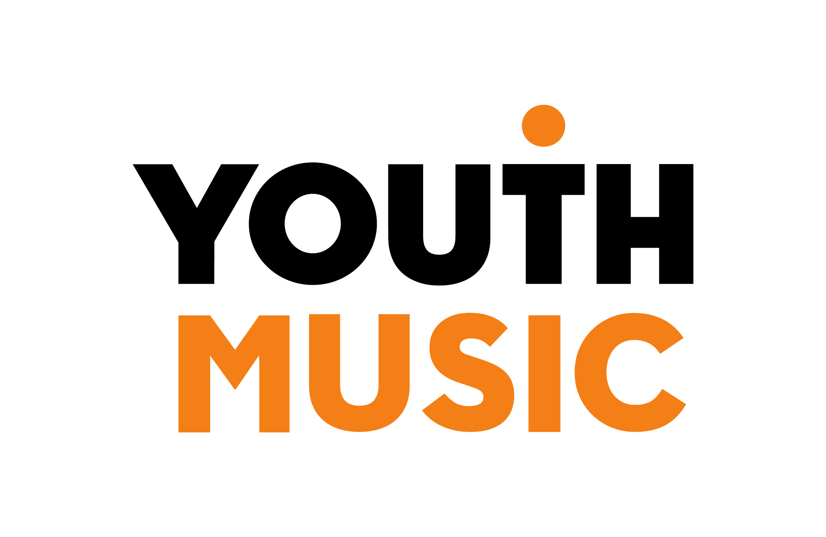
Guidance for applying to Youth Music’s Fund A

Contents
1. About Youth Music 3
2. Fund A summary 3
What do we mean by children and young people facing barriers? 3
Access support to make an application 4
Access fund - support for Disabled applicants to make an application 4
3. Fund A eligibility 5
Organisational eligibility checklist 5
Project eligibility checklist 5
Projects working in and with schools 6
Music Education Hubs 6
4. Application process 7
Application form 7
Assessment 7
5. Project design 9
Request amount 9
Project length 9
Youth Music’s priority areas 9
Your project must include the following activities: 10
COVID-proofing 11
6. Budget guidelines 12
Overview 12
Direct costs 12
Capital costs 12
Indirect costs 12
Match funding 13
7. What happens next if my application is successful? 14

About Youth Music
We're a national charity supporting young people's lives in music. Equity, diversity and inclusion drive our vision and mission. We want to equalise access to music: we focus on those who would otherwise miss out because of who they are, where they live, or what they're going through.
Through our funding programmes we invest in music programmes for children and young people, and work that helps organisations to diversify and be more inclusive. Programmes funded by Youth Music work with children and young people of all ages, from babies and their families through to young adults up to the age of 25, using the power of music to support musical, personal and social development.
We support around 300 projects each year, reaching more than 80,000 children and young people and 4,000 people in the workforce.
Youth Music is funded thanks to the National Lottery via Arts Council England, players of People's Postcode Lottery, and support from donors, partners and fundraisers.

Fund A summary
Grants of £2,000 to £30,000 are available and the fund is designed to support:
- Music-making and music-making related activities for children and young people (aged 0-25) facing barriers,
and/or
- Workforce and organisational development to promote a relevant, diverse, and inclusive music offer for all children and young people.
Applications are made through our grants portal and deadlines for applications are available on the Youth Music Network.

What do we mean by children and young people facing barriers?
We support children and young people facing barriers because of who they are, where they live or what they’re going through. Because of the barriers they face (which can often be multiple and complex), many children and young people miss out, and this causes under-representation in music education. Research shows that the following groups of children and young people face increased barriers to music education:
- Disabled young people
- Those from less advantaged socio-economic backgrounds
- Black, Asian and Minority Ethnic people
- Trans and non-binary people
- Rurally isolated young people
- Young people involved with or at risk of involvement in the youth justice system
- Young people experiencing or at risk of homelessness
- Young people experiencing mental or physical ill health (including those in hospital or other healthcare settings)
- Young people with experience of the care system
- Young people who are not in education, employment, or training
- Young people with refugee or asylum seeker status.
This is not an exhaustive list. It’s highly likely that these barriers also lead to under-representation in the workforce, particularly in positions of power and influence.

Access support to make an application
Youth Music is committed to offering a clear and accessible grant-making process that is open to everyone.
We use an online application system. This system does not currently meet Web Accessibility Guidelines. We know that the system may be inaccessible to some people. It is not optimised for use with accessible technologies such as screen readers.
We are aware that our application process may make it difficult for some users to access our funding. We are working hard to remove barriers to make our application processes more accessible. If you have difficulty making an application, please contact us to discuss how we can help. Please email us on grants@youthmusic.org.uk or call 020 7902 1060.

Access fund - support for Disabled applicants to make an application
If you identify as Disabled and require additional support to enable you to make an application to Youth Music, you can apply to our Access Fund. We offer funding of up to £900 to cover any additional access costs that might be required for you to make a full application to Fund A. You should apply for this money before you start making your application.
Full details about how to apply to the access fund are on the Youth Music Network.

Fund A eligibility
Before applying to Fund A, please check that your proposed project and your organisation meet the eligibility criteria. You will need to meet all of these criteria to apply – this does not guarantee that your project will be funded.

Organisational eligibility checklist
If you can answer yes to all the following points, then your organisation meets the Fund A criteria.
Criteria | Page reference
Is a UK based organisation* that has a signed governing document | 5
Has been legally constituted and providing activity for one year, and has a set of accounts | 5
Has the relevant insurances** in place (including employers’ and public liability) and complies with all relevant statutory legislation | 5
Has a safeguarding policy** that is regularly reflected on and updated | 12
Current grantholders only – is up to date on reporting requirements | 6
*Please note that for Fund A we will not fund;
- Individuals and sole traders
- Profit-making programmes
**We don’t automatically request policies and insurance, but they should be available upon request.

Project eligibility checklist
If you can answer yes to all the following points, then your project meets the Fund A criteria.
Criteria |  | Page reference
Offers a music-related programme for children or young people facing barriers in England |  | 3 & 11
Meets one or more of Youth Music’s priority areas  - Early years  - Disabled young people  - Young adults  - Youth justice system  - Young people facing barriers  - Organisations and the workforce |  | 10
Seeks funding of between £2,000 and £30,000 |  | 10
Lasts between 6 and 24 months |  | 10
Is co-designed by children/young people |  | 11
Embeds the Youth Music Quality Framework |  | 11
Doesn’t include ineligible activities |  | 13
Includes an evaluation plan to reflect on project’s intended outcomes |  | 11
Includes plans to share learning from the project with others |  | 11
For a school-based project and or from a Music Education Hub lead organisation – meets the additional requirements |  | 6
Meets the budget criteria:  - Pays staff the real Living Wage  - Is predominantly for revenue costs  - Doesn’t include ineligible costs |  | 13
Match Funding | 10% (at least 5% must be cash match funding) | 13
 | Minimum match is not from Arts Council England or National Lottery funding

Projects working in and with schools
If you are applying for a schools-based project for pupils at Key Stage 1 or above, please note that we will not fund the following:
- Whole class tuition on the same instrument or group of instruments (e.g. strings)
- Individual tuition fees for young people to learn an instrument
- Work in secondary schools where there is no employed music teacher.
- Music curriculum activities that could be supported through Department for Education funding
- GCSE Music or A-Level Music

Music Education Hubs
If you are applying as a Music Education Hub lead organisation, your project must demonstrate:
- a targeted focus on reaching and engaging children and young people and / or workforce who are under-represented in your current offer
- a strong workforce development element that will help improve inclusive practice across and beyond the staff team (e.g. to the local workforce who may not be employed by the hub lead organisation)
- strong partnerships to help engage and support underrepresented groups.
Read our Guidance for Music Education Hubs for more support.
Current grantholders
If you currently have a Youth Music grant you are eligible to apply to Fund A, as long as you:
- Are up to date with all reporting requirements
- If you hold a current Fund A grant it will be complete (all activities finished and evaluation report submitted) before the new Fund A grant starts.
Organisations can hold a maximum of two Youth Music grants at any one time from Funds A, B or C (only one of which can be a Fund A) and organisations cannot hold more than £350,000 of active Youth Music grants at any one time.
Organisations seeking repeat funding are required to submit an application which will be considered alongside all others received in that round. Previous grant management and reporting will inform funding decisions.

Application process
Fund A is a one -stage process. The steps in the application process are as follows:
- Submit your Application form online via our grants portal by 5pm on the deadline date.
- Application form is assessed by Youth Music, and a decision is made about whether or not it is awarded funding.
- A notification email is sent.
  - If you are unsuccessful this includes feedback on your application.
  - If you are successful, this will outline next steps about how to accept your grant and receive your first payment.

Application form
You will be asked to tell us:
- Who you want to work with and where you want to work
- What the need is for your project – including how children and young people have been involved in project design
- What the intended outcomes of your work are, how you plan to evaluate your programme and how you plan to share the learning from your programme.
- The activities you want to deliver
- A budget for your project
- The experience you have in delivering this work
- Confirmation that you have a safeguarding policy in place that is regularly reflected on and updated.
- A copy of your most recent accounts.
You can download an example Fund A application form from the Youth Music Network.

Assessment
Youth Music will assess all Fund A application forms. We will assess:
- Eligibility: Does your project and organisation meet our eligibility criteria?
- Funding priorities: Is your project a good match for our funding priorities?
- Working with children and young people facing barriers: Are you planning to work with children or young people facing barriers; have they been involved in project design and will they have opportunities to continue to influence the project?
- Need: Do you have a clear understanding of the needs of your participants, and have you evidenced the need for your project?
- Outcomes: Have you chosen suitable outcomes that are based on need? Do you have a good evaluation plan in place?
- Activity Plan: Do you have a good activity plan in place and is it likely to achieve your intended outcomes? Will it give young people opportunities to progress?
- Sharing practice: Do you have plans to share the learning from your project with others.
- Track record: Do you, your workforce and any project partners have the right skills and experience to deliver this project?
- Quality Framework: Have you embedded the Youth Music Quality Framework in your application?
- Budget: Is it realistically and correctly calculated? Does it meet all the budget criteria (including match funding targets)?
- Safeguarding: Have you got a safeguarding policy in place that is regularly reflected on and updated?
- Financial checks: Have you provided recent accounts, and do they show good financial management? Do you have a good reporting history with Companies House and/or the Charity Commission (if applicable)?
- Current/previous grantholder: What’s the impact of your work? Have you submitted honest and reflective reports? Have you demonstrated good grant management?
After application forms are assessed, Youth Music carries out a ‘portfolio-balancing’ process to decide which applications will be awarded funding. During this process we review the type of work being proposed, where it will take place and the organisations who have applied. The majority of applications we receive are fundable, so the portfolio-balancing process helps us prioritise our decision-making. We try to balance national, regional and local needs to fund a diverse range of organisations that promotes a sustainable infrastructure for children and young people’s music.
This means that competition for funding will be higher - and therefore the success rate lower - in regions and priority areas from where we regularly receive a high number of applications, and where Youth Music has historically invested more. We will aim to provide information about levels of competition across our regions and priority areas.

Project design

Request amount
You can request between £2,000 and £30,000.

Project length
Your project should last between 6 and 24 months.

Youth Music’s priority areas
We have six priority areas. Your project must fit into at least one of these areas.
- Early years
For children aged 0-5 who face barriers to accessing music-making because of their circumstances or where they live. We encourage programmes that promote:
- Access to quality, creative musical experiences that support children’s developmental needs.
- Shared learning between early years specialists, music specialists and parents, so that all become skilled, confident and engaged in encouraging young children’s musicality.
- Workforce diversity.
- Disabled young people
We encourage programmes for disabled young people (aged 0–25) that:
- Ensure that they have equitable access to progress in music in a way that meets their needs and aspirations.
- Provide routes for disabled young people into the workforce.
(We use the term ‘disabled’ rather than ‘SEN/D’ in line with the social model of disability, which states that disabling barriers make life harder for disabled people, and puts the onus on society to provide the right support to overcome disabling barriers.)
- Young adults (16–25 year olds)
For young adults aged 16-25 facing barriers who want to take their music further, or for whom music can support wider personal and social outcomes. We encourage programmes that:
- Improve young people’s confidence, skills, social networks and emotional wellbeing as well as providing specific mentoring, networking and industry opportunities.
- Have been co-created with young adults.
- Increase and enhance engagement with employment, education and training.
- Youth justice system
For children and young people (aged 0-25) who are, have been, or are at risk of being involved with the youth justice system. We encourage programmes that:
- Are youth-led and offer culturally relevant and engaging music programmes that promote personal and social outcomes alongside musical development.
- Work in partnership with other organisations and agencies to support progression and ensure that young people’s needs are met.
- Young people facing barriers
For children and young people (aged 0–25) who face barriers to music-making due to their characteristics or life circumstances, or because of where they live. We encourage programmes that:
- Are youth-led and offer culturally relevant and engaging music programmes that promote personal and social outcomes alongside musical development.
- Work in partnership with other organisations and agencies to reach young people facing barriers and ensure that their needs are met.
- Organisations and the workforce
Work that benefits the people and organisations who provide inclusive music-making opportunities for children and young people (aged 0-25). We encourage programmes that support and encourage:
- Organisations to be innovative, resilient, and inclusive.
- A diverse workforce that is networked and skilled in inclusive practice with children and young people.

Your project must include the following activities:
- Music-related activities for children or young people facing barriers in England: Activities must be music related and offer children or young people opportunities to progress and develop their skills. This can include accreditation where appropriate.
- Co-design by young people: Young people should be active participants in planning the project activities and there should be ongoing opportunities for them to contribute to project design as the project is delivered.

- An evaluation plan to reflect on the project’s outcomes: Fund A projects must set two outcomes and must build evaluation activities into their activity plan and budget. More information about outcomes and evaluation can be found on the Youth Music Network.

- Plans to share practice: Fund A projects must have plans to share the learning from their project with others and must build sharing practice into their activity plan and budget. We are open to who you share with and how you share. You could share practice with other organisations, networks, or Music Leaders. How you share practice could include (but is not limited to) conferences, CPD for other organisations or individuals, social media platforms, visits/exchanges with other organisations, blog posts or articles. All grantholders are encouraged to actively engage with the Youth Music Network, for example by posting articles, job opportunities and events and engaging in discussions.

- Youth Music Quality Framework: A quality framework is a tool to help you understand, measure and evaluate quality in your work. Youth Music’s quality framework - Do, Review, Improve - gathers together all the criteria we believe demonstrate quality in a music-making session. We also have a version for use in SEN/D settings and with Early Years children. We ask all Fund A grantholders to use Do, Review, Improve to reflect on their practice. And we ask anyone applying to us for funding through Fund A to show how they would build it into their project.

You can use Do, Review, Improve for planning, peer observation or self-reflection. It’s not intended to be a test, and you don’t need to score yourself or rank yourself against others. Instead, the quality framework is designed to help you think about your practice and the principles behind it, and to identify areas you may wish to develop.
Fund A project are encouraged but not required to include the following activities:
- Working in partnership: Fund A projects are encouraged, but not required to work with appropriate partner organisations who add value to their project and organisation.
- Workforce development: Fund A projects are encouraged, but not required to offer training and professional development activities to their staff.
Organisations must be able to demonstrate:
- A safeguarding policy that is regularly reflected on and updated: Organisations should undertake regular risk assessments and update safeguarding policies and procedures as required, actively working to ensure that they provide a safe space for children and young people and their staff teams.

COVID-proofing
We recommend planning your delivery on the assumption that there will be some form of social distancing measures in place for the foreseeable future, and potential future lockdowns. We realise that this may mean working with smaller numbers of children and young people and may have additional costs attached, e.g. for the purchase of protective equipment, additional cleaning, IT equipment for staff or young people, or additional staffing. You should ensure that your budget considers the additional costs associated with social distancing measures and enables you to respond to future lockdowns.

Budget guidelines

Overview
All applications must submit a fully costed budget.
The budget should be broken down into three areas.

Direct costs
- Costs that are as a direct result of the activity (e.g. music leader hours, project manager, venue hire)
- All staff should be paid at or above the real Living Wage.

Capital costs
- Costs for physical items that have a use which extends beyond the project or that could be sold on once the project has been completed (e.g. instruments or computers).
- Total capital costs should not exceed 15% of your overall request from Youth Music.

Indirect costs
- The day-to-day overhead costs that help to support the proposed project, and support other programmes or activities that your organisation provide (e.g. human resources, office rent and utilities, IT systems, governance, insurance, and audit fees).
- Youth Music offers full cost recovery to ensure that grants awarded cover the true costs of running a project. This means that you can apply for a grant to cover the direct project costs plus a relevant share of your organisation’s overheads (indirect costs).
- This toolkit from NPC is helpful for understanding the true costs of a project.

We are unable to fund the following expenditure:
- activities that have taken place before you have received confirmation of grant award
- costs incurred in making your application
- significant capital costs
- the purchase of land or buildings
- reserves, loans or interest payments
- VAT costs that can be recovered
- art forms that are not related to music
- Activities that promote party political or religious beliefs
- Activities that other statutory bodies would be expected to fund
- GCSE Music or A-Level Music

Match funding
All Youth Music grantholdersare expected to bring in match funding. Arts Council England or National Lottery funding (e.g. Awards for All, Big Lottery Fund, Heritage Lottery Fund) cannot be used towards the minimum Youth Music match funding requirement.
There are two types of match funding which should be included in a Youth Music application:
- Cash match funding. This is an amount of money given towards your project, typically a cash donation from an individual, grant-making organisation or corporate sponsor. Some organisations also use earned income (e.g. ticket sales) and their own reserves as cash match funding.
- In-kind match funding. This is a non-cash contribution to a project. Most in-kind match funding can be categorised into three areas:
- Support associated with people and services (e.g. staff and volunteer time, waived/reduced fees and other specialist support).
- Support associated with premises (e.g. meeting space or venue hire in your own premises or at a partner’s venue, if they are provided free or at a discounted rate).
- Support associated with goods (any goods, equipment or supplies that are gifted or loaned to you; or any of your own equipment that you use on the project but don’t request funding for).
For Fund A the minimum amount of match funding you need to commit to raising is 10% total match funding (at least 5% cash match funding).
Further support with budgets and match funding is available on the Youth Music Network.
If you are successful in your grant application, you need to provide evidence of cash match funding. We don’t usually ask for evidence of in-kind match funding.

What happens next if my application is successful?

- You will be assigned a Grants and Learning Officer who will support you throughout your grant.

- Special conditions (if applicable)
We may request that certain requirements are fulfilled before we can make a final decision about your grant and issue your funding agreement. You may need to provide further documentation or make changes to your application form.

You will usually have 1-2 weeks to respond to special conditions.

- Funding agreement issued
Your Grants and Learning Officer will issue your funding agreement and an Initial Grant Requirements online form. These will be sent out with notification of your successful application.

- Initial Grant Requirements form
To complete your Initial Grant Requirements form you must upload your
- signed funding agreement (signed by 2 people in your organisation)
- evidence of bank details
- evidence of cash match funding
- authorised signatories mandate
- responses to any assessment panel recommendations.

- First payment
If your initial grant requirements are satisfactorily met your Grants and Learning Officer will process your first payment.

We endeavour to make the first payment within 30 days of the submission of complete Initial Grant Requirements.

- External Communications
We will ask you to use our logo on grant-related material and celebrate the grant on social media – guidance and materials are provided in our Grantholder Communications Toolkit.
We also encourage you to sign up to the Youth Music Network so you can post jobs, events and blogs about your project and subscribe to the Network Newsletter to be kept up-to-date with all the latest news.

