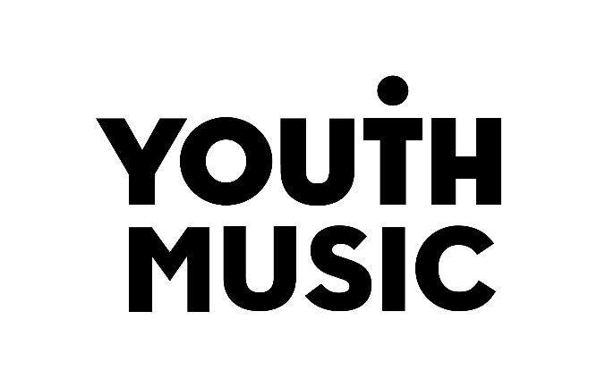

Plan, Do, Review
A guide to evaluating your Youth Music project.

Table of Contents
Introduction 3
Part 1: Plan 4
This guidance will help you to …. 4
How evaluation fits into the application and reporting process 5
What is an outcomes approach? 5
An outcomes approach 6
How evaluation data is used 7
Drafting your evaluation 9
Identify the purpose of your evaluation 9
Budget and resourcing 9
Drafting your evaluation plan 9
Types of data 10
Evaluation builder 10
How often to collect data 16
Types of data 16
Need help? 17

Introduction

The evaluation guidance is made up of three parts.

For Applicants:
- Plan: Creating an evaluation plan for your Youth Music application.

Remember: You only need to follow the guidance in this document to make an application, however you may find it useful to also read Do and Review.

For Grantholders:
- Do: Setting up and carrying out your evaluation plan.
- Review: Analysing and interpreting your evaluation data.

Part 1: Plan

Creating an evaluation plan for your Youth Music application.

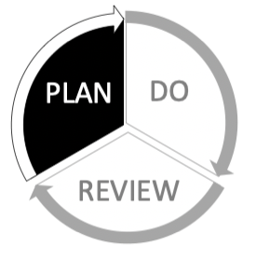

This guidance will help you to ….

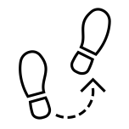
See how evaluation fits within the application/reporting process

Understand the principles of an outcomes approach

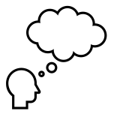
Think about your evaluation and resources

Choose your outcomes, outcome indicators and data collection tools

How evaluation fits into the application and reporting process

Application

In your application we ask you to draft your evaluation plan using an outcomes approach. You will plan the information you will collect about your activities, throughout the programme. This data will enable you to see how you are doing and help you to report to Youth Music.

Interim reporting

At an agreed stage we will ask you to reflect on the data you have collected so far. This will help you to see if you need to make any changes to improve your programme. You will share your findings with us in a short interim report.

Evaluation reporting

At the end of your programme, we will ask you to report on your work and to provide statistical information on your activities. Evaluation is about learning from experience and it is as useful to know what went wrong as what went right.

What is an outcomes approach?

Outcomes are the changes your project achieves. An outcomes approach helps you understand the relationship between what you do and why you do it. It helps you understand what is working and supports you to evidence change. Your project aim, outcomes and activities should all be related.

- Each of your outcomes should respond the need you have identified.
- Every activity you plan to deliver should relate to at least one of your outcomes.

All of your outcomes should align with the overall difference your project hopes to make.

Outputs are not the same as outcomes!

Outputs focus on the number of activities carried out. Outcomes focus on the changes that occur as a result of the activities.

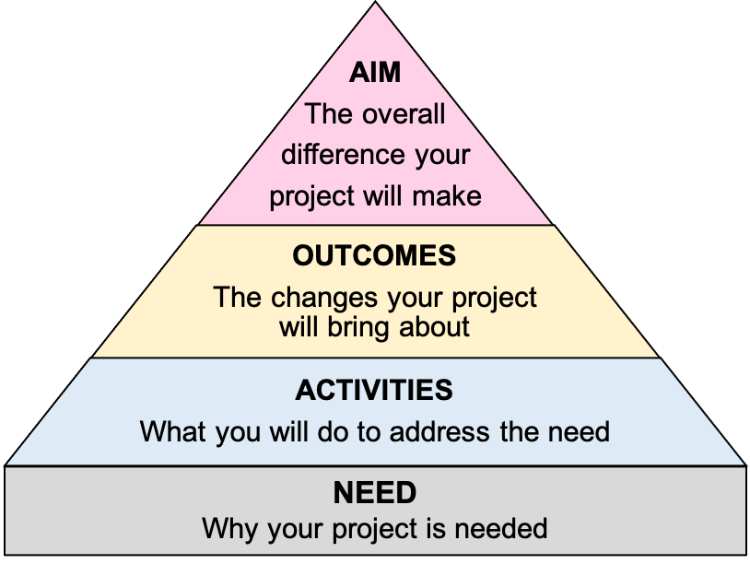

An outcomes approach
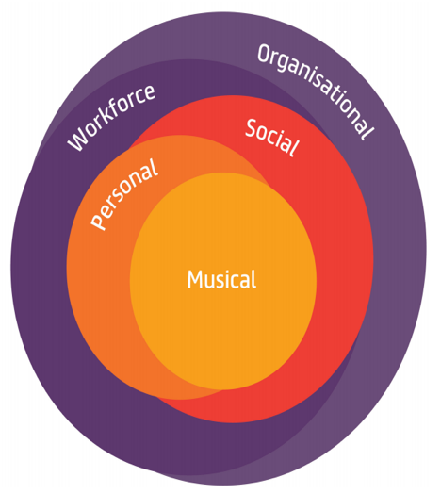
Youth Music supports organisations to take an outcomes approach to delivering projects. Outcomes are the changes your project achieves.

You decide what outcomes you think your project should achieve. You also decide how you will check to see if your project achieves these outcomes. Your evaluation plan captures this information.

Youth Music is interested in outcomes in 5 areas:

- Musical, personal and social outcomes for children and young people.
- Outcomes for the music workforce. (Changes in the way we work.)
- Outcomes for the organisations for which we work. (Changes in our organisations.)

How evaluation data is used

The information submitted by grantholders is used in a number of ways:
- To learn about the impact of our investment.
- To produce reports and resources.
- To identify what works and share what we learn with others.
- To inform how we make funding decisions and design our programmes.

Examples of how we share our impact:

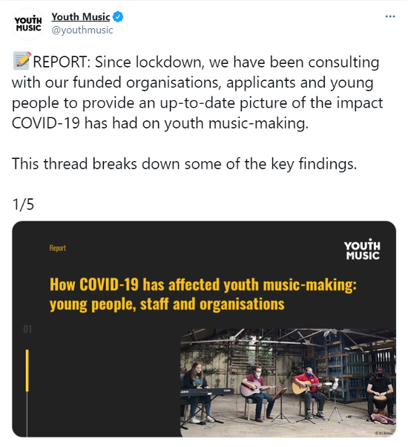

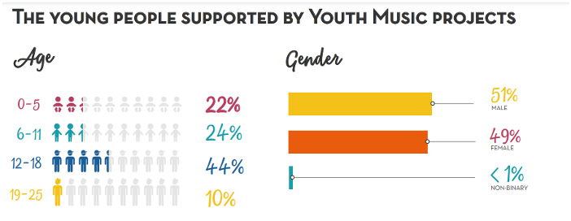

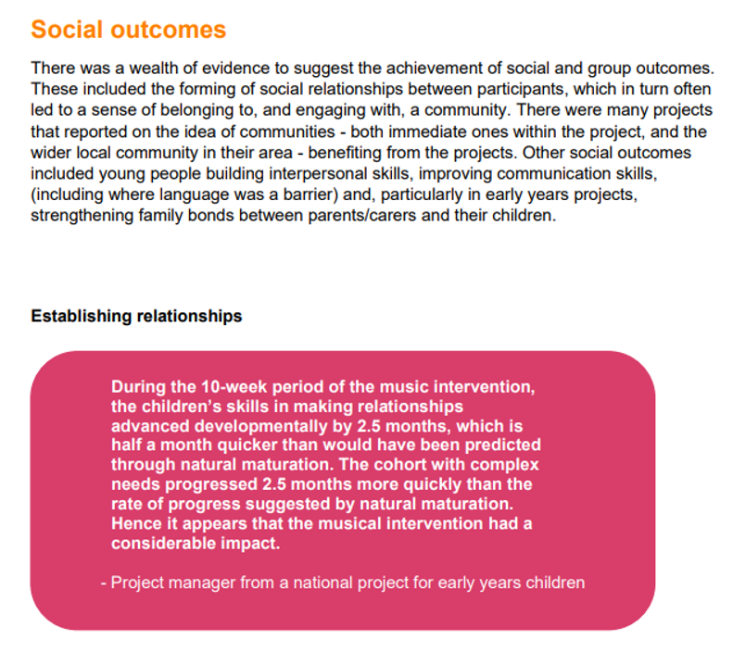

Drafting your evaluation

Identify the purpose of your evaluation

Evaluation can have different purposes. Think about who the evaluation is for and what you want it to explore. If your work brings about lots of different outcomes then think about which ones will be most useful to measure.

The purpose of evaluation in Youth Music funded projects is often a combination of the following:
- Learning and adapting – using findings to help adapt your work to the changing circumstances around you.
- Demonstrating impact – exploring whether your work brings about specific outcomes and showing to others how your work has made a difference.

Budget and resourcing

Your evaluation should be embedded in your project plan. You will need to allow time and resource to:
- Finalise your evaluation plan.
- Undertake data collection, storage and analysis.
- Present your findings.

You should include time and resource for this within your project plan and project budget.

You can appoint an external evaluator to help you with some or all of the process. This might be helpful if you want an external perspective or to fill a particular skills gap.

Drafting your evaluation plan

In your application to Youth Music, you will be asked to list your:

Outcomes - the changes your project wishes to achieve. These can be changes in behaviour, skills, knowledge, attitudes etc.

Outcome indicators - where you will look to identify change.

Data collection tools - what you will use to capture evidence of change.

Top Tips:
- Aim to keep your evaluation plan simple and focussed.

- Make use of existing processes and data collection where possible.

Types of data

There are two categories of data you are likely to use.
- Quantitative data helps you understand the scale or frequency of something. It often involves expressing amounts or proportions numerically.
- Qualitative data helps you understand opinions and experiences. It often involves describing a range of opinions through written narrative .

By collecting a mixture of quantitative and qualitative data, you can explore the depth and breadth of your outcomes.
- Quantitative data can help add scale and breadth to qualitative data.
- Qualitative data can help add context and depth to quantitative data.

Evaluation builder

You will be asked to track a set number of outcomes in your evaluation.

For each outcome, you’ll need to choose three outcome indicators and data collection tools.

You can use the menus on the following pages to help you do this.

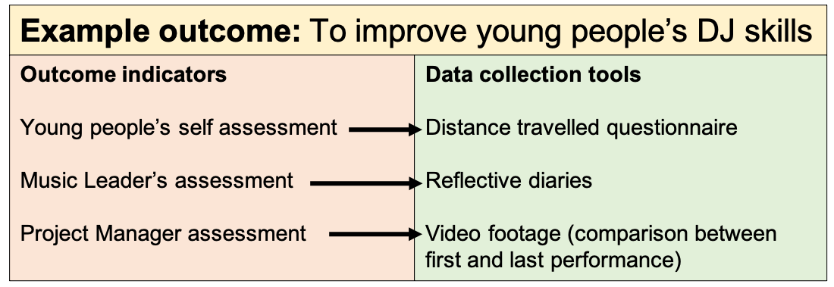

Musical outcomes builder

Musical outcomes relate to musical development in young people. This can include:
- Skills, knowledge and abilities
- Understanding or awareness of musical styles and approaches
- Ability to communicate ideas using music

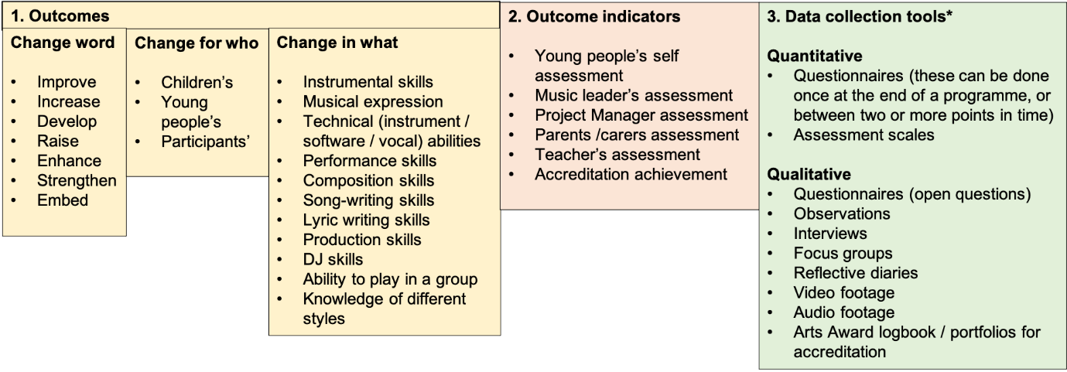

*Our data collection toolkit has examples of scales and questionnaires you can use to track musical development.

Personal outcomes builder

Personal outcomes relate to personal development. This can include:
- Skills, knowledge, abilities and behaviour
- How people feel about themselves
- Being able to do new things.
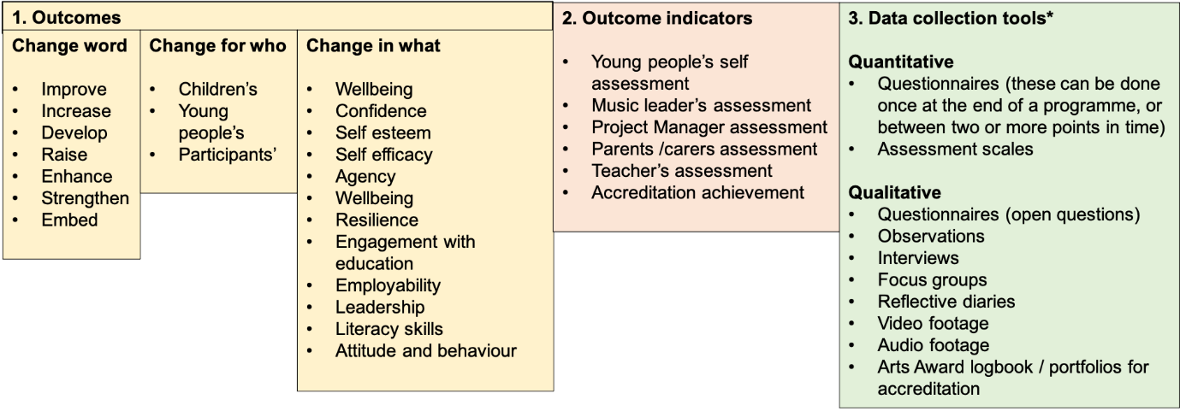

*Our data collection toolkit has examples of scales and questionnaires you can use to track changes in wellbeing, self-efficacy and agency.

Social outcomes builder

Social outcomes relate to changes in a person or group of people that can have broader benefits for people and society beyond the individual. These can include:
- Leadership, teamwork or interpersonal skills.
- Engagement with the community or services
- Interpersonal skills and relationships

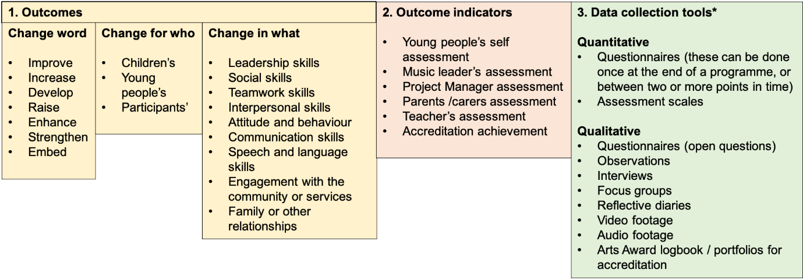
*Our data collection toolkit has examples of scales and questionnaires you can use to track changes in attitude and behaviour, leadership, social skills, teamwork and communication skills.

Workforce outcomes builder

Workforce outcomes relate to the skills, knowledge and personal development of the workforce employed on a project.

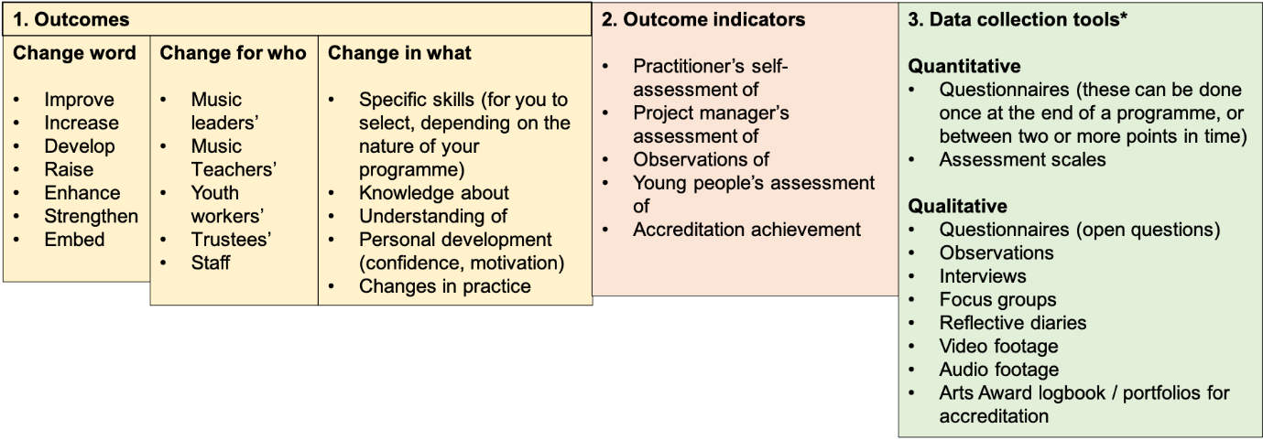

*Our data collection toolkit has examples of scales and questionnaires you can use to track changes in knowledge, skills, understanding and practice, as well as job satisfaction.

Organisational outcomes builder

Organisational outcomes refer to developments in your own or another organisation.

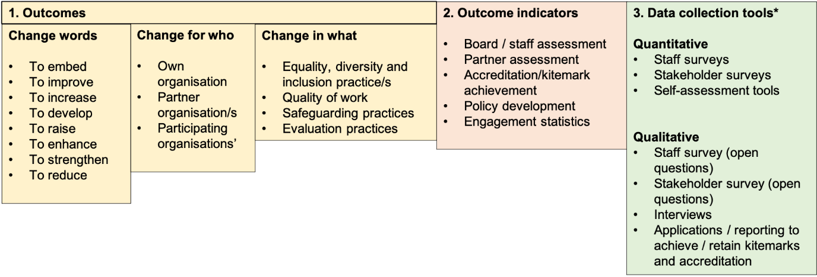

*Our data collection toolkit has examples of tools you can use to track changes in equality and diversity practice and quality. It also signposts to external tools to help you measure youth participation practice, safeguarding and impact measurement.

How often to collect data

More data does not necessarily lead to a stronger evaluation. The more data you collect, the more time you will need to spend analysing it. There are ways to streamline your data collection and analysis:
- Projects reaching large numbers of young people could collect data from a representative sample of participants rather than everyone.
- Reflective questionnaires could be used at the end of your project, rather than baseline and follow-up questionnaires.
- Qualitative data tends to take longer to analyse, so be careful about how many qualitative data collection tools you use.

Discussing your plans with your project team will help inform what to collect and when to collect it.

Baseline and follow up questionnaires ask respondents to complete a questionnaire at two different points in the project to establish distance travelled.
Reflective questionnaires ask respondents to reflect on distance travelled, usually towards end of a project.

Five types of data

What data you collect and how often you collect it will correspond to what you trying to achieve. The quantitative and qualitive data you collect is likely to be one of 5 main types:

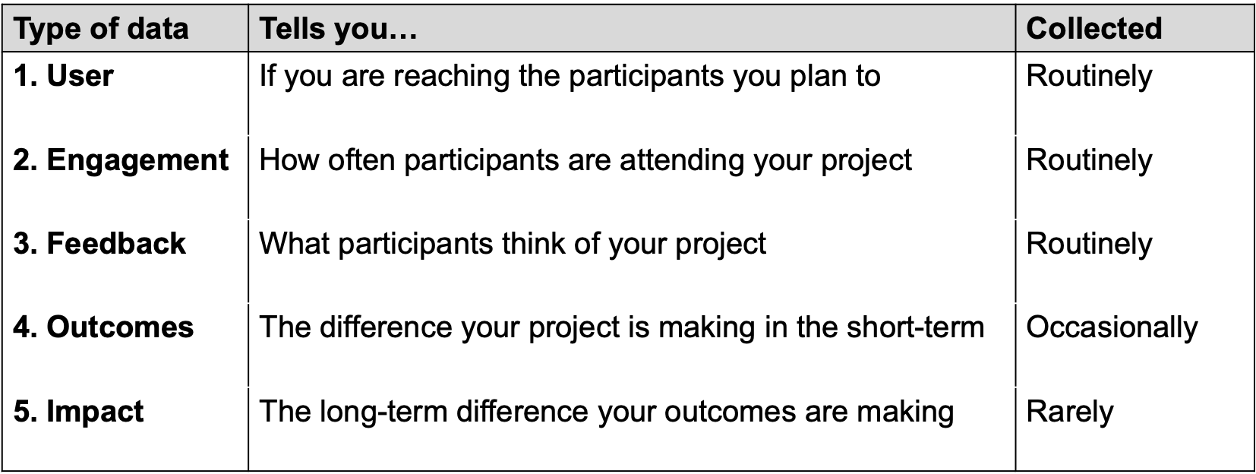
21

See NPC’s 5 Types of Data blog for further information.

Need help?

Available in the next parts of this guidance are:

Part 2: Do - Setting up and carrying out your evaluation
Part 3: Review - Analysing and interpreting your evaluation data

Youth Music can also provide additional support if you are successful in your grant application.
Email your Grants and Learning Officer, or contact us on:
- Email: grants@youthmusic.org.uk
- Telephone: 020 7902 1060

The National Foundation for Youth Music
Studios 3-5 Swan Court, 9 Tanner Street, London, SE1 3LE
Registered charity number: 1075032
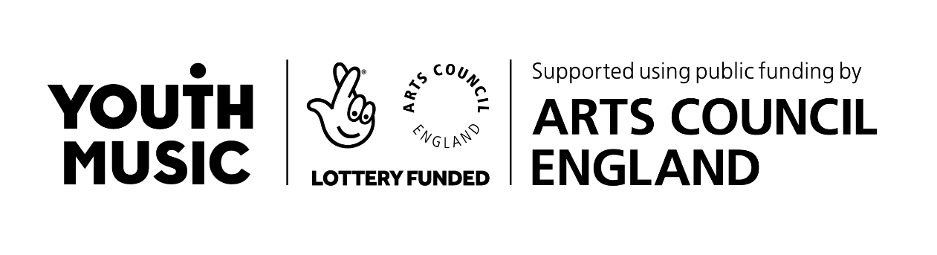
Limited company number: 3750674

