Plan, Do, Review
A guide to evaluating your Youth Music project.

Table of Contents
Introduction 3
Part 3: Review 4
This guidance will help you to... 4
Introduction to analysis 5
Analysing quantitative data 5
Analysing qualitative data 6
Interpreting the data 6
Unexpected results 6
Presenting your findings 7
Sharing learning 7
Final reflections 8
Need help? 8

Introduction

The evaluation guidance is made up of three parts.

For Applicants:
- Plan: Creating an evaluation plan for your Youth Music application.

Remember: You only need to follow the guidance in this document to make an application, however you may find it useful to also read Do and Review.

For Grantholders:
- Do: Setting up and carrying out your evaluation plan.
- Review: Analysing and interpreting your evaluation data.

Part 3: Review
Analysing and interpreting your evaluation data.
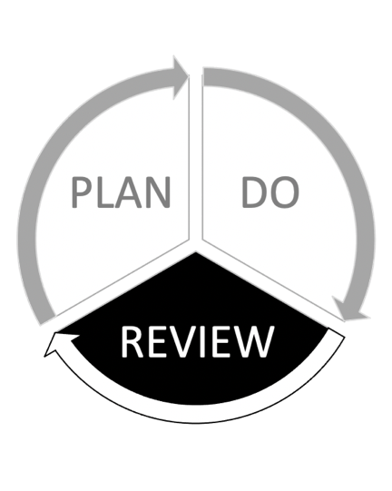

This guidance will help you to...
Process and analyse your evaluation data

Interpret the findings of your evaluation

Think about how to present your findings

Share learning and reflect on the entire evaluation process

Introduction to analysis
Evaluation data is unlikely to tell you much in its unprocessed state. Analysis is the process of converting this data into useful information to help you understand your project. The findings will help you draw conclusions about whether your work brought about the intended outcomes.
Before you start your interpretation, you’ll need to go through the following process with the raw data:
- consolidate it (bring it together into one place)
- clean it (remove obviously incomplete or inaccurate data)
- and then analyse it.

Analysing quantitative data
Quantitative data (e.g. self-assessment scales) help you understand the scale or frequency of something.
Analysing quantitative data involves reviewing all your raw data to look for patterns or trends. It helps you identify if any changes have occurred for the majority of participants or not.
The table below shows young people responses to the question: “coming to the music project has helped me feel more calm and relaxed”. This is part of a wider set of questions investigating the project’s impact on their wellbeing.
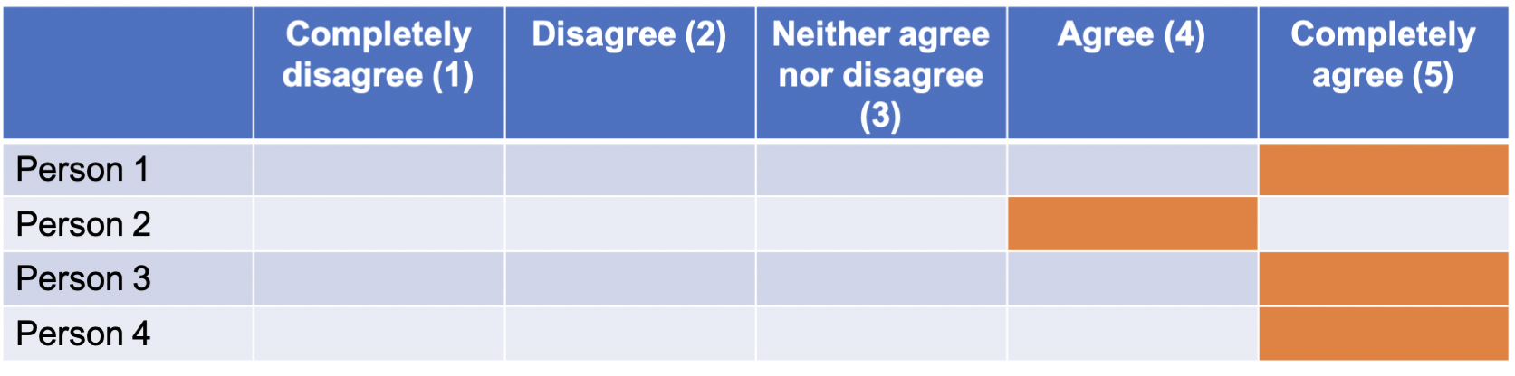
Calculating averages can help you understand the overall experience of a group of participants. For the previous example, you could say “We asked how much our music project made people more calm and relaxed. We used a scale of 1 – 5, with 5 being ‘completely agree’. The average score for our four respondents was 4.75.”
Looking at individual responses against the averages will help you understand the range of experiences. If the average score was 4.75 and someone had selected 1, you could consult the other data you collected to try and find out why their score was lower than other people’s.
If you are using baseline and follow up questionnaires, then comparing the average at two points in time can help demonstrate distance travelled. Putting your data into charts or graphs may help you identify patterns and trends over time. See our guidance on quantitative analysis for further information.

Analysing qualitative data
Qualitative data (e.g. interviews) help you understand the range of opinions and experiences. It can help bring meaning to quantitative data.
Analysing qualitative data involves coding your raw data into themes that are relevant to the outcomes you’re measuring.
Coding is the process of labelling your data so that it can be easily found for further analysis. Like using a hashtag on social media, it can help you to easily find all the data labelled with a particular code and see it in one place.
There are many ways to carry out this process: some people prefer to do it on paper using coloured highlighters and sticky labels, whereas others find it easier to copy and paste sections of the data into separate documents.
Whichever method you choose, separating your qualitative data into themes will help you to identify similarities between different people or sources. See our guidance on qualitative analysis for further information.

Interpreting the data
In your evaluation plan, you will have data from multiple sources (e.g. young people, music leaders, parents). Exploring the similarities and differences between the sources will help you interpret your data. The process of using multiple viewpoints to draw conclusions is called triangulation. Triangulation helps to make your findings more robust.
When analysing your data, consider how the results from different people or data compliment or contradict each other. As an example, young people have reported being more friendly to others, music leaders have seen an increase in group work, and parents have reported that their child has made new friends. In this case you can be fairly confident that young people’s interpersonal skills have improved.

Unexpected results
Sometimes, your data might reflect a result you aren’t expecting.
This is normal and there are plenty of ways to explain why this might happen. To understand your data further, ask yourself questions like:
- “What external factors could be contributing to this?”
- “Do any other data sources help me explain this result?”
- “What is surprising about the data?”
- “Is it a common trend or a one-off?”
- “What is it telling me about the project?”

Presenting your findings
Youth Music is flexible about how you present your findings, provided that it is done within the reporting framework provided. You can decide what format is most appropriate for your audiences.
You may want to consider creative formats such as a presentation deck, video, podcast or webpage. Try and make the information accessible and engaging. If you’re doing a written report, limit yourself to a maximum word count. Use photos and charts to break up chunks of text.
Use your evaluation to continue the dialogue with the people you’ve worked with. Youth-led outputs (such as podcasts, interviews or social media campaigns) can provide interesting content from different voices. Reflecting on the findings by the beneficiaries themselves (i.e. rather than a third party) might also lead you to new learning.

Sharing learning
To extract the maximum value from your evaluation, consider how you can share and reflect on the findings.
- You can disseminate your findings on social media, your own website, the Youth Music Network, the Youth Music Facebook Group or through newsletters and other online communities.
- Think about what your music leaders, staff teams, board and partners could learn from your findings.
- Involve young people in the learning stage as well. Provide a welcoming informal space for them to reflect on their own journey and the way you have run the project.
- Are there members of your local community who might benefit from hearing first-hand about the work done?

Final reflections
Here are some questions to help you reflect on the evaluation process:
- How successful was the evaluation process and what have you learned from it?
- How useful has it been to the project leaders and your organisation?
- How engaged were the participants?
- What would you change in future to improve your evaluation?
- Did you collect anything you did not use or that didn’t work? Do you need to collect it in future?
- How can you respond to feedback on your evaluation report?

Need help?
We’re here to help if you have any questions or need to make changes.
Available in other parts of this guidance are:
Part 1: Plan - Creating an evaluation plan for your Youth Music application
Part 2: Do - Setting up and carrying out your evaluation.
Email your Grants and Learning Officer, or contact us on:
- Email: grants@youthmusic.org.uk
- Telephone: 020 7902 1060

The National Foundation for Youth Music
Studios 3-5 Swan Court, 9 Tanner Street, London, SE1 3LE
Registered charity number: 1075032
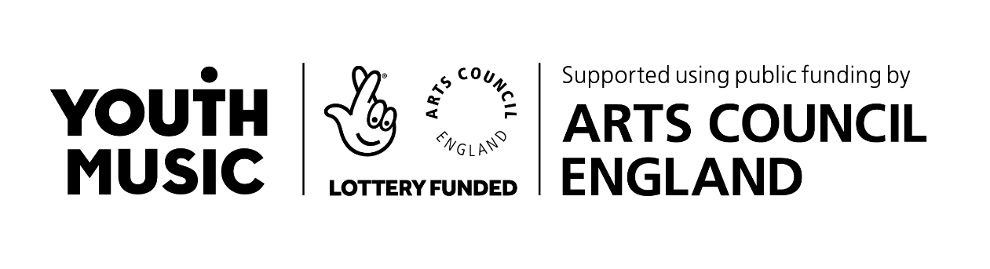
Limited company number: 3750674

