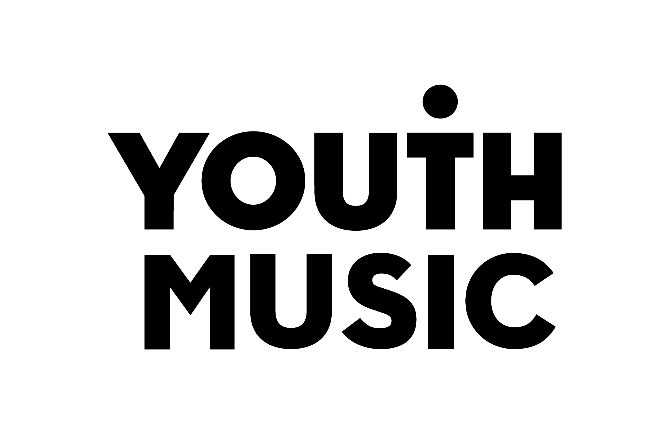

Youth Music
Fund B Evaluation Report

URN
Organisation name
Project title
Project start date
Project end date
Report author (name, job title)
Email address

This form template is for information only. All reporting must be completed through the online form available at https://grants.youthmusic.org.uk/

Guidance

Background

All Youth Music grantholders are asked to submit an evaluation report at the end of their programme. Once the report has been submitted and approved, your final grant payment will be made and your grant will be closed.

If your report is due but you are still delivering your programme, please contact your Grants and Learning Officer to discuss rescheduling the report due date.

We use the evaluation data you submit as part of our annual impact reporting. It enables us to reflect on our impact and reach, and helps us fulfil our own reporting requirements to Arts Council England.

What does this report cover?

This report has five main sections:

- Monitoring – you tell us what activities were delivered, who you worked with and how you spent the grant.
- Evaluation and learning – you report on the outcomes of your work.
- Organisational development – you tell us what has changed for your organisation over the course of the grant.
- Communications – a non-mandatory section of the report where you have the opportunity to submit photos, music and videos for use in Youth Music external communications.
- The final section, completed online, requests two signatories from your organisation certify that the information supplied within the report is a true and accurate representation.

April 2021 new report format - what has changed?

Changes have been made to our reporting requirements following a grantholder consultation. The four main changes in this new format are:

- Statistical data collection fields have been reduced and streamlined.
- The minimum number of outcomes that you report on has been reduced to three (although you can still report against five if you’d like).
- Evaluation reporting on outcomes can now be done in a flexible format, so your evaluation reports can be used beyond the grant.
- We now ask you about organisational improvements in safeguarding and equality, diversity and inclusion. These are core values for Youth Music and we want them to be a priority for all the organisations we fund.

If you have any questions about the new reporting format then please contact your Grants and Learning Officer.

Thank you for taking the time to submit this evaluation. We look forward to hearing about the outcomes of your work!

Section 1: Monitoring

Activities

This section asks for information about your project delivery. It has been designed for monitoring purposes, so we can see what you delivered against your original proposal.

Please summarise the activities and outputs you have delivered over the course of this grant, highlighting any changes that have occurred or activities listed in your application form that have not been delivered. (600 words max)
This should be a synopsis of your entire project, including not just music-making activities, but also strategic work such as:
• Recruitment of staff,
• Recruitment of young people,
• Data collection, review and reflection,
• Session delivery,
• Workforce development.

In responding to this question, you may find it helpful to refer to the activity or programme plan outlined in your application.

Budget report

Information from your application and any previous budget reports will be pre-populated in this section.

Youth Music grant spend

Description | Current spent | Forecast

In kind match funding

Item | Received | Outstanding

Cash match funding

Item | Received | Outstanding

Budget variances

Have you spent or committed the full amount of your grant award? | Yes / No
(If No) – Youth Music will consider requests to utilise underspend towards additional activity, so long as it is in line with the original aims of the project. All underspend requests need to be approved by Youth Music and unspent funds should be spent within 3 months of the original end date of the Programme. (max 200 words)
If you have any underspend that you would like to utilise, use this space to tell us more about your proposed activity, including:
- What will you do.
- Who will benefit from the activity.
- The time period of the proposed activity.
(If No) – What is the proposed end date of the underspend activity?
Proposed underspends must be completed within three months of the original project end date. Please contact your Grants & Learning Officer if you wish to propose underspend activity beyond this time frame.

Please use this space to outline any significant variances to your original budget (i.e. as a result of delays, over or underspend relating to specific items) (250 words max)

Who did you reach?

 | Total
Total number of children and young people you worked with  The total number of children and young people you have worked with over the course of your programme. This should also include participants who only attended taster sessions or one-off events. | 0
Number of core participants taking part in activities  The total number of children and young people you worked with over a more sustained period of time, i.e. attended three or more sessions. | 0

Age range (core participants only)

Please enter the number of core participants in each age bracket. The total number of individuals counted here should be equal to the total number of core participants above. If there are core participants whose age is unknown, please account for them in the ‘unknown age’ field.

Age Range | Total
0-5 | 0
6-11 | 0
12-15 | 0
16-18 | 0
19-25 | 0
Unknown Age | 0

Gender identity (core participants only)

Please enter the gender identity of each core participant. The total number of individuals counted here should be equal to the total number of core participants above. If there are core participants whose gender identity is unknown, please account for them in the ‘unknown’ field.

Gender | Total
Male | 0
Female | 0
Non binary | 0
Prefer to self-describe | 0
Prefer not to say | 0
Unknown | 0

Ethnicity (core participants only)

Please enter the ethnicity recorded for each core participant, this should equal the total number of core participants listed above. If there are participants whose ethnicity was not recorded please account for them in the ‘unknown ethnicity’ field.

 | Total
White
English/Welsh/Scottish/Northern Irish/British | 0
Irish | 0
Gypsy or Irish Traveller | 0
Other White Background | 0
Mixed/multiple ethnic groups
White and Black Caribbean | 0
White and Black African | 0
White and Asian | 0
Other Mixed / Multiple ethnic background | 0
Asian/Asian British
Indian | 0
Pakistani | 0
Bangladeshi | 0
Chinese | 0
Other Asian background | 0
Black/African/Caribbean/Black British
African | 0
Caribbean | 0
Other Black / African / Caribbean / Black British | 0
Other ethnic group
Arab | 0
Other ethnic group | 0
Other
Prefer to self-describe | 0
Prefer not to say | 0
Unknown ethnicity | 0

Barriers to participation

Did you work with any young people facing the following barriers to participation: | Tick all that apply
Asylum Seeker
Attends Pupil Referral Unit
Economic Deprivation
English as an additional language
Excluded from school
Homeless
Ill health
LGBTQ+
Looked after
Mental ill health
Not in Education, Employment or Training (NEET)
Physically disabled
Refugee
Rurally Isolated
Sensory impaired
Special Educational Needs
Traveller/Romany
Young Carer
Young Offender / at risk of offending
Other (please specify)

Staff profile

Total
Total number of roles supported through the funding (payroll)
Total number of roles supported through the funding (freelance)
Total number of young people (aged up to 25) undertaking paid work through the programme
Total number of staff or volunteers who had training or workforce development through the programme

What did you deliver?

 | Total
Group sessions | 0
121 sessions | 0
Training sessions for the workforce | 0
List the genres of music that were covered (50 words max)

Music Education Hubs

 | Total
Did this project take place as part of a Music Education Hub? | Y / N / Unsure

Progression outputs (core participants only)

 | Total
Number of participants who have progressed to other music-making activities/opportunities as a result of participation in the project | 0
Number of participants who have progressed to employment through the project (only applicable to projects who worked with people aged 16 years or over) | 0
Number of participants who have progressed to education, training or volunteering through the project (only applicable to projects who worked with people aged 16 years or over) | 0

Accreditation outputs

Accreditation | Number Achieved
Arts Award Discover
Arts Award Explore
Arts Award Bronze
Arts Award Silver
Arts Award Gold
ABRSM Grades
ASDAN
Certificate for Music Educators (CME)
NOCN
Rock School Accreditation
Trinity College Accreditation
AQA
BTEC
Duke of Edinburgh
Other (please specify): …………………………………..

Section 2: Evaluation and learning

Youth Music’s outcomes approach is designed to support your organisation’s learning. We are flexible about how you report to us. We want evaluation to be useful to your organisation beyond your funding requirements.

In your application to Youth Music, you provided us with a list of outcomes, outcome indicators, and data collection tools. Please use your evaluation data to provide us with an evaluation of the outcomes of the programme.

Format of evaluation reporting

You can submit this information to us in whatever format you choose (e.g. written report, webpage, podcast, documentary, presentation deck).

If you wish to submit a written report, you can download the 'Reporting on your outcomes' template from the Youth Music Network. (Please note that you are not required to use this template.)

Please ensure that you:

- Report on a minimum of 3 and a maximum of 5 outcomes.

- Tell us about the evaluation methodology.
  - What data did you collect and when?
  - Discuss any strengths or limitations to the data collection.

- Analyse and interpret the data.
  - What do your outcome indicators and other data suggest?
  - Taken together, do your outcome indicators show that your programme has helped bring about each intended outcome?
  - What could be the reason for any anomalies?

- Discuss your findings.
  - Identify any specific aspects of your programme that worked well or did not work well.
  - What does this mean for how you or others work in the future?

You may wish to draw on data you have submitted elsewhere in this report to provide additional context to external readers. This might include information about the young people you worked with and the type of programme you offered.

If your project is funded by multiple sources, it’s fine to submit the same report that you are using for other funders. In such instances, please indicate what proportion of the overall budget was made up of Youth Music investment. And if the Youth Music funding was used on a specific part of your project, then indicate which part.

Communicating your findings

Think about how you can make your findings accessible. If you are doing a written report, consider:
- Setting a maximum word limit
- Using short sentences and simple language
- Breaking up large chunks of text.

Think about how you can make your evaluation engaging. You may wish to include:
- Charts and infographics
- Quotes
- Photos
- Case studies
- Music
- Video clips.

Need inspiration or support?

Check out the evaluation resources pages on the Youth Music Network for more advice on analysis and presenting your findings.

We also have a number of Youth Music authored reports available on our website:

The Sound of the Next Generation

Exchanging Notes

A Blueprint for the Future

Reshape Music

Evaluation and learning

Provide a link or upload your evaluation report

What were your 3 main learning points from this programme? (300 words max)

Is there anything else you want to tell us? (300 words max)

Why not share your learning and evaluation on the Youth Music Network? You can write a post and upload your report or summarise your key learning for others.

Section 3: Organisational development

Diversity and inclusion

How has diversity and inclusion improved in your organisation over the course of the grant? (300 words max)

Diversity of leadership

In line with our ambition to promote equality, diversity and inclusion we will use this data to produce annual benchmark reports. When we produce reports, any data you provide would always be joined up with data from other grantholders and not attributed to your organisation.

If you do not currently collect this data then tick ‘not specified’. Read more on why we collect this data.

Are 51 per cent or more of your senior management team and board made up of people who are/define as:

Female | Y / N / Not specified
Non binary | Y / N / Not specified
LGBTQ | Y / N / Not specified
Aged between 18-25 | Y / N / Not specified
From a working class background | Y / N / Not specified
Black, Asian or Minority Ethnic | Y / N / Not specified
Disabled | Y / N / Not specified
Neurodivergent | Y / N / Not specified
Collectively, a combination of the above | Y / N / Not specified

Does your organisation self-define as having a diverse leadership team? | Yes, based on the characteristics above / Yes, for other reasons / No / Not specified / (If yes, for other reasons, please outline why) (50 words)

Safeguarding

In what ways have your safeguarding practices improved over the course of the grant? (300 words max)

Section 4: Communications

The information you provide in this section may be used in our own external communications to help show the impact of Youth Music funding. All of the photos you see on our website come from Youth Music programmes and we feature some of the best music and artists on our website and in social media.

You are not required to submit anything in this section of the report.

Music, videos, and film footage
Please include links to any music or videos that you wish to share with Youth Music, along with a brief description of each. We prefer to receive recordings in the form of links to your YouTube or Soundcloud page, although we can also accept MP3 recordings. By providing these links and attachments, you grant Youth Music permission to use them in our fundraising and communications materials. (300 words max)
Photographs
Please include links to or attachments of any photographs that you wish to share with Youth Music, following these specifications:

- Send in *.jpg, *.tif or *.png format.
- Include any credit you would like us to use, e.g. photographer’s name or organisation’s name.
- Include a caption if possible, e.g. ‘This photo shows young people composing their own rap lyrics at a workshop MusicBase held with professional rapper MC X’.
- Do not provide photographs unless you have appropriate permission to share and for the photos to be used publicly (you must be able, upon request, to produce evidence of consent for filming or taking photos of children under the age of 18).
- (300 words max)
☐ I declare that my organisation has the appropriate permissions for these photographs to be used externally

Section 5: Declaration

Two members of your organisation should be named below, both of whom should be authorised as signatories by your organisation to certify the grant expenditure.

Signatory 1

I am authorised to sign this form on behalf of the grant recipient. I certify that the information supplied within this report is a true and accurate representation.

Name: …………………………………………………………………………………….
Position in organisation: ………………………………………………………………..
Date of approval: ………………………………………………………………………...

Signatory 2

I am authorised to sign this form on behalf of the grant recipient. I certify that the information supplied within this report is a true and accurate representation.

Name: …………………………………………………………………………………….
Position in organisation: ………………………………………………………………..
Date of approval: ………………………………………………………………………...

