Plan, Do, Review
A guide to evaluating your Youth Music project.

Table of Contents
Introduction 4
Part 1: Plan 5
This guidance will help you to …. 5
How evaluation fits into the application and reporting process 6
What is an outcomes approach? 6
An outcomes approach 7
How evaluation data is used 8
Drafting your evaluation 10
Identify the purpose of your evaluation 10
Budget and resourcing 10
Drafting your evaluation plan 10
Types of data 11
Evaluation builder 11
How often to collect data 17
Types of data 17
Need help? 18
Part 2: Do 19
This guidance will help you to... 19
Getting started 20
Top tips for evaluation 20
Finalising data collection tools 21
When will data be collected? 21
How often to review data 21
Roles and responsibilities 22
Ethics and data protection – the basics 22
Storing data securely 22
Training and induction 23
Responding to challenges 23
Need help? 24
Part 3: Review 25
This guidance will help you to... 25
Introduction to analysis 26
Analysing quantitative data 26
Analysing qualitative data 27
Interpreting the data 27
Unexpected results 27
Presenting your findings 28
Sharing learning 28
Final reflections 29
Need help? 29

Introduction

The evaluation guidance is made up of three parts.

For Applicants:
- Plan: Creating an evaluation plan for your Youth Music application.

Remember: You only need to follow the guidance in this document to make an application, however you may find it useful to also read Do and Review.

For Grantholders:
- Do: Setting up and carrying out your evaluation plan.
- Review: Analysing and interpreting your evaluation data.

Part 1: Plan

Creating an evaluation plan for your Youth Music application.

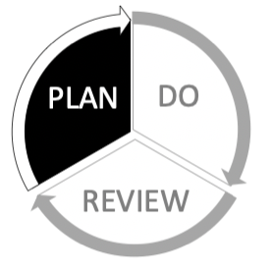

This guidance will help you to ….

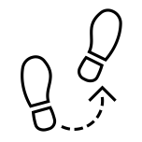
See how evaluation fits within the application/reporting process

Understand the principles of an outcomes approach

Think about your evaluation and resources

Choose your outcomes, outcome indicators and data collection tools

How evaluation fits into the application and reporting process

Application

In your application we ask you to draft your evaluation plan using an outcomes approach. You will plan the information you will collect about your activities, throughout the programme. This data will enable you to see how you are doing and help you to report to Youth Music.

Interim reporting

At an agreed stage we will ask you to reflect on the data you have collected so far. This will help you to see if you need to make any changes to improve your programme. You will share your findings with us in a short interim report.

Evaluation reporting

At the end of your programme, we will ask you to report on your work and to provide statistical information on your activities. Evaluation is about learning from experience and it is as useful to know what went wrong as what went right.

What is an outcomes approach?

Outcomes are the changes your project achieves. An outcomes approach helps you understand the relationship between what you do and why you do it. It helps you understand what is working and supports you to evidence change. Your project aim, outcomes and activities should all be related.

- Each of your outcomes should respond the need you have identified.
- Every activity you plan to deliver should relate to at least one of your outcomes.

All of your outcomes should align with the overall difference your project hopes to make.

Outputs are not the same as outcomes!

Outputs focus on the number of activities carried out. Outcomes focus on the changes that occur as a result of the activities.

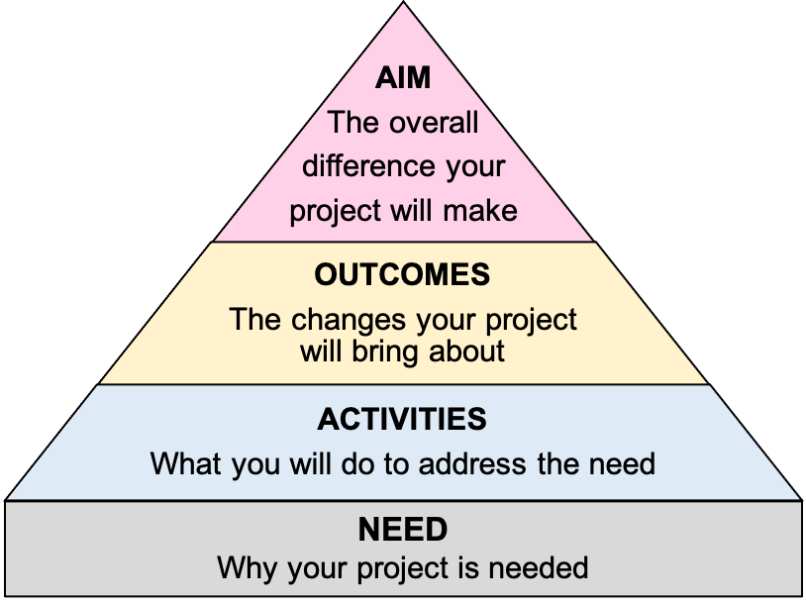

An outcomes approach
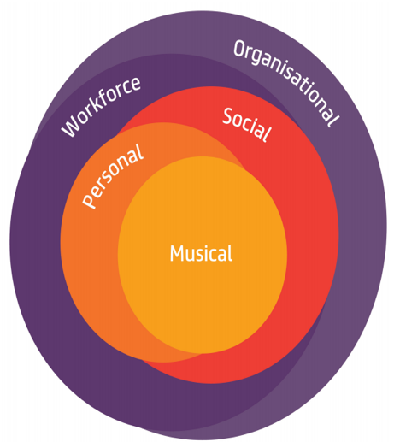
Youth Music supports organisations to take an outcomes approach to delivering projects. Outcomes are the changes your project achieves.

You decide what outcomes you think your project should achieve. You also decide how you will check to see if your project achieves these outcomes. Your evaluation plan captures this information.

Youth Music is interested in outcomes in 5 areas:

- Musical, personal and social outcomes for children and young people.
- Outcomes for the music workforce. (Changes in the way we work.)
- Outcomes for the organisations for which we work. (Changes in our organisations.)

How evaluation data is used

The information submitted by grantholders is used in a number of ways:
- To learn about the impact of our investment.
- To produce reports and resources.
- To identify what works and share what we learn with others.
- To inform how we make funding decisions and design our programmes.

Examples of how we share our impact:

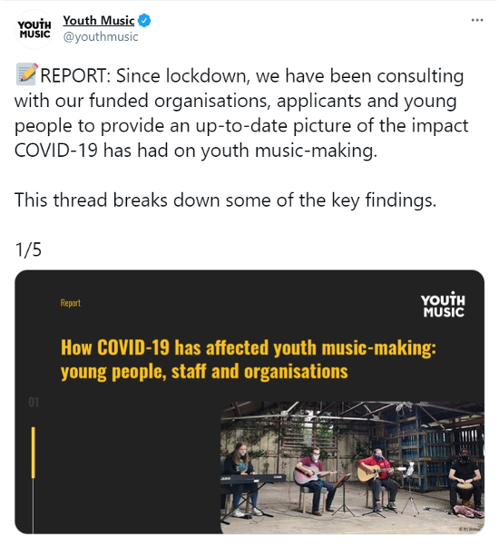

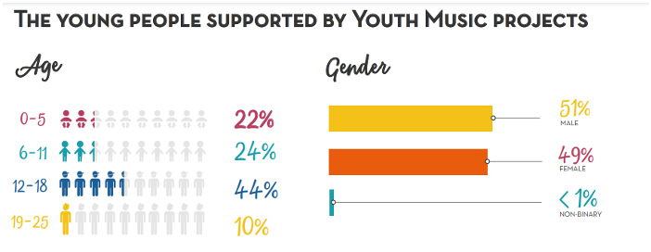

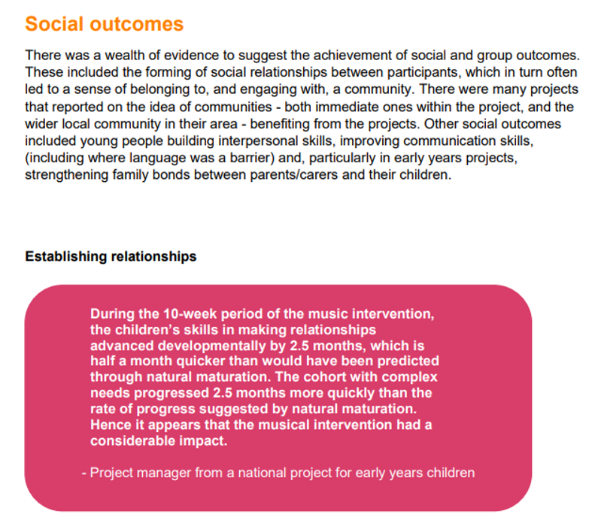

Drafting your evaluation

Identify the purpose of your evaluation

Evaluation can have different purposes. Think about who the evaluation is for and what you want it to explore. If your work brings about lots of different outcomes then think about which ones will be most useful to measure.

The purpose of evaluation in Youth Music funded projects is often a combination of the following:
- Learning and adapting – using findings to help adapt your work to the changing circumstances around you.
- Demonstrating impact – exploring whether your work brings about specific outcomes and showing to others how your work has made a difference.

Budget and resourcing

Your evaluation should be embedded in your project plan. You will need to allow time and resource to:
- Finalise your evaluation plan.
- Undertake data collection, storage and analysis.
- Present your findings.

You should include time and resource for this within your project plan and project budget.

You can appoint an external evaluator to help you with some or all of the process. This might be helpful if you want an external perspective or to fill a particular skills gap.

Drafting your evaluation plan

In your application to Youth Music, you will be asked to list your:

Outcomes - the changes your project wishes to achieve. These can be changes in behaviour, skills, knowledge, attitudes etc.

Outcome indicators - where you will look to identify change.

Data collection tools - what you will use to capture evidence of change.

Top Tips:
- Aim to keep your evaluation plan simple and focussed.
- Make use of existing processes and data collection where possible.

Types of data

There are two categories of data you are likely to use.
- Quantitative data helps you understand the scale or frequency of something. It often involves expressing amounts or proportions numerically.
- Qualitative data helps you understand opinions and experiences. It often involves describing a range of opinions through written narrative .

By collecting a mixture of quantitative and qualitative data, you can explore the depth and breadth of your outcomes.
- Quantitative data can help add scale and breadth to qualitative data.
- Qualitative data can help add context and depth to quantitative data.

Evaluation builder

You will be asked to track a set number of outcomes in your evaluation.

For each outcome, you’ll need to choose three outcome indicators and data collection tools.

You can use the menus on the following pages to help you do this.

Example outcome: To improve young people’s DJ skills
Outcome indicators

Young people’s self assessment

Music Leader’s assessment

Project Manager assessment
Data collection tools

Distance travelled questionnaire

Reflective diaries

Video footage (comparison between first and last performance)

Musical outcomes builder

Musical outcomes relate to musical development in young people. This can include:
- Skills, knowledge and abilities
- Understanding or awareness of musical styles and approaches
- Ability to communicate ideas using music

2. Outcome indicators
- Young people’s self assessment
- Music leader’s assessment
- Project Manager assessment
- Parents /carers assessment
- Teacher’s assessment
- Accreditation achievement
1. Outcomes
3. Data collection tools*
Quantitative
- Questionnaires (these can be done once at the end of a programme, or between two or more points in time)
- Assessment scales

Qualitative
- Questionnaires (open questions)
- Observations
- Interviews
- Focus groups
- Reflective diaries
- Video footage
- Audio footage
- Arts Award logbook / portfolios for accreditation
Change for who
- Children’s
- Young people’s
- Participants’
Change in what
- Instrumental skills
- Musical expression
- Technical (instrument / software / vocal) abilities
- Performance skills
- Composition skills
- Song-writing skills
- Lyric writing skills
- Production skills
- DJ skills
- Ability to play in a group
- Knowledge of different styles
Change word
- Improve
- Increase
- Develop
- Raise
- Enhance
- Strengthen
- Embed

*Our data collection toolkit has examples of scales and questionnaires you can use to track musical development.

Personal outcomes builder

Personal outcomes relate to personal development. This can include:
- Skills, knowledge, abilities and behaviour
- How people feel about themselves
- Being able to do new things.
3. Data collection tools*
Quantitative
- Questionnaires (these can be done once at the end of a programme, or between two or more points in time)
- Assessment scales

Qualitative
- Questionnaires (open questions)
- Observations
- Interviews
- Focus groups
- Reflective diaries
- Video footage
- Audio footage
- Arts Award logbook / portfolios for accreditation
2. Outcome indicators
- Young people’s self assessment
- Music leader’s assessment
- Project Manager assessment
- Parents /carers assessment
- Teacher’s assessment
- Accreditation achievement
1. Outcomes
Change in what
- Wellbeing
- Confidence
- Self esteem
- Self efficacy
- Agency
- Wellbeing
- Resilience
- Engagement with education
- Employability
- Leadership
- Literacy skills
- Attitude and behaviour
Change for who
- Children’s
- Young people’s
- Participants’
Change word
- Improve
- Increase
- Develop
- Raise
- Enhance
- Strengthen
- Embed

*Our data collection toolkit has examples of scales and questionnaires you can use to track changes in wellbeing, self-efficacy and agency.

Social outcomes builder

Social outcomes relate to changes in a person or group of people that can have broader benefits for people and society beyond the individual. These can include:
- Leadership, teamwork or interpersonal skills.
- Engagement with the community or services
- Interpersonal skills and relationships

3. Data collection tools*
Quantitative
- Questionnaires (these can be done once at the end of a programme, or between two or more points in time)
- Assessment scales

Qualitative
- Questionnaires (open questions)
- Observations
- Interviews
- Focus groups
- Reflective diaries
- Video footage
- Audio footage
- Arts Award logbook / portfolios for accreditation
2. Outcome indicators
- Young people’s self assessment
- Music leader’s assessment
- Project Manager assessment
- Parents /carers assessment
- Teacher’s assessment
- Accreditation achievement
1. Outcomes
Change in what
- Leadership skills
- Social skills
- Teamwork skills
- Interpersonal skills
- Attitude and behaviour
- Communication skills
- Speech and language skills
- Engagement with the community or services
- Family or other relationships
Change for who
- Children’s
- Young people’s
- Participants’
Change word
- Improve
- Increase
- Develop
- Raise
- Enhance
- Strengthen
- Embed

*Our data collection toolkit has examples of scales and questionnaires you can use to track
changes in attitude and behaviour, leadership, social skills, teamwork and communication skills.

Workforce outcomes builder

Workforce outcomes relate to the skills, knowledge and personal development of the workforce employed on a project.

2. Outcome indicators
- Practitioner’s self-assessment of
- Project manager’s assessment of
- Observations of
- Young people’s assessment of
- Accreditation achievement
3. Data collection tools*
Quantitative
- Questionnaires (these can be done once at the end of a programme, or between two or more points in time)
- Assessment scales

Qualitative
- Questionnaires (open questions)
- Observations
- Interviews
- Focus groups
- Reflective diaries
- Video footage
- Audio footage
- Arts Award logbook / portfolios for accreditation
1. Outcomes
Change in what
- Specific skills (for you to select, depending on the nature of your programme)
- Knowledge about
- Understanding of
- Personal development (confidence, motivation)
- Changes in practice
Change for who
- Music leaders’
- Music Teachers’
- Youth workers’
- Trustees’
- Staff
Change word
- Improve
- Increase
- Develop
- Raise
- Enhance
- Strengthen
- Embed

*Our data collection toolkit has examples of scales and questionnaires you can use to track changes in knowledge, skills, understanding and practice, as well as job satisfaction.

Organisational outcomes builder

Organisational outcomes refer to developments in your own or another organisation.

1. Outcomes
3. Data collection tools*
Quantitative
- Staff surveys
- Stakeholder surveys
- Self-assessment tools

Qualitative
- Staff survey (open questions)
- Stakeholder survey (open questions)
- Interviews
- Applications / reporting to achieve / retain kitemarks and accreditation

2. Outcome indicators
- Board / staff assessment
- Partner assessment
- Accreditation/kitemark achievement
- Policy development
- Engagement statistics
Change for who
- Own organisation
- Partner organisation/s
- Participating organisations
Change word
- Embed
- Improve
- Increase
- Develop
- Raise
- Enhance
- Strengthen
- Reduce

Change in what
- Equality, diversity and inclusion practice/s
- Quality of work
- Safeguarding practices
- Evaluation practices

*Our data collection toolkit has examples of tools you can use to track changes in equality and diversity practice and quality. It also signposts to external tools to help you measure youth participation practice, safeguarding and impact measurement.

How often to collect data

More data does not necessarily lead to a stronger evaluation. The more data you collect, the more time you will need to spend analysing it. There are ways to streamline your data collection and analysis:
- Projects reaching large numbers of young people could collect data from a representative sample of participants rather than everyone.
- Reflective questionnaires could be used at the end of your project, rather than baseline and follow-up questionnaires.
- Qualitative data tends to take longer to analyse, so be careful about how many qualitative data collection tools you use.

Discussing your plans with your project team will help inform what to collect and when to collect it.

Baseline and follow up questionnaires ask respondents to complete a questionnaire at two different points in the project to establish distance travelled.
Reflective questionnaires ask respondents to reflect on distance travelled, usually towards end of a project.

Five types of data

What data you collect and how often you collect it will correspond to what you trying to achieve. The quantitative and qualitive data you collect is likely to be one of 5 main types:

Type of data  21 | Tells you… | Collected
1. User | If you are reaching the participants you plan to | Routinely
2. Engagement | How often participants are attending your project | Routinely
3. Feedback | What participants think of your project | Routinely
4. Outcomes | The difference your project is making in the short-term | Occasionally
5. Impact | The long-term difference your outcomes are making | Rarely
See NPC’s 5 Types of Data blog for further information.

Need help?

Email your Grants and Learning Officer, or contact us on:
- Email: grants@youthmusic.org.uk
- Telephone: 020 7902 1060

Available in the next parts of this guidance are:
- Part 2: Do - Setting up and carrying out your evaluation
- Part 3: Review - Analysing and interpreting your evaluation data

Youth Music can also provide additional support if you are successful in your grant application.

Part 2: Do
Setting up and carrying out your evaluation.
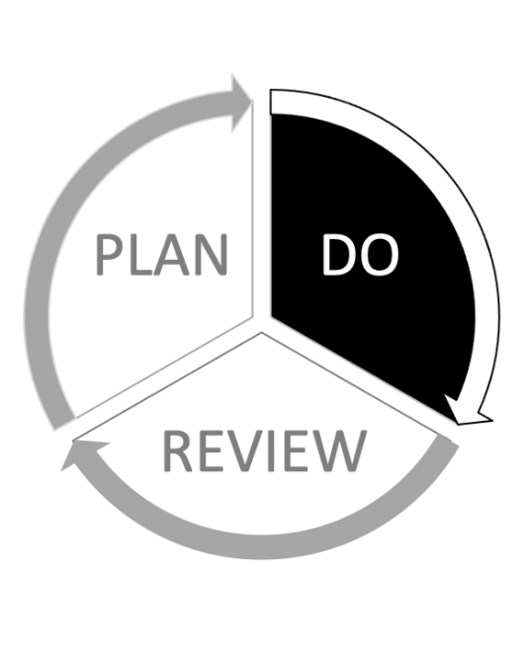

This guidance will help you to...
Finalise the data collection and review points

Assign roles and responsibilities.

Work safely and ethically

Induct people into the evaluation process

Getting started
Before you read on, you may find it helpful to refer back to:
- Your completed application form (available from https://grants.youthmusic.org.uk). This contains:
  - Outcomes and draft evaluation plan.
  - Project timescales.
  - Budget
- Any advice provided by your Grants & Learning Officer.
- Part 1 of this guidance, which helped you plan your evaluation.

Top tips for evaluation
Keep it simple. Focus on quality of data, not quantity. Measure a few things really well. Make sure your plans are realistic in terms of time and budget.

Involve others. Plan the evaluation with the team (including young people). Reflect on findings together.

Build the process into your plans. Evaluation is a continuous process. Regular review and adjustment will help you to continually improve.

Finalising data collection tools
A summary of different data collection tools and their pros and cons can be found here. As you finalise the tools you plan to use, think about:
- Accessibility. Will the questions be understood? Can people engage with the format? Would spoken or creative methods work better than written methods?
- Time taken to collect, process and analyse data. Some methods are easy to collect but take longer to process or analyse (e.g. video recordings, focus groups). If you are using questionnaires, then online tools such as SurveyMonkey can help to speed up processing times.
- The format of your final evaluation. Will the types of data you are collecting work in your final evaluation? Will they tell you what you want to find out? Consider collecting some multi-media content to help bring your findings to life.
If you are planning to use questionnaires/scales, see the Youth Music evaluation scales for more guidance.
Before your finalise your tools, check-in with key delivery staff to ensure plans are realistic.

When will data be collected?
- Choose the right time to collect your evaluation data. Take time to engage young people and build their trust before you introduce evaluation.
- Don’t collect data that is not necessary. Whilst you might record engagement (or attendance) data routinely, you do not need to ask participants to evaluate their progress at every session. Part 1 of this evaluation guidance provides advice on different types of data.
- Build data collection into your staff time and your session planning. You should be clear when the data collection will take place and how long it will take. Separate the process clearly from the music-making. Don’t just squeeze it in at the end of a session.

How often to review data
- Once you have collected data, review it regularly and as you go along. This allows you to adjust your plans based on what you are learning. It also makes writing your evaluation easier at the end of the project.
- Use regular reflection meetings to reflect on evaluation data with your team (and external evaluator if you have one). This can help you to interpret what the data means. It will also help you plan adjustments before the project comes to an end.

Roles and responsibilities
Some of the data collection may need to be done by a member of your team who works closely with young people.
- In evaluation, we often ask for sensitive information from people. It can help when the person asking the question has a trusted relationship with the evaluation subject. They should also know how to respond if someone discloses something.
If you are working with an external evaluator, ensure they are inducted into your processes. They should also be introduced to the team and young people.
You’ll also need to build time into people’s roles to process the data (e.g. transcribing interviews or entering numbers into a spreadsheet) and then analyse it.

Ethics and data protection – the basics
Your evaluation should be conducted ethically. The process should never compromise participant safety. Some basic rules:
- Personal information must be stored securely in line with your organisational data protection and safeguarding policies.
- You should always explain why you are asking for information and how you plan to use it.
- It is important that you have the appropriate consent from participants, or their guardians if they are under 16.
  - Getting forms back from guardians can take time, so factor this into your planning.
- Participants have the right to opt out of the evaluation process at any point.
Further guidance on Ethics and data protection can be found through this link.

Storing data securely
If you collect any form of personal data (such as people’s names and other identifying factors) you are required by law to store it securely. This may mean:
- Anonymising data as soon as it has been collected (collect the data anonymously in the first place if you can).
- Password protecting files, including during data transfer.
- Deleting data from emails, devices or personal computers. We advise you not to use personal devices for evaluation.
After you have completed your evaluation of your project, consider whether you need to keep the data. Ensure you don’t keep it longer than you need to.

Training and induction
Everyone involved in the project (including young people) should understand what the evaluation is, and why you are doing it. The evaluation respondents should understand that they do not have to participate, and can withdraw at any time.
Induct key staff into the evaluation at the outset. The induction should cover:
- Their role in the evaluation – what are their specific requirements?
- An overview of the wider evaluation plan
- How to make data collection more accessible and engaging for participants. Build in flexibility around formats, timings or approaches.
- Safeguarding, ethics and data protection.
- What you will produce at the end of the project and where you will share it.

Responding to challenges
Evaluation needs to work for you and the young people you work with. Carrying out evaluation in a project can bring challenges. See our Common evaluation challenges resource for examples of common issues other grantholders have experienced.
It’s okay to adapt your processes to improve your evaluation. Please remember to share any important learning about the process in your final evaluation.

Need help?
We’re here to help if you have any questions or need to make changes.
Available in other parts of this guidance are:
Part 1: Plan - Creating an evaluation plan for your Youth Music application
Part 3: Review - Analysing and interpreting your evaluation data
Email your Grants and Learning Officer, or contact us on:
Email: grants@youthmusic.org.uk Telephone: 020 7902 1060

Part 3: Review
Analysing and interpreting your evaluation data.
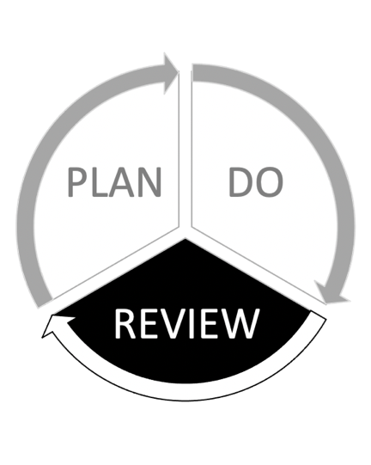

This guidance will help you to...
Process and analyse your evaluation data

Interpret the findings of your evaluation

Think about how to present your findings

Share learning and reflect on the entire evaluation process

Introduction to analysis
Evaluation data is unlikely to tell you much in its unprocessed state. Analysis is the process of converting this data into useful information to help you understand your project. The findings will help you draw conclusions about whether your work brought about the intended outcomes.
Before you start your interpretation, you’ll need to go through the following process with the raw data:
- consolidate it (bring it together into one place)
- clean it (remove obviously incomplete or inaccurate data)
- and then analyse it.

Analysing quantitative data
Quantitative data (e.g. self-assessment scales) help you understand the scale or frequency of something.
Analysing quantitative data involves reviewing all your raw data to look for patterns or trends. It helps you identify if any changes have occurred for the majority of participants or not.
The table below shows young people responses to the question: “coming to the music project has helped me feel more calm and relaxed”. This is part of a wider set of questions investigating the project’s impact on their wellbeing.
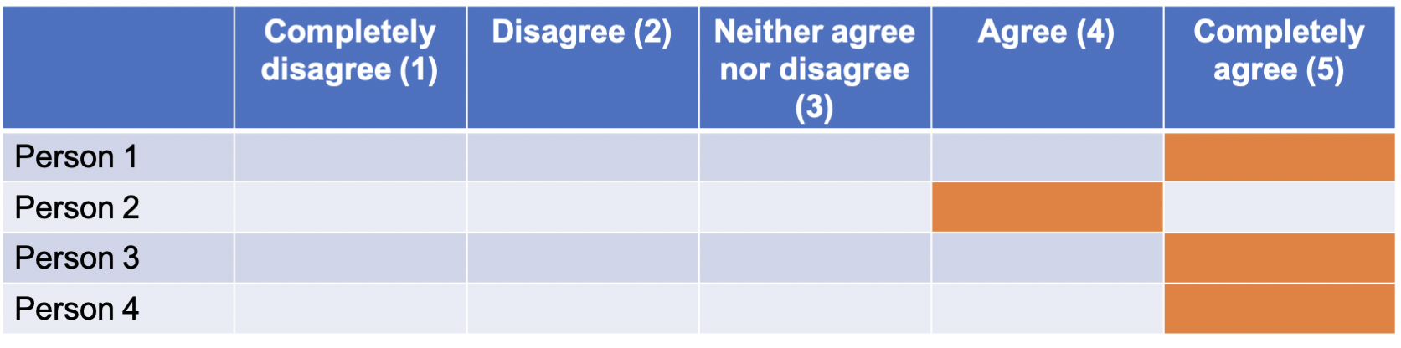
Calculating averages can help you understand the overall experience of a group of participants. For the previous example, you could say “We asked how much our music project made people more calm and relaxed. We used a scale of 1 – 5, with 5 being ‘completely agree’. The average score for our four respondents was 4.75.”
Looking at individual responses against the averages will help you understand the range of experiences. If the average score was 4.75 and someone had selected 1, you could consult the other data you collected to try and find out why their score was lower than other people’s.
If you are using baseline and follow up questionnaires, then comparing the average at two points in time can help demonstrate distance travelled. Putting your data into charts or graphs may help you identify patterns and trends over time. See our guidance on quantitative analysis for further information.

Analysing qualitative data
Qualitative data (e.g. interviews) help you understand the range of opinions and experiences. It can help bring meaning to quantitative data.
Analysing qualitative data involves coding your raw data into themes that are relevant to the outcomes you’re measuring.
Coding is the process of labelling your data so that it can be easily found for further analysis. Like using a hashtag on social media, it can help you to easily find all the data labelled with a particular code and see it in one place.
There are many ways to carry out this process: some people prefer to do it on paper using coloured highlighters and sticky labels, whereas others find it easier to copy and paste sections of the data into separate documents.
Whichever method you choose, separating your qualitative data into themes will help you to identify similarities between different people or sources. See our guidance on qualitative analysis for further information.

Interpreting the data
In your evaluation plan, you will have data from multiple sources (e.g. young people, music leaders, parents). Exploring the similarities and differences between the sources will help you interpret your data. The process of using multiple viewpoints to draw conclusions is called triangulation. Triangulation helps to make your findings more robust.
When analysing your data, consider how the results from different people or data compliment or contradict each other. As an example, young people have reported being more friendly to others, music leaders have seen an increase in group work, and parents have reported that their child has made new friends. In this case you can be fairly confident that young people’s interpersonal skills have improved.

Unexpected results
Sometimes, your data might reflect a result you aren’t expecting.
This is normal and there are plenty of ways to explain why this might happen. To understand your data further, ask yourself questions like:
- “What external factors could be contributing to this?”
- “Do any other data sources help me explain this result?”
- “What is surprising about the data?”
- “Is it a common trend or a one-off?”
- “What is it telling me about the project?”

Presenting your findings
Youth Music is flexible about how you present your findings, provided that it is done within the reporting framework provided. You can decide what format is most appropriate for your audiences.
You may want to consider creative formats such as a presentation deck, video, podcast or webpage. Try and make the information accessible and engaging. If you’re doing a written report, limit yourself to a maximum word count. Use photos and charts to break up chunks of text.
Use your evaluation to continue the dialogue with the people you’ve worked with. Youth-led outputs (such as podcasts, interviews or social media campaigns) can provide interesting content from different voices. Reflecting on the findings by the beneficiaries themselves (i.e. rather than a third party) might also lead you to new learning.

Sharing learning
To extract the maximum value from your evaluation, consider how you can share and reflect on the findings.
- You can disseminate your findings on social media, your own website, the Youth Music Network, the Youth Music Facebook Group or through newsletters and other online communities.
- Think about what your music leaders, staff teams, board and partners could learn from your findings.
- Involve young people in the learning stage as well. Provide a welcoming informal space for them to reflect on their own journey and the way you have run the project.
- Are there members of your local community who might benefit from hearing first-hand about the work done?

Final reflections
Here are some questions to help you reflect on the evaluation process:
- How successful was the evaluation process and what have you learned from it?
- How useful has it been to the project leaders and your organisation?
- How engaged were the participants?
- What would you change in future to improve your evaluation?
- Did you collect anything you did not use or that didn’t work? Do you need to collect it in future?
- How can you respond to feedback on your evaluation report?

Need help?
We’re here to help if you have any questions or need to make changes.
Available in other parts of this guidance are:
Part 1: Plan - Creating an evaluation plan for your Youth Music application
Part 2: Do - Setting up and carrying out your evaluation.
Email your Grants and Learning Officer, or contact us on:
- Email: grants@youthmusic.org.uk
- Telephone: 020 7902 1060

The National Foundation for Youth Music
Studios 3-5 Swan Court, 9 Tanner Street, London, SE1 3LE
Registered charity number: 1075032
Limited company number: 3750674
