Youth Music Stakeholder Survey

2022 Summary

What Is the stakeholder survey?

Every year, we send the stakeholder survey to all organisations that have applied for, or hold, a Youth Music grant. You can see our findings from last year here.

The survey is completed anonymously. It is an important way for us to check how we’re doing as a funder, and how we can improve.

Respondent information

This year, the Stakeholder Survey had a response rate of 10%.
Seventy five percent of respondents (73) indicated that they were a current or previous funded partner. 22% were unsuccessful and 4% had never applied.
Region of operation (106)
8% multiple regions

A total of 64% of respondents self-defined as having a diverse leadership team at their organisation.

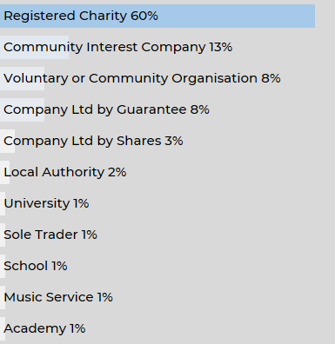
Organisation type (106)

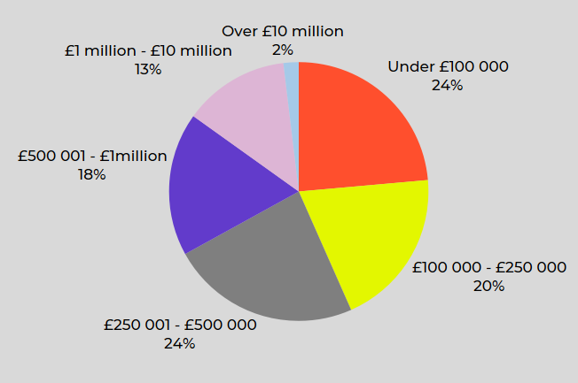

Organisation turnover (106)

Applying for funding

Sixty seven percent of respondents (71) had applied for funding more than once. 29% (31) had applied once. Applicants had applied for the following funds (note that the new Youth Music Trailblazer and Catalyser Funds will be captured in this year’s survey):

Fund A | 53%
Fund B | 38%
Recharge Fund | 31%
Funding Rounds Prior to 2021 | 30%
Incubator Fund | 10%
Fund Rounds After April 2021 | 6%

Of those that have applied
Which Youth Music funding round(s) have you applied for? (105)

Respondents were asked how they would rate the following aspects of the Youth Music application process on a scale from “Very poor” to “Excellent” (there were also options if they did not use the resource or were not aware of it.)

 | Very poor | Below average | Average | Above average | Excellent | Was aware of this, but did not use | Was not aware of this | #
Phone/email support from Youth Music staff |  | 2% | 17% | 20% | 46% | 12% | 4% | 103
Applicant guidance notes |  | 2% | 16% | 31% | 48% | 2% | 1% | 102
 | Very poor | Below average | Average | Above average | Excellent | Was aware of this, but did not use | Was not aware of this | #
Information on Youth Music's current funding priorities and criteria |  | 2% | 16% | 39% | 43% | 1% |  | 103
Information on Youth Music's currently funded projects | 1% | 2% | 17% | 39% | 30% | 9% | 2% | 103
Online grants portal (where you apply and manage grants) |  | 3% | 26% | 40% | 30% |  | 1% | 103
Application questions and language |  | 2% | 21% | 44% | 31% | 1% | 1% | 103
Youth Music Network website | 1% | 4% | 24% | 36% | 21% | 6% | 8% | 103
Youth Music website |  | 4% | 19% | 42% | 32% | 3% |  | 103

The survey also asked what one thing you would improve about the application process, with around half of respondents answering the question. Many respondents were already happy with our application process and did not suggest any changes:

“I think that it is pretty straight forward, for me personally, I think the more language is clear, straight forward and accessible the easier it is to relate to young people and consult with young people who need projects”

The most common suggestion for improvement revolved around website use, in particular the grants portal and Youth Music Network:

“The grants portal is clunky to use and searching for specific themes on the YM Network can sometimes be difficult/unclear.”
“Grants portal feels a little clunky sometimes”

Reporting to Youth Music

On a scale from “Strongly disagree” to “Strongly agree”, respondents were asked “To what extent do you agree with the following statements about our relationship management?” This was answered by both past and current funded partners.

 | Strongly disagree | Disagree | Neither agree nor disagree | Agree | Strongly agree | #
Youth Music staff are often available to respond to my queries |  |  | 13% | 47% | 40% | 85
Youth Music staff respond to my queries effectively |  | 1% | 6% | 44% | 49% | 86
I feel comfortable approaching Youth Music staff with a problem |  | 1% | 3% | 37% | 58% | 86
Youth Music staff are flexible with the requirements of my grant |  |  | 7% | 43% | 50% | 86
The requirements of my grant were made clear to me from the outset |  |  | 2% | 56% | 41% | 85

93% of respondents agreeing/strongly agreeing that Youth Music staff are flexible with requirements of my grant.

97% of respondents agreeing/strongly agreeing that the requirements of my grant were made clear to me from the outset.

“We understood what we needed to do from the start and YM have pretty much given us freedom to run the project how we want. Which is very refreshing and has allowed us to excel and not feel under pressure”

Qualitative responses to survey questions about our relationship management were overwhelmingly positive. There were particularly positive about their experiences with Grants & Learning Officers:

“All staff are incredibly supportive and clear about what they can and can’t do”

Evaluating a Youth Music project

Respondents were also asked to rate Youth Music on our evaluation practices. The survey asked “To what extent do you agree with the following statements about Youth Music’s evaluation process?”

 | Strongly disagree | Disagree | Neither agree nor disagree | Agree | Strongly agree | #
My evaluation skills have improved  as a result of reporting to Youth Music | 1% | 6% | 29% | 38% | 26% | 86
I use the evaluation data I collect for Youth Music reporting for other purposes (e.g. other funders, own organisational use) | 1% | 5% | 13% | 48% | 33% | 85
I have been well supported with the evaluation process by Youth Music staff and resources | 1% | 2% | 24% | 45% | 27% | 86
Reporting to Youth Music is accessible to me and my organisation |  | 4% | 19% | 48% | 29% | 85

There was also an opportunity to leave a comment when answering the questions. The majority of comments complemented the Youth Music evaluation process, emphasising that our processes had helped to improve their practice moving forward:

“YM reporting has significantly strengthened our evaluation practices as an organisation.”
“Youth Music really got us going on evaluating projects properly. It was a kickstart that has ended [up] really benefiting us long term.”

Youth Music's Impact
To evaluate Youth Music’s impact, respondents were asked: “Overall, how would you rate Youth Music’s impact on the following?”

 | No impact | Below average impact | Average impact | Above average impact | Significant impact | #
Your organisation | 10% | 1% | 11% | 29% | 50% | 94
Your organisation's approach to Equality, Diversity and Inclusion | 16% |  | 38% | 28% | 18% | 93
Your organisation's Safeguarding practices | 24% | 2% | 38% | 26% | 11% | 93
Your wider field of work | 11% |  | 28% | 29% | 32% | 93

Those who said we have not had an impact explained that it was due to the already strong standard of their practices:

“We already have rigorous safeguarding practices.”

Most of the comments on rating Youth Music as a funder were positive, outlining the varying degrees of impact Youth Music has had on an organisations operations:

“Our Youth Music funded project has been so popular and successful it's now embedded as part of our 'core' delivery - it's had significant impact on our youth offer to our Seniors cohort.”
“Having access to a youth music funded project enables us to develop wider partnerships, ensure that everyone has equal access to the arts (Music) within a community arts setting, ensures our safeguarding practice is live, operational and prevents harm and continues to raise our profile as a key DPO.”

Further to the above question, respondents were also asked: “Overall, how would you rate Youth Music as a funder?”

 | No impact | Some impact | Average impact | Above average impact | Significant impact | #
Total | 7% | 2% | 5% | 29% | 56% | 94
Current/previous funded partner |  |  | 7% | 28% | 65% | 71

This led onto the survey asking to describe Youth Music in one word, with the results shown in the word cloud below (n=73):

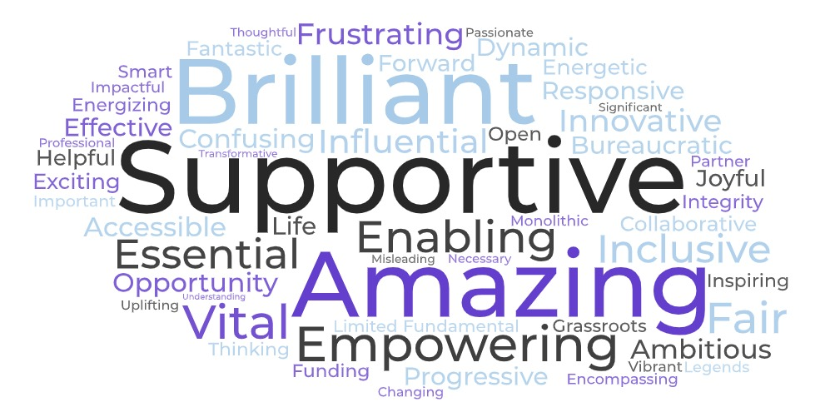

Consistent with previous years, the most used word to describe Youth Music was ‘supportive’, with ‘brilliant’, ‘amazing’ and ‘empowering’ growing significantly in frequency.

When given the opportunity to expand on the word they had provided, it was mainly used as a space to give a message of thanks to Youth Music:

“Thank you, thank you for all of your support. It's transformed our organisation more than we could possibly imagine.”

Some used this space to provide feedback on how Youth Music could improve, with the common theme being increased funding opportunities:

“Seems to be so well funded and so will have money to do research etc. but for me I'd like that money to go back into projects, a lot more projects, rather than keep feeding the one, or the few”

Insights

We collected benchmark data on two new questions in this year’s survey. One to understand the impact of the cost of living crisis for the sector, and another to understand the progress being made in environmental sustainability. We will continue to collect this data year on year to monitor progress.

Cost-of-Living Crisis

We asked respondents to select and rank any concerns that apply to them from a predetermined list. The three most pressing concerns are; the impact on children and young people organisations work with (36%), increased demand for services (23%), and fall in donations or income (16%).

 | Proportion of respondents that ranked concern first | Proportion of respondents that ranked the concern in their top three
Impact on children and young people you work with | 36% | 71%
Impact on staff wellbeing | 3% | 29%
Increased demand for services | 23% | 43%
Increased costs from wages | 8% | 30%
Fall in donations or income | 16% | 41%
Increased cost of supplies and equipment | 3% | 20%
Increased costs from utilities | 4% | 24%
Ability to survive long-term | 8% | 16%
Increased rent | 0% | 10%
Decreased demand for services | 1% | 5%
Other | 0% | 4%

In what ways is the cost of living affecting your organisation? Please select all that apply and rank your concerns, with 1 being most important. (80)

“Impact on children and young people you work with” was overwhelmingly the most common theme throughout the data, with safeguarding issues being mentioned. This included children and young people having a lack of access to food and travel, as well as negative impacts on mental health:

“HUGELY - we've had safe-guarding issues around children being hungry. Families are under extreme stress.”
“We're seeing an increase in young people not eating enough.”
“We have had a reduction in attendance from those economically disadvantaged that we are trying to reach most. We think this is because less parents/carers have the time to bring children to our sessions, and/or less money to transport them. We haven’t seen this impact the young people yet but only because those it is impacting most are not attending!”
“Apart from the obvious (household income not going as far), I think a lot of Young People's mental health is suffering because they are worried about their parents/guardians, and if there is something else they're worried about they feel they don't want to burden/worry their parents any further. This is leading a number of YP to get to the point of real crisis because they’re bottling up a lot of worry”

“Increased demand for services” was rated highly in importance, but the qualitative data suggests that many are unable to meet this increased demand. A common theme was a lack of access to music provision occurring due to the cost-of-living crisis. An increased demand for other services was another theme in the data, such as running foodbanks and providing transport:

“Less spare cash, has seen a drop off of opportunities, irregular work patterns have also put a strain on structured learning.”
“They can't afford to make music without support - it's hard to keep music-making a priority amongst so many other issues like food & warmth”
“Parents using food banks, we are having to pick up the young people we work with for sessions as families have no spare money for them”
“We have seen a dramatic increase in the number of families accessing our food bank. The reasons given are more to do with increases in food and fuel costs than any other reasons previously given (such as poor health, benefit sanctions, etc).”

Though rarely ranked in respondents’ top three concerns, “Impact on staff wellbeing” placed second on the weighted ranking. This was due to the higher volume of selection as a lower importance concern. Though often selected, there was little reference to staff wellbeing in the qualitative data, often being mentioned among other concerns:

“It’s just starting to effect us, our leaders, and young people are all getting effected and will get effected in the coming months. Food and well-being will become a need of all our young people and staff.”
“As a result of the cost of living crisis and the lack of core funding to keep employees working to help children and young people be involved in music in our area they are now seriously deprived of the opportunities we once were able to offer”
“Children, families and teachers are all tired and even simple things need to be pulled out of the bag. uncertainty takes a toll”

Environmental Sustainability

Youth Music is committed to good practices around environmental sustainability. The climate and ecological crisis is increasing in importance across all our work and we’ve signed the Funder Commitment on Climate Change. We’re keen to hear more about the current practice of organisations in order to inform our own work in this area, so in this year’s Stakeholder Survey, we collected benchmark data around environmental sustainability by asking “Do any of the following statements apply to your organisation?”

 | Not sure | Not applicable | No | Yes | #
We plan to develop an environmental action plan | 21% | 25% | 10% | 44% | 81
We have an environmental action plan which has specific targets to improve our environmental impact | 15% | 13% | 30% | 42% | 79
We take active steps to improve our environmental impact - but these are not formalised into a specific plan | 10% | 22% | 12% | 56% | 81
We commit budget to fulfil our environmental commitments | 18% | 9% | 46% | 28% | 79
We have signed an environment pledge or declaration (e.g. ‘music declares emergency') | 14% | 9% | 58% | 19% | 79
We have developed partnerships with other organisations to share learning and resources in this area | 14% | 4% | 41% | 42% | 79
We have a dedicated environmental working group | 6% | 6% | 67% | 21% | 79
We creatively embed environmental themes in our work with young people | 9% | 5% | 30% | 57% | 78

The comment section showed a general positive view of implementing procedures to promote environmental sustainability. It also provided insight into those who do not currently have a formalised plan in place, with the majority saying they were currently in the process of implementing one:

“We are process of developing specific targets and activities into a plan for our whole environmental position”

There were also respondents who provided actions they are taking that fell outside of the options we provided, such as community gardens and reducing carbon footprint:

“We have an eco-friendly community garden around our centre and café... we have a greenhouse raised beds embryonic orchard solar lights thermal composters and more”

Youth Voice

Last year, Youth Music launched a youth voice campaign called #ShareTheMic, aiming to encourage young people influencing how an organisation or project is run. This also included creating the #ShareTheMic: Youth Voice Hub, which provides resources for organisations to implement youth voice in their work.

We were keen to find out the current steps being taken in youth voice practice to inform the next stage of the campaign development, so we asked respondents “Do any of the following statements apply to your organisation?”

 | Not sure | No | Yes | #
Children and young people directly influence what we deliver on our creative programmes | 2% | 1% | 96% | 82
We consult formally with children and young people using surveys, focus groups or other means | 1% | 13% | 86% | 83
Young people are part of our Trustee board | 1% | 66% | 33% | 82
We have a dedicated young people's advisory board | 6% | 56% | 38% | 82
Children and young people directly influence our organisation's strategy | 5% | 20% | 76% | 82
We have a youth leadership programme | 4% | 50% | 46% | 80
Children and young people are involved with our campaigning and advocacy work through adult-led campaigns | 6% | 50% | 44% | 78
Children and young people are involved with campaigning and advocacy work through youth led campaigns | 3% | 59% | 38% | 78
We support children and young people to run their own events and projects | 2% | 21% | 77% | 81
We provide entry-level employment opportunities for young people (e.g. internships, apprenticeships, kickstarter) | 1% | 24% | 75% | 83
We regularly feedback to children and young people about what we've heard and how we are acting upon it | 7% | 13% | 79% | 82

Funding Principles

At Youth Music, we are committed to being a Flexible Funder. So, we signed up to the eight funding principles to inform how we work, as well as adding an extra two of our own.

We then asked respondents to rate us against these principles, using a scale from “Very poor” to “Excellent”.

 | Very poor | Below average | Average | Above average | Excellent | #
Principle 1. We will not waste your time. | 3% | 3% | 13% | 42% | 39% | 105
Principle 2. We will only ask relevant questions. | 1% | 2% | 15% | 49% | 35% | 104
Principle 3. We will accept our share of risk. | 1% | 3% | 22% | 45% | 29% | 103
Principle 4. We will act with urgency. |  | 3% | 22% | 42% | 33% | 105
Principle 5. We will be transparent about our decisions. | 3% | 6% | 18% | 40% | 33% | 103
Principle 6. We will enable you to respond flexibly to changing priorities and needs. | 2% | 2% | 11% | 34% | 51% | 102
Principle 7. We will be clear about our relationship from the start. |  | 3% | 17% | 43% | 38% | 103
Principle 8. We will commit to light touch reporting. |  | 7% | 25% | 40% | 28% | 97
Principle 9. We will be accessible. | 2% |  | 25% | 38% | 36% | 104
Principle 10. We will involve people in our programme design and decision-making. | 1% | 3% | 21% | 39% | 35% | 99

We were rated highly across all the funding principles, with a range between 68% and 85% rating us as above average/excellent.

“The way Youth Music have refined/streamlined your funding process in recent years is an excellent example for other funders to follow.” – Principle 2: We will only ask relevant questions
“Youth Music was one of the most supportive funders throughout the pandemic and really encouraged us to continue finding ways to work with freelance musicians and to be experimental in our approach. This has really helped innovate our practice going forward.” – Principle 3: We will accept our share of risk
“During our debrief of our failed recharge application we felt the feedback didn't match the criteria. Earlier failures have tended to be very helpful.” – Principle 5: We will be transparent about our decisions
“It's fantastic to see a funder live by their values and the influence of young people's input is clear in the changes you've made to your funding programmes.” – Principle 10: We will involve people in our programme design and decision-making

Recommendations and how we've responded

In response to the findings of this year’s Stakeholder Survey, we have decided to reintroduce a set of recommendations – we last did this in 2019. Either strengthened or led by the data collected in this survey, we are taking the following steps:

Recommendation 1. Provide support to counter impact of the cost-of-living crisis

Further to the findings from the Stakeholder Survey, Youth Music launched its programme in January 2023 to support projects during the cost-of-living crisis. See our response here: Is the cost-of-living crisis threatening the future of grassroots music projects? We have also developed a Cost of Living resource hub.

Recommendation 2. Provide guidance on fundraising

Stakeholders requested guidance on fundraising practices. Backed by this new insight, Youth Music’s learning programme, Exchanging Notes, is running a cost-of-living-crisis resilience programme that includes guidance on fundraising. The sessions began in March 2023.

Recommendation 3. Raise awareness of the #ShareTheMic: Youth Voice Hub

Guidance for implementing youth voice in an organisation was also requested in the survey. However, 40% of respondents said they weren’t aware of our #ShareTheMic: Youth Voice Hub. So, we’re going to raise awareness of the #ShareTheMic hub to ensure Stakeholders are aware of the resources available to them.

Recommendation 4. Support in gaining knowledge so organisations can improve their environmental sustainability

Stakeholders told us they wanted to be doing more towards environmental sustainability. As a first step, Youth Music will provide initial training via its Exchanging Notes programme in summer 2023.

Recommendation 5. Consider how future resources and Exchanging Notes sessions are relevant to different contexts and settings

Stakeholders requested guidance that was specific to their organisation’s focus. In response, we hosted an Explore Evaluation session that was Early Years focussed. Moving forward and will continue to do this for other contexts.

Recommendation 6. Combine the Youth Music website and Youth Music Network website

Survey respondents reported issues with navigating and using the Youth Music Network website. In 2023, Youth Music will be re-launching the Youth Music and Youth Music Network websites, combining the two into one website.

THE NATIONAL FOUNDATION FOR YOUTH MUSIC
STUDIO LG01, THE PRINT ROOMS
164-180 UNION STREET, LONDON, SE1 0LH
REGISTERED CHARITY NUMBER: 1075032
LIMITED COMPANY NUMBER: 3750674

