YOUTH MUSIC FEEDBACK SURVEY

2023
Photo from Babigloo Music for Babies, by Jayne Jackson

Contents

Introduction 2
Respondent Information 3
Applying to Youth Music 4
Reporting to Youth Music 6
Youth Music Impact 7
Cost of Living 10
Environmental Sustainability 12
Youth Voice 13
Living Wage 14
Funding Principles 15
Recommendations 17

Introduction

The Youth Music Feedback Survey is an annual survey we undertake with our funded partners, as well as those who applied for Youth Music funding in the last financial year. We conduct the survey to evaluate our performance as a funder and determine areas we can improve our performance. We also use it to gather insights about the grassroots organisations and young people we work with. A separate NextGen Feedback survey is conducted annually, too.

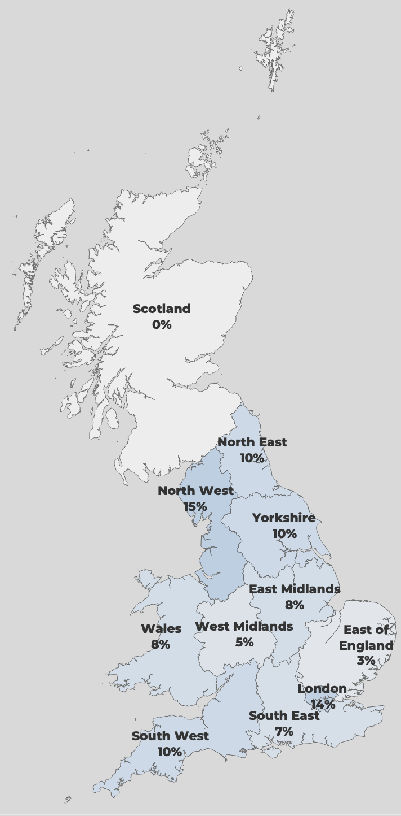
National
10%
Organisation type (119)

Respondent Information
119
Responses
(+12% from 2022)

15%
Response rate
(+5% from 2022)

Seventy-nine percent (94) of respondents were current/previous funded partners. 19% were unsuccessful applicants and 2% had never applied.

Region of operation (119)

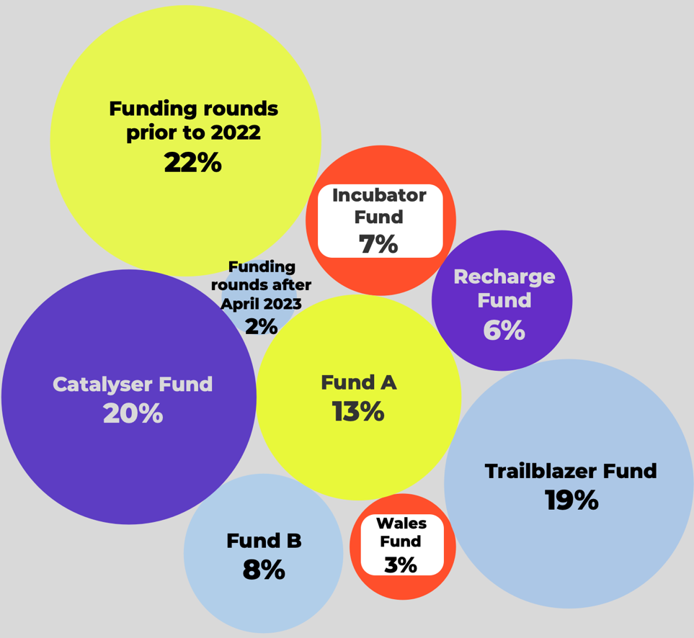

Organisation size (119)
Funds applied for (respondents could select multiple) (119)

Applying to Youth Music
 |  |  |  |  |  |  |  | Above average/Excellent
 | Was not aware of this | Aware, but did not use | Very poor | Below average | Average | Above average | Excellent | 2023 | Diff. from 2022 (103)
Information on Youth Music's current funding priorities and criteria | 1% | 0% | 0% | 1% | 9% | 37% | 52% | 89% | +7%
Applicant guidance notes | 0% | 0% | 0% | 1% | 5% | 38% | 56% | 94% | +15%
Phone/email support from Youth Music staff | 2% | 10% | 1% | 3% | 9% | 20% | 56% | 76% | +10%
Application questions and language | 0% | 1% | 0% | 3% | 14% | 42% | 41% | 83% | +8%
Application form format | 0% | 0% | 1% | 3% | 16% | 44% | 36% | 80% | New for 2023
Online grants portal (where you apply and manage grants) | 1% | 1% | 0% | 4% | 23% | 39% | 33% | 72% | +2%
Youth Music website | 0% | 0% | 1% | 3% | 11% | 51% | 35% | 85% | +12%
Youth Music Network website | 5% | 10% | 0% | 5% | 12% | 39% | 29% | 68% | +11%
Information on Youth Music's currently funded projects | 4% | 9% | 0% | 4% | 19% | 33% | 32% | 65% | -4%

How would you rate the following aspects of the application process? (111)

Respondents were also asked, ‘If you could improve one thing about the application process, what would it be and why?’. The most common response was to suggest no changes:

“Honestly the application was really straight forward so I wouldn't change anything.”

The most suggested improvements involved website use, including both Youth Music websites and the online grant application portal:

“The grant application portal, Youth Music Website and Youth Music Network websites all seem to have been developed by people who weren't talking to each-other. Not clear why Network needs to be a separate website, just makes stuff harder to find.”

“The website can be difficult to navigate to find what you need.”

Reporting to Youth Music
 |  |  |  |  |  | Agree/Strongly Agree
 | Strongly disagree | Disagree | Neither agree nor disagree | Agree | Strongly agree | 2023 | Diff. from 2022 (86)
Youth Music staff are often available to respond to my queries | 0% | 1% | 10% | 27% | 62% | 88% | +3%
Youth Music staff respond to my queries promptly | 0% | 2% | 6% | 30% | 62% | 92% | -1%
I feel comfortable approaching Youth Music staff with a problem | 0% | 0% | 5% | 20% | 76% | 95% | 0%
Youth Music staff are flexible with the requirements of my grant | 0% | 0% | 5% | 35% | 60% | 95% | +2%
The requirements of my grant were made clear to me from the outset | 0% | 0% | 5% | 36% | 60% | 95% | -2%

To what extent do you agree with the following statements about our relationship management?
(87 previous/current funded partners)

The comment section to the question was overwhelmingly positive, with the majority of respondents praising the relationship they have with their grant manager:

“I find the grant managers I have worked with to be exceptional. They feel like genuine partners, working with us to help us to succeed in work which we all equally feel is meaningful and much-needed.”

“Nothing but good things to say about the YM team - excellent service and quick responses, and generous with their time.”

“I think that the reporting and relationship with our grant managers is great. It feels like Youth Music is made of people rather than just being a website for funding.”

Youth Music Impact
Above average/
Significant impact
 | No impact | Below average impact | Average impact | Above average impact | Significant impact | 2023 | Diff. from 2022 (94)
Your organisation | 9% | 5% | 7% | 16% | 63% | 80% | +1%
Your organisation's approach to IDEA | 12% | 7% | 25% | 31% | 26% | 57% | +10%
Your organisation's Safeguarding practices | 16% | 6% | 35% | 23% | 20% | 43% | +7%
Your wider field of work | 7% | 7% | 15% | 32% | 39% | 71% | +10%
Your organisation's sustainability | 11% | 8% | 12% | 25% | 45% | 70% | New for 2023

Overall, how would you rate Youth Music’s impact on the following? (104)

In the comment section, many respondents told us how we have been key to their sustainability and growth:

“Our YM funded projects have allowed our organisation to grow and sustain long term partnerships, explore new models of working, implement new processes and policies and build a more resilient, accessible and inclusive workforce across our whole region.”

Others mentioned how our impact had influenced a change in their practices:

“You are one of the funders who make us think in a wider way about our organisation, and our whole practice has changed as a result of working with YM over the years.”

Our overall above average/excellent rating as a funder increased to 90% compared to 2022.

Respondents were also asked to describe Youth Music in one word. Consistent with previous years, ‘Supportive’ was the most common response.

Other common responses were ‘Great’, ‘Vital’ and ‘Inclusive’.

We introduced a new question this year, asking respondents if there is anything other funders are doing that they would recommend we implement (34).

The most common responses were additional funding opportunities and more project visits:

“More visits to see the services being delivered. We want to celebrate our funding with you!”

“Creating the opportunity for longer term funding (3 to 5 years). An opportunity to converse when a one year project is coming to an end and encouragement and support to secure longer term funding based on success.”

Above average/Excellent
Above average/Excellent
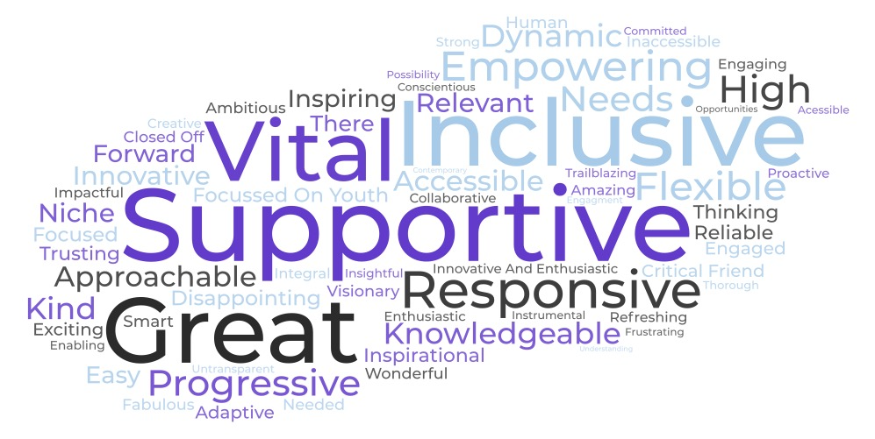
What is the one word you would use to describe Youth Music? (90)
Overall, how would you rate Youth Music as a funder? (104)
Additionally, some respondents felt that other funders should be learning from Youth Music:

“I think you're leading the way on making applications simple, with clear process and excellent relationship managers.”

“No, it's the other way around, recommending your guidance on evaluation to others.”

“I think YM should be giving other funders advice...”

“No. Youth Music set the standards.”

“Actually, I feel that other funders should look at how Youth Music operate.”

Cost of Living

We asked respondents to select and rank any concerns that apply to them from a predetermined list. The three effects most commonly ranked first in importance were:

Impact on CYP you work with – (27%)

Increased costs from wages – (11%)

Increased demand for services – (37%)

In 2022, ‘Impact on CYP you work with’ was the most commonly ranked first in importance, and ‘Increased demand for services’ took second place; these two options have switched places. ‘Increased costs from wages’ has replaced ‘Fall in donations or income’ in third place.
 | Proportion of respondents who selected |  | Proportion of respondents that ranked impact first in importance
Impact on children and young people you work with | 82% |  | 27%
Impact on staff wellbeing | 79% |  | 2%
Increased cost of supplies and equipment | 76% |  | 1%
Increased costs from wages | 66% |  | 11%
Increased demand for services | 65% |  | 37%
Increased costs from utilities | 61% |  | 2%
Less funds available to apply for | 61% |  | 3%
Fall in donations or income | 55% |  | 3%
Fewer successful funding applications | 55% |  | 4%
Ability to survive long-term | 46% |  | 1%
Increased rent | 38% |  | 3%
Decreased demand for services | 22% |  | 5%
Other | 10% |  | 0%

In what ways is the cost of living affecting your organisation? Please select all that apply and rank your concerns, with 1 being most important. (94)

Consistent with last year, ‘Impact on children and young people you work with’ was ranked highest in importance in the weighted ranking and second in the proportion of people ranking it first. This aligns with the qualitative data, with this theme being by far the most common. The sub-themes were also consistent with 2022, including a lack of access to food, essentials, and transport, as well as negative impacts on mental health:

“We are seeing young people who aren't having access to as much food as they need. Young people without coats and appropriate shoes. Young people who are anxious and concerned about their parents being able to afford the bills.”

“Aside from pressure on households affecting families and young people through lack of utilities and food, we are noticing struggles in attendance due to transport costs along with more mental health crisis presentation due to family dynamics and added stresses.”

“Families are still struggling to find extra money for travel for young people which impacts on our time as we have to pick a lot of the young people up for gifts/studio sessions/rehearsals. We also have started providing regular food as some young [people] have no energy from not eating.”

This year, ‘Increased demand for services’ was most commonly ranked as first in importance. While mentioned by a few in the qualitative data, there is no clear indication why this has happened.

Environmental Sustainability

 | Not applicable | Not sure | No | Yes |  |  | “Yes”, diff. from 2022 (81)
We plan to develop an environmental action plan | 21% | 23% | 12% | 44% |  |  | 0%
We have an environmental action plan which has specific targets to improve our environmental impact | 7% | 11% | 52% | 29% |  |  | -13%
We take active steps to improve our environmental impact - but these are not formalised into a specific plan | 13% | 6% | 13% | 69% |  |  | +13%
We commit budget to fulfil our environmental commitments | 10% | 15% | 37% | 37% |  |  | +9%
We have signed an environment pledge or declaration (e.g. ˜music declares emergency') | 5% | 18% | 64% | 13% |  |  | -6%
We have developed partnerships with other organisations to share learning and resources in this area | 2% | 19% | 37% | 42% |  |  | 0%
We have a dedicated environmental working group | 5% | 7% | 64% | 24% |  |  | +3%
We creatively embed environmental themes in our work with young people | 1% | 8% | 30% | 61% |  |  | +4%
We have received training in environmental sustainability or a related topic | 4% | 8% | 52% | 36% |  |  | New for 2023

Do any of the following statements apply to your organisation? (97)

Youth Voice

 | Not sure | No | Yes |  |  | “Yes”, diff. from 2022 (83)
Children and young people directly influence what we deliver on our creative programmes | 0% | 1% | 99% |  |  | +3%
We consult formally with children and young people using surveys, focus groups or other means | 0% | 6% | 94% |  |  | +8%
Young people are part of our Trustee board | 1% | 71% | 28% |  |  | -5%
We have a dedicated young people's advisory board | 3% | 49% | 47% |  |  | +9%
Children and young people directly influence our organisation's strategy | 2% | 18% | 80% |  |  | +4%
We have a youth leadership programme | 2% | 52% | 46% |  |  | 0%
Children and young people are involved with our campaigning and advocacy work through adult-led campaigns | 10% | 52% | 38% |  |  | -7%
Children and young people are involved with campaigning and advocacy work through youth led campaigns | 9% | 49% | 41% |  |  | +3%
We support children and young people to run their own events and projects | 3% | 25% | 72% |  |  | -5%
We provide entry-level employment opportunities for young people (e.g. internships, apprenticeships, kickstarter) | 7% | 29% | 64% |  |  | -11%
We regularly feedback to children and young people about what we've heard and how we are acting upon it | 4% | 19% | 77% |  |  | -2%

Do any of the following statements apply to your organisation? (98)

Living Wage

We re-introduced questions about the real Living Wage for the Feedback Survey 2023; we last asked in 2021. The rate at the time of the survey was £10.90 per hour or £11.95 in London.

Does your organisation pay the Living Wage rate (or higher) to all of your employees (FTE and contracted)? The rate is currently £10.90 per hour or £11.95 in London (98)

Of those who said “Yes”, we also asked if this was as a direct result of Youth Music’s commitment to supporting funded partners to pay the Living Wage, with 10% saying “Yes” (91).

Is your organisation an accredited Living Wage employer? (98)

Funding Principles
 |  |  |  |  |  | Above average/Excellent
 | Very poor | Below average | Average | Above average | Excellent | 2023 | Diff. from 2022 (105)
Principle 1. We will not waste your time. | 1% | 5% | 8% | 36% | 50% | 86% | +5%
Principle 2. We will only ask relevant questions. | 1% | 1% | 16% | 35% | 47% | 83% | -1%
Principle 3. We will accept our share of risk. | 1% | 4% | 17% | 34% | 44% | 78% | +4%
Principle 4. We will act with urgency. | 0% | 3% | 19% | 31% | 46% | 77% | +2%
Principle 5. We will be transparent about our decisions. | 3% | 5% | 16% | 33% | 43% | 76% | +3%
Principle 6. We will enable you to respond flexibly to changing priorities and needs. | 1% | 1% | 11% | 26% | 61% | 87% | +2%
Principle 7. We will be clear about our relationship from the start. | 1% | 1% | 7% | 33% | 58% | 91% | +10%
Principle 8. We will commit to light touch reporting. | 0% | 3% | 21% | 31% | 45% | 76% | +8%
Principle 9. We will be accessible. | 1% | 3% | 12% | 42% | 42% | 85% | +11%
Principle 10. We will involve people in our programme design and decision-making. | 0% | 3% | 20% | 38% | 40% | 77% | +3%

How would you rate us against this principle? (116)

We were rated highly across all ten of our funding principles, ranging from 76% to 91% rating us as above average/excellent.

“The clarity of questions and any subsequent 'check-ins’ for applications mean that you get a chance to explain your intent rather than fall at the first funding hurdle - thank you.” (Principle 2)

“Yes, I think that the relationship is clear. Most importantly it IS a relationship. It's not just funding. We know that Youth Music is interested in what we are doing, what we are learning and that there is a conversation and a two way thing. This is not always the case with other funders.” (Principle 7)

“Reporting well does still take a good amount of time, however it is clear that YM have thought about what is essential. Having the flexibility with the evaluation parts of the report helps with this and makes it easier to use the work in other places.” (Principle 8)

Recommendations

We’re really pleased to see the positive response for the work we do! However, we acknowledge that there were still some areas highlighted in the survey that we could look to improve.

Led by these insights, we are taking the following steps:

Recommendation One: Combine the Youth Music website and Youth Music Network website.

Consistent with previous years, respondents shared that they had issues navigating and using our websites. Last year, we said that we planned to re-launch the Youth Music website, combining both the Youth Music and Youth Music Network website. We can confirm that the process to re-launch the Youth Music website is now underway.

Recommendation Two: Youth Music staff to continue to make project visits.

In the last financial year, we were able to conduct project visits in every region we operate in across the UK. We’ll continue to conduct regular projects visits, allowing us to see the great work our funded partners do.

Recommendation Three: Provide further safeguarding and diversity support.

We have continued to develop our Safeguarding Hub, which includes resources to support your safeguarding practices. We host regular safeguarding training with our safeguarding associate through Exchanging Notes.

We continued to build the IDEA Hub to provide support on improving inclusion, diversity, equity and access practices.

Recommendation Four: Support with networking opportunities.

We regularly update our project map on the Youth Music Network website. This map shows all the active Youth Music funded projects in England. The map also includes the project focus, so you can also find organisations working in the same area as you.

We provide opportunities for networking through our Facebook Group, Exchanging Notes learning programmes and funded partner induction sessions.

THE NATIONAL FOUNDATION FOR YOUTH MUSIC
STUDIO LG01, THE PRINT ROOMS
164-180 UNION STREET, LONDON, SE1 0LH
REGISTERED CHARITY NUMBER: 1075032
LIMITED COMPANY NUMBER: 03750674

