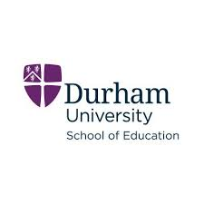

Northern Bridge Collaborative Doctoral Awards PhD opportunity:

Arts and Creativity: Raising Attainment, Attendance and Aspiration in Young People Facing Disadvantage

While the benefits of high-quality arts education are frequently observed in practice, the evidence that support these benefits, across a young person’s educational experience and attainment, is limited. Not only is arts learning insufficiently evaluated, but inequably distributed: young people facing disadvantage are less likely to receive the advantages it confers. By working with the educational charity Hand Of, the CDA researcher and project team will analyse, evaluate and, in due course, model a set of interventions that can raise attainment, attendance and aspiration in young people marginalised by mainstream education and make a significant intervention into policy and the research field.

More information about the project can be found at: [Collaborative Doctoral Awards (Staff-led) | Northern Bridge Consortium | Newcastle University](https://northernbridge.ac.uk/applyforastudentship/cda/)

Questions about the project can be directed to Dr Sophie Ward: [s.c.ward@durham.ac.uk](mailto:s.c.ward@durham.ac.uk) Interested candidates should submit a short (approx. 500 word) personal statement saying why they are interested in the work of Hand Of and why they are the right person to conduct this evaluation; academic CV; Bachelors/Masters transcripts and certificates, and two letters of references (at least one academic) by **4pm Monday 3rd March 2025**. These should be submitted to [ed.pgrstudents@durham.ac.uk](mailto:ed.pgrstudents@durham.ac.uk)

The successful candidate will need to meet the entry requirements for the School of Education PhD programme ([Research Degrees - Durham University](https://www.durham.ac.uk/departments/academic/education/postgraduate-study/research-degrees/) ). Shortlisted candidates will be invited for interviews in March 2025.