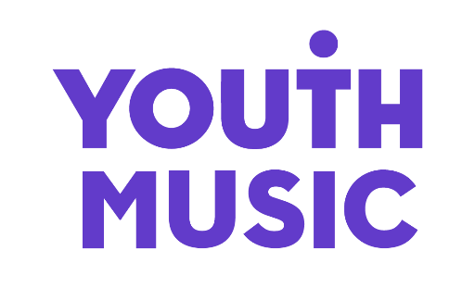

Access Fund to support d/Deaf and Disabled applicants

If you identify as d/Deaf, Disabled or Neurodivergent and need further support to make an application to Youth Music, you can apply to our Access Fund. This provides funding to cover any additional access costs that might be required for you to make an application to one of Youth Music’s main grant funds.

Maximum funding levels

You can ask for up to:

- £350 for a NextGen Fund application (please contact Adam Cookson if you think you will need more funding to submit an application to this fund: adam.cookson@youthmusic.org.uk)

- £900 for a Trailblazer Fund or Incubator Fund application

- £1,500 for a Catalyser Fund application (up to £300 will be paid ahead of the Expression of Interest stage; the remaining funds will be paid if you are invited to submit a full application)

Please note that applications received more than 6 weeks before the fund opens will not be considered. For example, if you want to apply to a Trailblazer Fund round that opens on 1 April, the earliest you could apply to the Access Fund for application support would be 11 February.

If you submit an Access Fund application more than 6 weeks before the relevant funding programme opens, your application will be rejected and you will be asked to resubmit at a later date.

How to access this funding

There are three ways you can make an application for access funds. Pick whichever option best suits you.

As part of the application we ask you to send us a copy of a recent bank statement, no more than three months old. If your application is approved we will pay the funds directly into this account.

Option A

Complete a short online application form and attach a recent current account statement.

Click here to access the application form.

Option B

Download the questions in Word or PDF format, and email your answers to finance@youthmusic.org.uk.

Please remember to attach a copy of a recent current account statement.

Click here to access the application questions in Word or PDF format.

Option C

Download the questions in Word or PDF format, record your answers as a video or voice note and then email the file to finance@youthmusic.org.uk.

Please remember to attach a copy of your organisation’s most recent current account statement.

What happens next

We will get back to you with a decision within 5 working days of receiving your application. When we review your application, we may contact the reference you provided as part of our checks. We will aim to get the payment into your bank account within 2 weeks of approving your application (although we recommend that you allow for 3 weeks in your planning).

Contact Us

If you need further support, or if you have any questions, please contact the Grants and Learning Team by emailing grants@youthmusic.org.uk or calling 020 7902 1060.

Access Fund FAQs

Are there application deadlines for the Access Fund?

There are no set deadlines for the Access Fund. However, applications received more than 6 weeks before the fund opens will not be considered. For example, if you want to apply to a Trailblazer round that opens on 1 April, the earliest you could apply to the Access Fund for application support would be 11 February.

We will get back to you with a decision within 5 working days of receiving your application. We will aim to get the payment into your bank account within 2 weeks of approving your application (although we recommend that you allow for 3 weeks in your planning).

Please make sure that you’re aware of the application deadlines for the main Youth Music grant fund you want to apply for, and that you allow enough time to meet this deadline in your planning. (Click here to view Youth Music’s funding application deadlines.)

Can I apply more than once?

Yes – there are no limits on the number of times that you can apply to the Access Fund.

Can Youth Music help me choose an access support worker?

Unfortunately, at this time Youth Music are not able to offer advice or guidance on choosing an access support worker.

What further support is available with my application once I’ve been awarded an Access Fund grant?

A member of the Grants and Learning Team can provide application advice and support to both you and/or your access support worker. You can contact the Grants and Learning Team by emailing grants@youthmusic.org.uk or calling 020 7902 1060.

Are there any costs that Youth Music doesn’t support under the Access Fund?

The Access Fund has been designed to support Disabled applicants to submit grant applications on our online system. You cannot use the Access Fund to cover the following costs:

- Access support for developing your project before you are ready to apply (e.g. initial project scoping, consultation, or project planning).

- Translation of our guidance or application form into other spoken languages.

- Translation of your application from another spoken language into English.

I’m not able to submit an Access Fund application using any of the available options. Is there another way for me to apply?

If you need further support to apply for the Access Fund please contact the Grants and Learning Team by emailing grants@youthmusic.org.uk or calling 020 7902 1060. A member of staff will help you to submit your application. This might involve going through the questions with you over the phone and submitting the application on your behalf.

