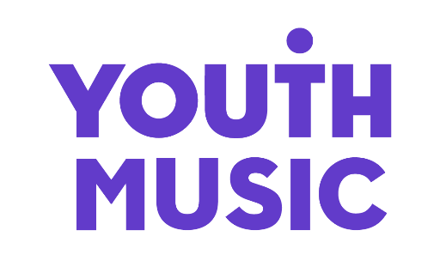

Access Fund Application Form – Individuals (NextGen Fund)

This fund is available for applicants who identify as d/Deaf, Disabled or Neurodivergent and need additional access support to make an application to Youth Music. All questions marked with an asterisk require an answer.
Please email your answers to finance@youthmusic.org.uk. Alternatively, you can record your answers as a video or voice note and then email the file to finance@youthmusic.org.uk.
Please remember to attach a copy of a recent current account statement.
If you would find it easier, you can submit your application by completing the online application form. Click here to access the online version of the application form.
We will aim to get back to you with a decision within 5 working days of receiving your request.
If you need further support to apply to this fund, or if you have any questions, please contact the Grants & Learning Team by emailing grants@youthmusic.org.uk or calling 020 7902 1060.

- Name*

- Please confirm that you wish to use an Access Fund grant to apply to Youth Music’s NextGen Fund*

- Which NextGen Fund Round do you intend to apply in? Details of upcoming funding rounds can be found on the Youth Music website. (We may be in touch to check any discrepancies if you do not go on to submit a NextGen Fund application after receiving an Access Fund grant.)*

- Email address*

- Telephone number

- How would you like us to contact you if we have any questions about this application?*

  - Email
  - Phone call
  - Other (please specify)

- Why do you need additional support to make a funding application to Youth Music?*

- How much money are you asking for? (Maximum request amount is £350 for a NextGen Fund application.)*

- What will you spend the money on? Where possible, please include breakdowns of specific costs (e.g. paying a support worker for 1 day @ £250 per day).*

- Is there anything else that you would like to tell us?

- When you submit your answers, please attach a copy of your most recent current account statement. If your application is successful, the funds will be transferred into this account.*

- Please provide some examples of your previous relevant work. This can be done via document upload or providing links to recordings, videos or your strongest social media account that best represents your work. If you are not able to provide examples, please explain why.*

- Please confirm that you are under 30 years old.

- Please provide the contact details of a professional who can confirm that you are who you say you are. We may contact them when we are reviewing your application, so they will need to know you have given their name as a reference.

  - Full name
  - Job title
  - Email address
  - Phone number

- Declaration:

I hereby confirm that I have read the NextGen Fund Eligibility Criteria and I am eligible to apply.

I declare that the information I have given on this form is correct and true to my knowledge.

I understand that to knowingly provide inaccurate information or omit information will be considered a breach of trust and potentially fraud. I am aware that in these circumstances Youth Music would follow up accordingly and make the relevant authorities aware of the misrepresentation as appropriate.

Name
Signed
Date

